SYSTEM TRANSACTIONS

INTRODUCTION

This chapter discusses in great detail all the out-going and in-coming HA/GP Links Registration transactions.

For each type of transaction, there is included:
- A background to and an overview of the Registration transaction.
- A diagrammatic representation of the functionality of the suggested processing for each transaction.
- A detailed description of the suggested processing required for that transaction within the GP System including all the mandatory requirements to be placed on the GP System.
- A table of the fields required for the transaction. The table includes field names, whether the field is mandatory and the validation and possible translation rules which MUST be undertaken by the GP System (out-going Registration transactions).
- A table of the translation rules which MUST be undertaken by the GP System to convert the received EDIFACT messages for use on the GP System (in-coming Registration transactions).

STANDARD OUT-GOING REGISTRATION PROCESSING

Overview

This section describes the processing which should be carried out on all out-going Registration information in order to prepare it for transmission (either across the Network within EDIFACT messages or by the use of paper forms).

In addition, it details those areas of the standard processing which are mandatory.

This section alleviates the need to repeat a description of this processing in the following sections which deal with the individual out-going Registration transactions.

Processing Diagram

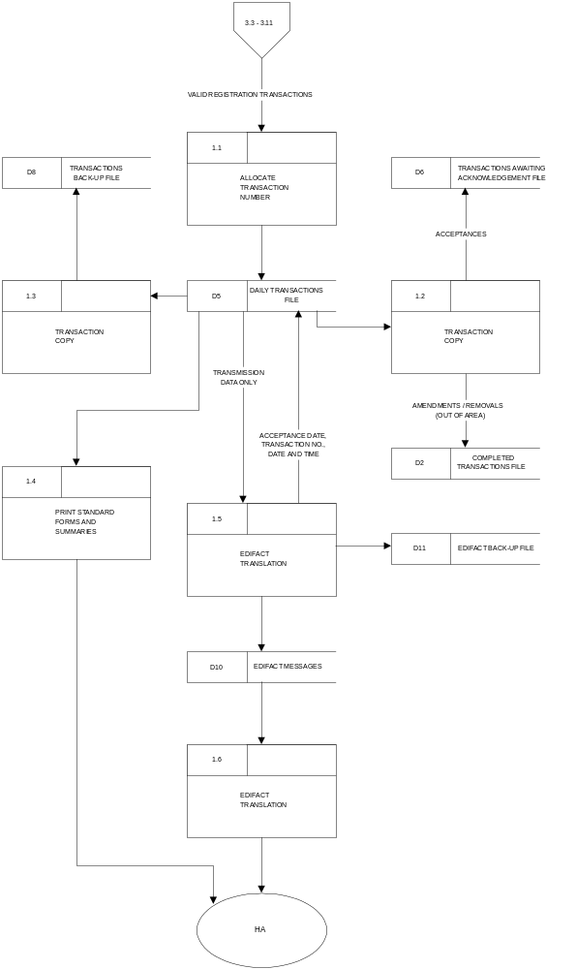

Processing Description and Further Mandatory Requirements

3.2.3.a Transmitting from the "Daily Transactions" file

Registration changes captured by the GP System and patient downloads to be sent across the Network MUST be stored within the "Daily Transactions" file awaiting subsequent processing.

The transmission process may be either started at the request of a GP or may be automatically started by the GP System at some pre-defined time (it is strongly recommended that the GP System should allow for the transmission process to be both started at the request of a GP and automatically started by the GP System at some pre-defined time). The transmission process MUST be a single process involving the printing of transactions destined for HAs with which the GP Practice is "manual", the translation to EDIFACT format of transactions destined for HAs with which the GP Practice is "linked" and the transmission of these onto the Network.

At this time, for transactions destined for HAs with which the GP Practice is "manual", the following processing MUST occur:
- Acceptance and Amendment transactions MUST be printed out on the corresponding standard form.
- Removal (Out of Area) transactions MUST be printed out and manually advised to the HAs using existing procedures.
- A summary of the transactions MUST be printed out (the Daily Transactions Summary).

For transactions destined for HAs with which the GP Practice is "linked", the following processing MUST occur:
- Each transaction MUST be allocated the next available Registration Transaction Number for the GP Practice. These MUST be allocated in the order in which the transactions were generated.
- The interface software between the GP System and EDIFACT MUST extract the fields to be transmitted from the "Daily Transactions" file, validate each field against the validation rules listed for each Transaction Type and, if successful, translate them in order to construct the equivalent transactions within EDIFACT format.
- As part of the translation process, each Registration transaction MUST be allocated a Transaction Date and Time and each Acceptance transaction MUST be allocated an Acceptance Date.
The Transaction Date and Time MUST be obtained from the GP System date and time and MUST be the same for all the transactions to be transmitted. The Transaction Date and Time MUST be combined within one EDIFACT message for each Transaction Type and MUST be the date and time that the first transaction to be transmitted was successfully translated.
The Acceptance Date allocated to each Acceptance transaction MUST be equal to the Transaction Date for that Acceptance - all the Acceptance transactions MUST, therefore, have the same Acceptance Date.

- The transmission software MUST then allow the EDIFACT interchanges to be transmitted onto the Network after successfully linking with the Network. This MUST occur within 12 hours of the start of the translation process.
Should transmission not occur within 12 hours of the start of the translation process, the translation MUST be repeated in order to ensure that the Transaction Dates and Times and the Acceptance Dates are updated.

Once the transmission has successfully completed:
- A copy of each valid Acceptance transaction within the "Daily Transactions" file sent across the Network MUST be taken and stored within the "Transactions awaiting Acknowledgement" file. To each transaction stored within this file should be added the Transaction Number, Transaction Date, Transaction Time and Acceptance Date allocated to each Acceptance by the translation process.
- If the GP System allows for the details of a newly-registered patient to be amended up until the time of transmission, the GP System MUST now set the "Freeze" flag for all the patients corresponding to the Acceptance transactions sent across the Network. Any changes made MUST, of course, be included within the Acceptance (see section 4.3.3).
- A copy of each valid Amendment, Removal (Out of Area) and Deduction Request transaction within the "Daily Transactions" file sent across the Network MUST be taken and stored within the "Completed Transactions" file. To each transaction stored within this file should be added the Transaction Number, Transaction Date and Transaction Time allocated to each transaction by the translation process.
- Acceptances, Amendments, Deduction Requests and Removals (Out of Area) destined for HAs with which the GP Practice is "linked" MUST be copied from the "Daily Transactions" file to the application level "Transaction Backup" file.
- The "Daily Transactions" file MUST be emptied.

3.2.3.b Transmitting from the "Transaction Backup" file

As part of the transmission process above, the "Daily Transactions" file MUST be copied to an application level "Transaction Backup" file.

If a GP requests that an Interchange is re-sent from this application level "Transaction Backup" file (see section 4.3.29), the following processing MUST be undertaken for the transactions originally sent within that Interchange.

The transmission process MUST be a single process involving the printing of transactions destined for HAs with which the GP Practice was previously "linked" and is now "manual", the translation of transactions destined for HAs with which the GP Practice is still "linked" and the transmission of these onto the Network.

At this time, for transactions destined for HAs with which the GP Practice is now "manual" having previously been "linked", the following processing MUST occur:
- Acceptance and Amendment transactions MUST be printed out on the corresponding standard form.
- Removal (Out of Area) transactions MUST be printed out and manually advised to the HAs using existing procedures.
- A summary of the transactions MUST be printed out (the Daily Transactions Summary).

For transactions destined for HAs with which the GP Practice is still "linked", the following processing MUST occur:
- Each transaction MUST be allocated the next available Registration Transaction Number for the GP Practice. These MUST be allocated in the order in which the transactions were generated.
- The interface software between the GP System and EDIFACT MUST extract the fields to be transmitted from the "Transaction Backup" file, validate each field against the validation rules listed for each Transaction Type, and - if successful - translate them in order to construct the equivalent transactions within EDIFACT format.
- As part of the translation process, each Registration transaction MUST be allocated a new Transaction Date and Time and each Acceptance transaction MUST be allocated a new Acceptance Date.
The Transaction Date and Time MUST be obtained from the GP System date and time and MUST be the same for all the transactions to be transmitted. The Transaction Date and Time MUST be combined within one EDIFACT message for each Transaction Type and MUST be the date and time that the first transaction to be transmitted was successfully translated.
The Acceptance Date allocated to each Acceptance transaction MUST be equal to the Transaction Date for that Acceptance. All the Acceptance transactions MUST, therefore, have the same Acceptance Date.
- The transmission software MUST then allow the EDIFACT interchanges to be transmitted after successfully linking with the Network. This MUST occur within 12 hours of the start of the translation process.
Should transmission not occur within 12 hours of the start of the translation process, the translation MUST be repeated in order to ensure that the Transaction Dates and Times and the Acceptance Dates are updated.

Once the transmission has successfully completed:
- A copy of each Acceptance within the Interchange re-sent from the "Transaction Backup" file should already exist within the "Transactions awaiting Acknowledgement" file.
For each Acceptance transaction within the Interchange re-sent from the "Transaction Backup" file:
- If the Acceptance is re-sent across the Network and a copy does exist within the "Transactions awaiting Acknowledgement" file, the Transaction Number, Transaction Date, Transaction Time and Acceptance Date allocated to the Acceptance MUST be updated within this file by this translation process.
- If the Acceptance is re-sent across the Network and a copy does not exist within the "Transactions awaiting Acknowledgement" file, a copy of the Acceptance MUST be taken from the "Transaction Backup" and stored within the "Transactions awaiting Acknowledgement" file. To the transaction should be added the Transaction Number, Transaction Date, Transaction Time and Acceptance Date allocated to each Acceptance by this translation process.
- If the Acceptance is printed out on a standard form and a copy does exist within the "Transactions awaiting Acknowledgement" file, the Acceptance within the "Transactions awaiting Acknowledgement" file MUST be deleted. Additionally, any "Freeze" flag set for that patient MUST be removed.

- For each Amendment, Removal (Out of Area) and Deduction Request transaction within the Interchange re-sent from the "Transaction Backup" file:
- A copy of the Amendment, Removal (Out of Area) or Deduction Request MUST be taken from the "Transaction Backup" file and stored within the "Completed Transactions" file. To the transaction should be added the Transaction Number, Transaction Date and Transaction Time allocated to each transaction by this translation process.

- A further copy of all Acceptances, Amendments, Removals (Out of Area) and Deduction Requests destined for HAs with which the GP Practice is "linked" MUST be taken within the "Transaction Backup" file.

OUT-GOING MANUALLY-ENTERED ACCEPTANCES

Overview

The GP System MUST be capable of recording all patient Acceptances and "capturing" them for transmission to the appropriate HA for that patient (that is, the patient's responsible HA).

For a GP Practice that is "linked" with an HA, the details of the patient Acceptance MUST be transmitted to that HA within an Acceptance transaction.

For a GP Practice that is "manual" with an HA, the details of the patient Acceptance MUST be advised to that HA by the use of an Acceptance standard form.

The GP System MUST be designed to establish the Acceptance Type each patient represents. This Acceptance Type will be included within the Acceptance transactions/forms sent to the HA.

HAs will have the option to either approve or reject Acceptance transactions/forms received from GPs, Acceptance transactions/forms only being rejected if the transaction/form has been forwarded to the incorrect HA for that patient.

Any changes made by HA staff to Acceptance transactions received from "linked" GP Practices or Acceptance standard forms received from "manual" GP Practices before being applied to the HA database will be advised back to the originating GP.

Processing Diagram

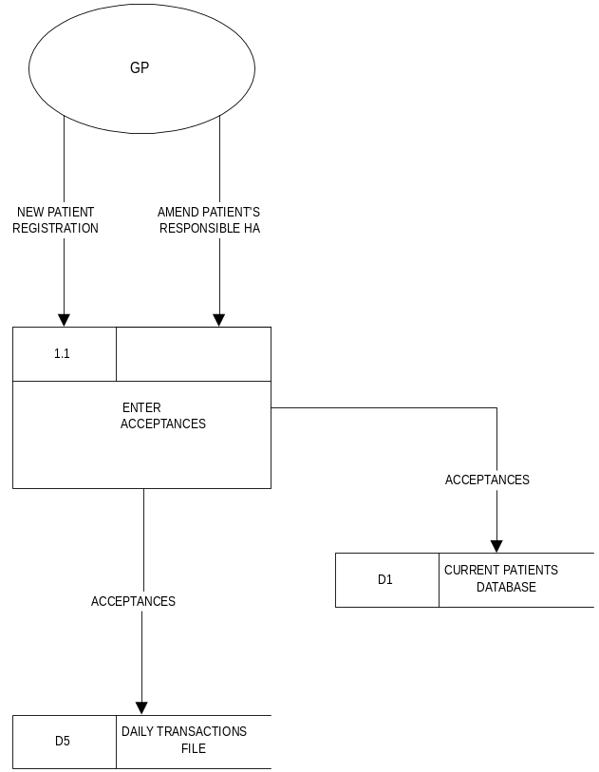

Processing Description and Further Mandatory Requirements

It is assumed that when a patient attends a Practice for the first time, he/she will either be accepted as either:
- a newly registered patient, by the completion of an Acceptance form (FP1, FP4, FP13, FP58); or
- a Temporary Resident, by the completion of a Temporary Resident form (FP19).

The GP System MUST differentiate between the new Registration on the GP System of a patient representing a Temporary Resident and a patient whose Registration is to be recorded as a "permanent" Acceptance on an HA System.

The Registration on the GP System of a patient representing a Temporary Resident MUST NOT be advised by a Registration transaction/form to an HA. However, the Registration on the GP System of a patient whose Registration is to be recorded as a "permanent" Acceptance on an HA System MUST be captured for transmission to the HA responsible for that patient (determined by the patient's registered address).

The procedure for handling a Temporary Resident is given in the separate document covering the requirements relating to the processing of Items of Service claims:
- General Practitioner Systems Specification - Items of Service Claims Processing.

A patient is usually treated as a Temporary Resident if he/she does not intend to live at an address covered by that GP Practice for more than 3 months.

For the purpose of this Specification, it is assumed that the patient is to register as a "permanent" patient at that Practice.

The GP System MUST be designed to establish the Acceptance Type each patient represents. This Acceptance Type will be included within the Acceptance transactions/forms sent to the HA.

The GP System may either establish the Acceptance Type a patient represents from the patient data entered or allow for the Acceptance Type to be manually entered and the patient data validated against this Acceptance Type. (Previously, the derivation of the Acceptance Type has been a manual process at the HA.)

It is strongly recommended that the Acceptance Type is derived from the patient data entered rather than manually entered. If the Acceptance Type is derived from the patient data entered, it MUST be calculated according to the algorithm detailed below. If the Acceptance Type is manually entered, the GP System MUST ensure that the patient data entered does not conflict with the Acceptance Type according to this same algorithm.

It is anticipated that the GP System will prompt the GP to determine the following minimum basic information about the patient:
NHS Number
* Surname
Previous Surname
Forename(s)
Title
* Sex
Date of Birth
* Present Address excluding Postcode
Postcode
Place of Birth [mandatory if NHS Number not entered]
* Patient's Responsible GP
* Patient's Responsible HA

(* = Mandatory field)

Note that the NHS Number may be in any valid format for NHS Numbers (see Appendix F for valid NHS Number formats). Once entered, this NHS Number will be the most up-to-date NHS Number of the patient on the GP System and will, therefore, be used to identify the patient in any subsequent transactions.

The following suggested processing for the GP System will:
- establish the patient Acceptance Type.
- establish the additional patient information required for a patient of that Acceptance Type.

3.3.3.a Algorithm to determine the Patient Acceptance Type

The GP System will prompt the GP to establish whether the patient has a valid medical card (FP4).
If Yes : The patient will at this stage represent a Transfer In.
If No :
The GP System will then prompt the GP to establish whether the patient has a valid Ex-Services form (FP13).
If Yes : The patient will represent Ex-Services.
If No :
The GP System will then prompt the GP to establish whether the patient has a valid pink "Baby Card" (FP58).
If Yes : The GP System will then prompt the GP to establish whether the patient's Place of Birth is in England or Wales.
If Yes and the patient is less than 12 months old, the patient will represent a Birth.
If Yes and the patient is more than or exactly 12 months old, the patient will represent a 1st Acceptance.
If No, the patient will represent a 1st Acceptance.
If No :
The GP System will then prompt the GP to establish whether the patient has been previously registered under the NHS.
If Yes : The GP System will then prompt the GP to establish:
- The patient's Previous GP's Name
- The patient's Previous Address

The GP System will then prompt the GP to establish whether the patient was within the medical cover of the Armed Services.
If Yes : The GP System will then prompt the GP to establish whether the patient has Dates of Enlistment.
If Yes : The patient will represent Ex-Services.
If No : The patient will, at this stage, represent a Transfer In - the Service Dependant Marker being set.
If No : The GP System will then prompt the GP to establish whether the patient is registering having just come from abroad (outside the UK).
If Yes : The GP System will then prompt the GP to establish the Date the Patient left the UK and the Date the Patient entered the UK.
If the date difference is more than 3 months - the patient will represent an Immigrant.
If the date difference is less than or equal to 3 months - the patient will represent a Transfer In.
If No : The GP System will then prompt the GP to establish whether the patient is registering having been a private patient.
If Yes : The patient will represent a 1st Acceptance.
If No : The patient will, at this stage, represent a Transfer In.

If No :
The GP System will then prompt the GP to establish whether the Place of Birth is outside the UK.
If Yes : The patient will represent an Immigrant.
If No : The patient will represent a 1st Acceptance.

If the patient represents a Birth, the GP System will prompt the GP for the following additional items of information (values may have already been ascertained above):
Drugs Dispensed Marker
RPP Mileage
Blocked Route/Special District Marker
Walking Units
Residential Institute Code
Free Text (GP Notes)

It follows, therefore, that the following items of information may be included within a Birth Acceptance:
* Patient's Responsible GP
* Patient's Responsible HA
* NHS Number
* Surname
Previous Surname
First Forename
Second Forename
Other Forenames
Title
* Sex
* Date of Birth
* Present Address excluding Postcode
Postcode
Place of Birth
Drugs Dispensed Marker
RPP Mileage
Blocked Route/Special District Marker
Walking Units
Residential Institute Code
Free Text (GP Notes)

(* = Mandatory field)

If the patient represents a 1st Acceptance, the GP System will prompt the GP for the following additional items of information (values may have already been ascertained above):
Drugs Dispensed Marker
RPP Mileage
Blocked Route/Special District Marker
Walking Units
Residential Institute Code
Free Text (GP Notes)

It follows, therefore, that the following items of information may be included within a 1st Acceptance Acceptance:
* Patient's Responsible GP
* Patient's Responsible HA
NHS Number
* Surname
Previous Surname
First Forename
Second Forename
Other Forenames
Title
* Sex
Date of Birth
* Present Address excluding Postcode
Postcode
Place of Birth [mandatory if NHS Number not entered]
Drugs Dispensed Marker
RPP Mileage
Blocked Route/Special District Marker
Walking Units
Residential Institute Code
Free Text (GP Notes)

(* = Mandatory field)

If the patient at this stage represents a Transfer In, the GP System will prompt the GP for the following additional items of information (values may have already been ascertained above):
Drugs Dispensed Marker
RPP Mileage
Blocked Route/Special District Marker
Walking Units
Residential Institute Code
* Previous Address - 5 fields
* Previous GP Name
Previous HA Cipher
Free Text (GP Notes)

(* = Mandatory field: for Previous Address at least one of the five fields MUST be completed.)

It follows, therefore, that the following items of information may be included within a Transfer In Acceptance:
* Patient's Responsible GP
* Patient's Responsible HA
NHS Number
* Surname
Previous Surname
First Forename
Second Forename
Other Forenames
Title
* Sex
Date of Birth
* Present Address excluding Postcode
Postcode
Place of Birth [mandatory if NHS Number not entered]
Drugs Dispensed Marker
RPP Mileage
Blocked Route/Special District Marker
Walking Units
Residential Institute Code
* Previous Address - 5 fields
* Previous GP Name
Previous HA Cipher
Free Text (GP Notes)

(* = Mandatory field: for Previous Address at least one of the five fields MUST be completed.)

If the patient represents an Immigrant, the GP System will prompt the GP for the following additional items of information (values may have already been ascertained above):
Drugs Dispensed Marker
RPP Mileage
Blocked Route/Special District Marker
Walking Units
Residential Institute Code
* Date of Entry into the UK
Date Patient left the UK
Previous Address - 5 fields
Previous GP Name
Previous HA Cipher
Free Text (GP Notes)

(* = Mandatory field)

It follows, therefore, that the following items of information may be included within an Immigrant Acceptance:
* Patient's Responsible GP
* Patient's Responsible HA
NHS Number
* Surname
Previous Surname
First Forename
Second Forename
Other Forenames
Title
* Sex
Date of Birth
* Present Address excluding Postcode
Postcode
Place of Birth [mandatory if NHS Number not entered]
Drugs Dispensed Marker
RPP Mileage
Blocked Route/Special District Marker
Walking Units
Residential Institute Code
* Date of Entry into the UK
Date Patient left the UK
Previous Address - 5 fields
Previous GP Name
Previous HA Cipher
Free Text (GP Notes)

(* = Mandatory field)

If the patient represents Ex-Services, the GP System will prompt the GP for the following additional items of information (values may have already been ascertained above):
Drugs Dispensed Marker
RPP Mileage
Blocked Route/Special District Marker
Walking Units
Residential Institute Code
Previous Address - 5 fields
Date of Enlistment (Joining)
Date of Enlistment (Leaving)
Free Text (GP Notes)

It follows, therefore, that the following items of information may be included within an Ex-Services Acceptance:
* Patient's Responsible GP
* Patient's Responsible HA
NHS Number
* Surname
Previous Surname
First Forename
Second Forename
Other Forenames
Title
* Sex
Date of Birth
* Present Address excluding Postcode
Postcode
Place of Birth [mandatory if NHS Number not entered]
Drugs Dispensed Marker
RPP Mileage
Blocked Route/Special District Marker
Walking Units
Residential Institute Code
Previous Address - 5 fields
Date of Enlistment (Joining)
Date of Enlistment (Leaving)
Free Text (GP Notes)

(* = Mandatory field)

The patient Acceptance details MUST be validated at the point of data entry. This data entry validation will ensure that no Acceptances to be sent across the Network will fail the process of translation to/from EDIFACT format and that the Acceptance details may always be applied to the HA database without alteration.

The items of information to be included in an out-going Acceptance are listed in section 3.3.4.

It is a requirement that the HA responsible for each patient be stored against that patient. How this is achieved will not be dictated by this document. It may be that the HA Cipher will be stored for all patients, or a default stored for that Practice and only Ciphers different from this default stored for patients. The only requirement is that each patient's responsible HA be available for use in determining the required destination of transactions generated by the GP System.

A manually-entered Acceptance generated at the GP Practice as a result of the manual entry of a new patient Registration MUST be allocated an Acceptance Code of "A".

The GP System MUST set a "Freeze" flag against the Registration details for a newly-accepted patient. If the GP System allows for the details of a newly-registered patient to be amended up until the time that the Acceptance for that patient is removed from the "Daily Transactions" file by the transmission process, this "Freeze" flag MUST be set as part of the transmission process. If not, the "Freeze" flag MUST be set at the time of the patient Registration. This "Freeze" flag is discussed in greater detail in section 4.3.3.

It is appreciated that in a large number of Practices:
- The patient Registration information is not entered into the GP System at the time of the patient actually attending the Practice but at some later time.
- Patient Registrations are handled by Practice staff as well as GPs.

In order that all the required information to register a new patient on the GP System is obtained by staff within a Practice when dealing with the Registration of that patient, GP System suppliers may consider it necessary to issue a "list of Acceptance questions" for their System. This list of questions should ensure that the required patient information is always obtained for cases where the information is not being put straight into the computer.

A manually-entered Acceptance may also be generated by amending the HA Cipher for an existing patient. If the GP System is set to "manual" for a patient's responsible HA, the GP System MUST allow for that patient's responsible HA to be amended to another, different HA. A Practice should only amend the HA Cipher for a patient if an FP22 printout, containing an entry for that patient with a reason for deduction of "6 - New HA/Same GP", has been received from the patient's previous responsible HA. If so amended, the GP System MUST generate an Acceptance to be advised to the patient's new responsible HA (in such a case, the GP System MUST allow the GP to enter some free text [GP Notes] to accompany the generated Acceptance). Such an Acceptance MUST be allocated an Acceptance Code of "S".

For this generated Acceptance:
- The Acceptance Type MUST equal "3" (Transfer In).
- The patient's previous address (within the patient's previous responsible HA's area) MUST be included within the Previous Address fields. A Previous Address field may only contain a non-null value if all the preceding Previous Address fields also contain non-null values.
- If the patient's responsible GP is unchanged, the patient's current responsible GP's name MUST be included within the Previous GP Name field. If the patient's responsible GP is changed within the Practice, the patient's previous responsible GP's name MUST be included within the Previous GP Name field.
- The patient's previous responsible HA's Cipher MUST be included within the Previous HA Cipher field.
- The patient's NHS Number MUST be included if known unless the NHS Number commences with a "?" character and, hence, represents a Query NHS Number. If the patient does have a Query NHS Number, this MUST be removed on the GP System and no NHS Number included within the Acceptance.
Note that this NHS Number may be in any valid format for NHS Numbers. This NHS Number will be the most up-to-date NHS Number of the patient on the GP System and will, therefore, be used to identify the patient in any subsequent transactions.
- Any values held for any of the following items of information MUST also be included within the generated Acceptance:
* Surname
Previous Surname
First Forename
Second Forename
Other Forenames
Title
* Sex
Date of Birth
* Present Address excluding Postcode
Postcode
Place of Birth [mandatory if NHS Number not known]
Drugs Dispensed Marker
RPP Mileage
Blocked Route/Special District Marker
Walking Units
Residential Institute Code
(* = Mandatory field)

Details of the captured Acceptance MUST be stored within the "Daily Transactions" file awaiting subsequent transmission.

It is recommended that the following information is stored (where known) for each patient Acceptance within the "Daily Transactions" file:
Transaction Type
Patient's Responsible GP Code
Patient's Responsible HA Cipher
Acceptance Type
NHS Number
Surname
Previous Surname
First Forename
Second Forename
Other Forenames
Title
Sex
Date of Birth
Present Address excluding Postcode - 5 fields
Postcode
Place of Birth
Drugs Dispensed Marker
RPP Mileage
Blocked Route/Special District Marker
Walking Units
Residential Institute Code
Previous Address - 5 fields
Previous GP Name
Previous HA Cipher
Date of Entry into the UK
Date Patient left the UK
Date of Enlistment (Joining)
Date of Enlistment (Leaving)
Service Dependant Marker
Acceptance Code
Free Text (GP Notes)

During the transmission process, each Acceptance will either generate an Acceptance transaction to be advised to an HA over the Network or will be printed on an Acceptance standard form.

Additionally, as part of this transmission process, details of Acceptances advised to an HA within Acceptance transactions across the Network MUST be copied to the "Transactions awaiting Acknowledgement" file.

It is recommended that, in addition to the information listed above, the following additional information is stored for each patient Acceptance within the "Transactions awaiting Acknowledgement" file:
Transaction Date
Transaction Time
Transaction Number
Acceptance Date

The format of Acceptances within the "Daily Transactions" file and the "Transactions awaiting Acknowledgement" file is not being dictated by this Specification. However, it is strongly recommended that data is stored within these files in the format that it MUST be sent to the HAs and stored within subsequent Archive files.

Acceptances within the Archive files MUST be in the exact format specified in Appendix A and MUST meet the validation requirements listed in section 3.3.4. (An Archive file is generated each time an Archive process is undertaken on the "Completed Transactions" file.)

Data Fields - Format/Validation - Mandatory Requirements

The following information may be included within an Acceptance. Fields marked (M) are mandatory and MUST always contain a valid, non-null value; fields marked (N-M) are non-mandatory and may or may not contain a non-null value.

Transaction Type (M)
Within Archive files, the Transaction Type MUST equal "ACG".
All out-going Acceptance transactions generated by the transmission process for a "linked" HA MUST be combined within one EDIFACT message.

GP Code (M)
Within EDIFACT Acceptance transactions, Acceptance standard forms and Archive files, the GP Code MUST be the valid GMC National code for the patient's GP concatenated with "," concatenated with the "local" code for the patient's GP as known by the destination HA (see section 4.3.7). The GP Code MUST:
- Have alphanumeric and "," characters only.
- Have a maximum length of 14 characters, in the following format:
Characters 1-7 = Fixed 7 numeric character GMC National GP code
Character 8 = comma (",")
Characters 9-14 = 1-6 alphanumeric character Local GP code.
- Have alphabetic characters in upper case.

Destination HA Cipher (M)
Within EDIFACT Acceptance transactions, Acceptance standard forms and Archive files, the Destination HA Cipher MUST:
- Be the Cipher of the patient's responsible HA.
- Be a valid HA Cipher; i.e. be a current live England and Wales code from the Table of Valid HA Ciphers (see Appendix D). As such, the Destination HA Cipher MUST:
- Have alphanumeric characters only.
- Have a maximum length of 3 characters.
- Have alphabetic characters in upper case.

Transaction Date and Time (M)
Within Archive files, the Transaction Date MUST be in the format "CCYYMMDD" and the Transaction Time in the format "HHMM".

Transaction Number (M)
Within EDIFACT Acceptance transactions and Archive files, the Transaction Number MUST:
- Have numeric characters only.
- Have a maximum length of 7 characters.
- Have a value of a positive integer.

Acceptance Type (M)
Within Acceptance standard forms, the Acceptance Type MUST be one of the following:
- 1 (BIRTH)
- 2 (1ST ACCEPTANCE)
- 3 (TRANSFER IN)
- 4 (IMMIGRANT)
- 5 (EX-SERVICES)
Within EDIFACT Acceptance transactions and Archive files, the Acceptance Type MUST:
- Have a single numeric character only.
- Have a value of a positive integer in the range 1 to 5 where:
- 1 represents a Birth.
- 2 represents a 1st Acceptance.
- 3 represents a Transfer In.
- 4 represents an Immigrant.
- 5 represents Ex-Services.

NHS Number (N-M)
Within EDIFACT Acceptance transactions, Acceptance standard forms and Archive files, the NHS Number MUST be in one of the acceptable formats detailed in Appendix F. As such, the NHS Number MUST:
- Have alphanumeric or "/" characters only.
- Have a maximum length of 15 characters.
- Have alphabetic characters in upper case.
or MUST be an all-numeric Number of 10 digits including a check digit (the 10th and final digit in the Number).

Surname (M)
Within EDIFACT Acceptance transactions, Acceptance standard forms and Archive files, the Surname MUST:
- Have alphabetic, SPACE, "'" and "-" characters only.
- Have a maximum length of 35 characters (Surnames of greater than 35 characters MUST be truncated for these purposes).
- Have alphabetic characters in upper case.

First Forename (N-M)
Within EDIFACT Acceptance transactions, Acceptance standard forms and Archive files, the First Forename MUST:
- Have alphabetic, SPACE, "'" "," "-" and "." characters only.
- Have a maximum length of 35 characters (First Forenames of more than 35 characters MUST be truncated for these purposes).
- Have alphabetic characters in upper case.

Second Forename (N-M)
Within EDIFACT Acceptance transactions, Acceptance standard forms and Archive files, the Second Forename MUST:
- Have alphabetic, SPACE, "'" "," "-" and "." characters only.
- Have a maximum length of 35 characters (Second Forenames of more than 35 characters MUST be truncated for these purposes).
- Have alphabetic characters in upper case.

Other Forenames (N-M)
Within EDIFACT Acceptance transactions, Acceptance standard forms and Archive files, Other Forenames MUST:
- Have alphabetic, SPACE, "'" "," "-" and "." characters only.
- Have a maximum length of 35 characters (Other Forenames totalling more than 35 characters MUST be truncated for these purposes).
- Have alphabetic characters in upper case.

Previous Surname (N-M)
Within EDIFACT Acceptance transactions, Acceptance standard forms and Archive files, the Previous Surname MUST:
- Have alphabetic, SPACE, "'" and "-" characters only.
- Have a maximum length of 35 characters (Previous Surnames of more than 35 characters MUST be truncated for these purposes).
- Have alphabetic characters in upper case.

Title (N-M)
Within EDIFACT Acceptance transactions, Acceptance standard forms and Archive files, the Title MUST:
- Have alphabetic, SPACE, "'" and "-" characters only.
- Have a maximum length of 35 characters (Titles of more than 35 characters MUST be truncated for these purposes).
- Have alphabetic characters in upper case.
The values entered for the Sex and Title fields MUST be checked to ensure that no conflict arises between a patient's Title and Sex. For example, a patient cannot be given a Title of "MR" and a Sex of "Female".

Sex (M)
Within Acceptance standard forms and Archive files, the Sex MUST be "M" for Male, "F" for Female, "I" for Indeterminate/Not Known or "S" for Not Specified.
Within EDIFACT Acceptance transactions, the Sex MUST be "1" for Male, "2" for Female, "0" for Indeterminate/Not Known or "9" for Not Specified within the Sex data element.

Date of Birth (N-M)
Within Acceptance standard forms, the Date of Birth MUST be in the format "DD/MM/CCYY".
Within Archive files, the Date of Birth MUST be in the format "CCYYMMDD".
Within EDIFACT Acceptance transactions, the Date of Birth MUST have qualifier "329", format "102" - "CCYYMMDD" within a DTM segment.
For all these, the Date of Birth MUST NOT be in the future.

Address - House Name (N-M)
Within EDIFACT Acceptance transactions, Acceptance standard forms and Archive files, the Address - House Name MUST:
- Have alphanumeric, SPACE, "'", "-", "." and "," characters only.
- Have a maximum length of 35 characters (House Names of more than 35 characters MUST be truncated for these purposes).
- Have alphabetic characters in upper case.
The Address - House Name MUST only contain the flat number or name of a property (if one exists).
Either the Address - House Name or the Address - Number/Road Name must be present.

Address - Number/Road Name (N-M)
Within EDIFACT Acceptance transactions, Acceptance standard forms and Archive files, the Address – Number/Road Name MUST:
- Have alphanumeric, SPACE, "'", "-", "." and "," characters only.
- Have a maximum length of 35 characters (Number/Road Names of more than 35 characters MUST be truncated for these purposes).
- Have alphabetic characters in upper case.
The Address - Number/Road Name MUST only contain the property number (if one exists) and the road/street name for the patient.
Either the Address - House Name or the Address - Number/Road Name must be present.

Address - Locality (N-M)
Within EDIFACT Acceptance transactions, Acceptance standard forms and Archive files, the Address – Locality Name MUST:
- Have alphanumeric, SPACE, "'", "-", "." and "," characters only.
- Have a maximum length of 35 characters (Localities of more than 35 characters MUST be truncated for these purposes).
- Have alphabetic characters in upper case.
The Address - Locality MUST only contain the first village/town name/area (if one exists) if different to the property's post town name.

Address - Post Town (M)
Within EDIFACT Acceptance transactions, Acceptance standard forms and Archive files, the Address - Post Town MUST:
- Have alphanumeric, SPACE, "'", "-", "." and "," characters only.
- Have a maximum length of 35 characters (Post Towns of greater than 35 characters MUST be truncated for these purposes).
- Have alphabetic characters in upper case.
The Address - Post Town MUST only contain the post town name of the property.

Address - County (N-M)
Within EDIFACT Acceptance transactions, Acceptance standard forms and Archive files, the Address - County MUST:
- Have alphanumeric, SPACE, "'", "-", "." and "," characters only.
- Have a maximum length of 35 characters (Counties of more than 35 characters MUST be truncated for these purposes).
- Have alphabetic characters in upper case.
The Address - County MUST only contain the county of the property (if one exists).

Address - Postcode (N-M)
Within EDIFACT Acceptance transactions, Acceptance standard forms and Archive files, the Address - Postcode MUST:
- Have alphanumeric and SPACE characters only.
- Have alphabetic characters in upper case.
- Have a fixed length of 8 characters and be in one of the following six formats:
"AN NAA" For postcodes of the format "AN NAA"
"ANN NAA" For postcodes of the format "ANN NAA"
"AAN NAA" For postcodes of the format "AAN NAA"
"AANN NAA" For postcodes of the format "AANN NAA"
"ANA NAA" For postcodes of the format "ANA NAA"
"AANA NAA" For postcodes of the format "AANA NAA"

Drugs Dispensed Marker (N-M)
Within EDIFACT Acceptance transactions, Acceptance standard forms and Archive files, the Drugs Dispensed Marker MUST only contain a single upper case "Y" character if being set "on".

RPP Mileage (N-M)
Within EDIFACT Acceptance transactions, Acceptance standard forms and Archive files, the RPP Mileage MUST:
- Have numeric characters only.
- Have a maximum length of 2 characters.
- Have a value of a positive integer in the range 3 to 50.

Blocked Route/Special District Marker (N-M)
Within EDIFACT Acceptance transactions, Acceptance standard forms and Archive files, the Blocked Route/Special District Marker MUST contain a single upper case "B" or "S" character if being set to "Blocked Route" or "Special District", respectively.

Walking Units (N-M)
Within EDIFACT Acceptance transactions, Acceptance standard forms and Archive files, the Walking Units MUST:
- Have numeric characters only.
- Have a maximum length of 2 characters.
- Have a value of a positive integer in the range 3 to 99 and be exactly divisible by 3.
The GP System MUST ensure that a non-zero value for Walking Units may only be held for a patient if a non-zero value for RPP Mileage is also held for that patient.

Residential Institute Code (N-M)
Within EDIFACT Acceptance transactions, Acceptance standard forms and Archive files, the Residential Institute Code MUST:
- Be a valid Residential Institute Code; i.e. the Code MUST be within the Table of Valid Residential Institute Codes for the patient's responsible HA (see section 4.3.4). As such, the Residential Institute Code MUST:
- Have alphanumeric characters only.
- Have a maximum length of 2 characters.
- Have alphabetic characters in upper case.

Place of Birth (N-M)
Within EDIFACT Acceptance transactions, Acceptance standard forms and Archive files, the Place of Birth MUST:
- Have alphanumeric, SPACE, "'", "-", "." and "," characters only.
- Have a maximum length of 22 characters (Places of Birth of greater than 22 characters MUST be truncated for these purposes).
- Have alphabetic characters in upper case.

Date of Acceptance (M)
Within Acceptance standard forms, the Date of Acceptance MUST be in the format "DD/MM/CCYY".
Within Archive files, the Date of Acceptance MUST be in the format "CCYYMMDD".
Within EDIFACT Acceptance transactions, the Date of Acceptance MUST have qualifier "956", format "102" - "CCYYMMDD" within a DTM segment.
For all these, the Date of Acceptance MUST NOT be in the future.

Date of Entry into UK (N-M)
Within Acceptance standard forms, the Date of Entry into UK MUST be in the format "DD/MM/CCYY".
Within Archive files, the Date of Entry into UK MUST be in the format "CCYYMMDD".
Within EDIFACT Acceptance transactions, the Date of Entry into UK MUST have qualifier "957", format "102" - "CCYYMMDD" within a DTM segment.
For all these, the Date of Entry into UK MUST NOT be in the future.

Date of Exit from UK (N-M)
Within Acceptance standard forms, the Date of Exit from UK MUST be in the format "DD/MM/CCYY".
Within Archive files, the Date of Exit from UK MUST be in the format "CCYYMMDD".
Within EDIFACT Acceptance transactions, the Date of Exit from UK MUST have qualifier "958", format "102" - "CCYYMMDD" within a DTM segment.
For all these, the Date of Exit from UK MUST NOT be in the future.
If both the Date of Exit from UK and Date of Entry into UK fields contain non-null values, the Date of Exit from UK field MUST be prior to the Date of Entry into UK field.

Previous Address - 5 fields (N-M)
Within EDIFACT Acceptance transactions, Acceptance standard forms and Archive files, the fields (5 maximum) for the Previous Address MUST:
- Have alphanumeric, SPACE, "'", "-", "." and "," characters only.
- Have a maximum length of 35 characters (fields of more than 35 characters MUST be truncated for these purposes).
- Have alphabetic characters in upper case.
Note that, if the Previous Address contains a blank field, all the following Previous Address fields must also be blank.

Previous GP Name (N-M)
Within EDIFACT Acceptance transactions, Acceptance standard forms and Archive files, the Previous GP Name MUST:
- Have alphanumeric, SPACE, "'" and "-" characters only.
- Have a maximum length of 35 characters (Previous GP Names of more than 35 characters MUST be truncated for these purposes).
- Have alphabetic characters in upper case.
Because the length of this field is limited to 35 characters, it is recommended that it is used for GP Initials and Surname only.

Previous HA Cipher (N-M)
Within EDIFACT Acceptance transactions, Acceptance standard forms and Archive files, the Previous HA Cipher MUST be a valid HA Cipher, i.e. the Cipher MUST be one of the valid codes within the Table of Valid HA Ciphers (see Appendix D). As such, the Previous HA Cipher MUST:
- Have alphanumeric characters only.
- Have a maximum length of 3 characters.
- Have alphabetic characters in upper case.

Date of Enlistment (Joining) (N-M)
Within Acceptance standard forms, the Date of Enlistment (Joining) MUST be in the format "DD/MM/CCYY".
Within Archive files, the Date of Enlistment (Joining) MUST be in the format "CCYYMMDD".
Within EDIFACT Acceptance transactions, the Date of Enlistment (Joining) MUST have qualifier "959", format "102" - "CCYYMMDD" within a DTM segment.
For all these, the Date of Enlistment (Joining) MUST NOT be in the future.

Date of Enlistment (Leaving) (N-M)
Within Acceptance standard forms, the Date of Enlistment (Leaving) MUST be in the format "DD/MM/CCYY".
Within Archive files, the Date of Enlistment (Leaving) MUST be in the format "CCYYMMDD".
Within EDIFACT Acceptance transactions, the Date of Enlistment (Leaving) MUST have qualifier "960", format "102" - "CCYYMMDD" within a DTM segment.
For all these, the Date of Enlistment (Leaving) MUST NOT be in the future.
The Date of Enlistment (Joining) represents the date that the patient joined the armed services. The Date of Enlistment (Leaving) represents the date that the patient left the armed services.
If both the Date of Enlistment (Joining) and Date of Enlistment (Leaving) fields contain non-null values, the Date of Enlistment (Joining) field MUST be prior to the Date of Enlistment (Leaving) field.

Service Dependant Marker (N-M)
Within EDIFACT Acceptance transactions, Acceptance standard forms and Archive files, the Service Dependant Marker MUST contain a single upper case "Y" character if being set "on".

Acceptance Code (M)
Within EDIFACT Acceptance transactions and Archive files, the Acceptance Code MUST contain a single upper case "A" character for all manually-entered Acceptances of a new patient Registration.
For Acceptances generated by amending the HA Cipher for an existing patient (following receipt by the Practice of an FP22 printout from the patient’s previous HA with a reason for deduction of "6 – New HA/Same GP"), the Acceptance Code MUST contain a single upper case "S" character.

GP Notes (N-M)
Within EDIFACT Acceptance transactions, Acceptance standard forms and Archive files, the GP Notes MUST:
- Only contain characters within the EDIFACT Level A character set.
- Have a maximum length of 60 characters.
- Have alphabetic characters in upper case.

INTERNAL TRANSFERS WITHIN A PARTNERSHIP

Overview

If a patient registered with a "linked" Practice changes his/her registered GP within the Partnership, this change of GP will be notified to the HA within an Acceptance transaction.

At the HA, this Acceptance transaction will be processed as an Internal Transfer rather than an amendment to the patient's GP Code. As a result, both an Approval and a Deduction transaction will be generated to be returned to the Practice.

The GP System will be required to "freeze" the registration details of the patient at the time of the change of GP Code. This "freeze" status will be removed on receipt of the Approval transaction from the HA.

The corresponding Deduction transaction (identifying the patient with his/her old GP) will simply indicate that it has been generated as a result of the Internal Transfer of that patient within the Partnership. The Deduction transaction will not be processed on the GP System as a deduction – i.e. the patient will not be removed from the GP System; however, the Deduction transaction will still be written to the "Completed Transactions" file and archived. This Deduction Type will have the Deduction code "16 - Internal Transfer within Partnership".

Any Medical Record status stored against the patient on the GP System will remain unaltered.

On the HA System, a change of GP Code on the HA System for a patient with a linked Practice will not be captured and advised to the Practice.

Processing Diagram

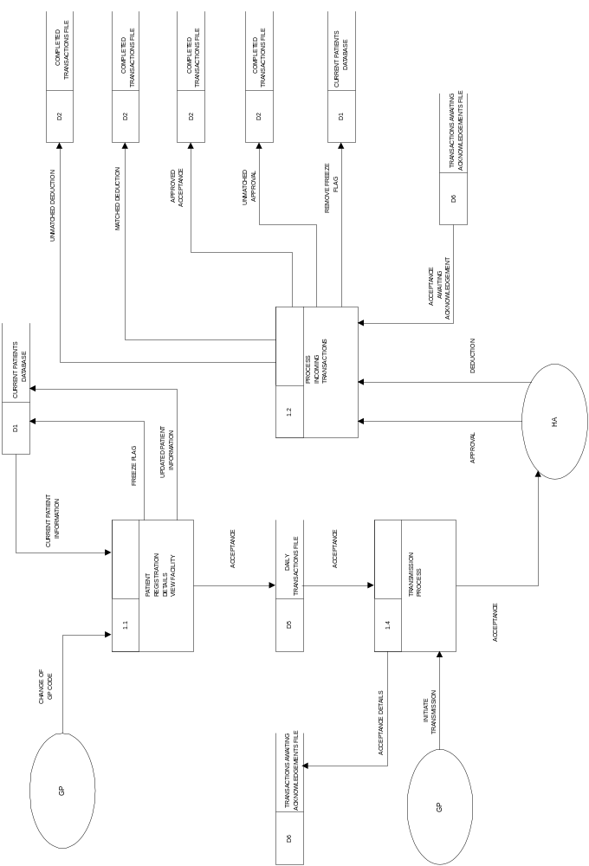

Processing Description

A change to the registered GP for a patient on the GP System must be captured for transmission to the HA responsible for that patient within an Acceptance.

The GP System must allow for any of the following additional items of patient registration information to be amended at the same time:
- Surname
- First Forename
- Second Forename
- Other Forenames
- Previous Surname
- Title
- Sex
- Date of Birth
- Present Address excluding Postcode - 5 fields
- Postcode
- Drugs Dispensed Marker
- RPP Mileage
- Blocked Route/Special District Marker
- Walking Units
- Residential Institute Code

If the GP System is set to "linked" for that patient's responsible HA the GP System must not allow for a manual change to be made to either the patient's HA Cipher or NHS Number. This existing NHS Number must be included within the Acceptance transaction to the HA determined by the existing HA Cipher for that patient.

If the GP System is set to "manual" for that patient's responsible HA, the GP System must allow for a manual change to be made to both the patient's HA Cipher and NHS Number. If both the HA Cipher and the registered GP of the patient are changed, the rules for a notification of registration as a result of a change of HA Cipher are as detailed in section 2.2.25 of this specification (see also section 3.3).

For an Acceptance representing an Internal Transfer of a patient within the Partnership:
- An input field (GP Notes) must be provided to allow the GP to enter an item of free text (non-mandatory) to accompany the Acceptance.
- The patient registration details must be validated on the GP System at the point of data entry. This data entry validation must ensure that no Acceptances to be sent across the Network will fail the process of translation to/from EDIFACT format and that the Acceptance details may always be applied to the HA patient database without alteration.
- The GP System must set a "freeze" flag against the registration details of a patient internally transferred between GPs within the Partnership whose responsible HA is "linked" with that GP Practice.

For this generated Acceptance:
- The Acceptance Type must equal "3" (Transfer In).
- The Previous Address, Previous GP Name and Previous HA Cipher fields must all be empty.
- The patient's NHS Number must be included even if this is a Query NHS number.
- Any values held for any of the following items of information for the patient must also be included within the generated Acceptance:
Surname
First Forename
Second Forename
Other Forenames
Previous Surname
Title
Sex
Date of Birth
Address - 5 fields
Postcode
Drugs Dispensed Marker
RPP Mileage
Blocked Route/Special District Marker
Walking Units
Residential Institute Code
- The Acceptance Code must equal "I". This will signify to the HA that the Acceptance was generated at the GP Practice as a result of a change of GP for that patient.
- All other existing functionality within the GP System for Acceptances still applies.

To summarise:
- If the GP Practice amend the GP of a patient, this must be notified to the patient's responsible HA within an Acceptance. This Acceptance must:
- Contain the latest information for that patient held on the GP System.
- Contain no values for Previous Address, Previous GP Name and Previous HA Cipher.
- Have an Acceptance Type of "3" ("Transfer In").
- Include the patient's NHS Number (even if this is a Query NHS Number).

- If the HA Cipher for that patient is also amended, this Acceptance must:
- Contain the latest information for that patient held on the GP System.
- Be directed to the new responsible HA for that patient.
- Have values for Previous Address, Previous GP Name and Previous HA Cipher (that is, those values held for the patient prior to being amended).
- Have an Acceptance Type of "3" ("Transfer In").
- Include the patient's NHS Number (if known) unless the NHS Number commences with a "?" character and, hence, represents a Query NHS Number. If the patient does have a Query NHS Number, this must be removed on the GP System and no NHS Number included within the Acceptance. (Note - an Acceptance without an NHS Number must include a non-null value for the Place of Birth of the patient.)
- During the transmission process, each Acceptance will either generate an Acceptance transaction to be advised to an HA over the Network (the Practice being "linked" with that HA) or will be printed on an Acceptance standard form (the Practice being "non-linked" with that HA).

If an Acceptance generated by the change of a patient's GP is to be advised to the patient's responsible HA within an Acceptance transaction over the Network, this Acceptance must have an Acceptance Code of "I".

If an Acceptance generated by the change of a patient's GP and responsible HA is to be advised to the patient's new responsible HA within an Acceptance transaction over the Network, this Acceptance must have an Acceptance Code of "S". This will signify to the HA that the Acceptance was generated at the GP Practice as a result of the patient having moved across an HA boundary whilst remaining with the same Partnership.

Each Acceptance transaction notified to a "linked" HA as a result of the Internal Transfer of a patient within the Partnership will be acknowledged by the receipt of an Approval transaction from that HA. This functionality of the GP System is covered in section 3.16 of this specification.

Additionally, within the same Interchange from the HA, the GP Practice may expect to receive a Deduction transaction. A Deduction transaction generated by the HA System as a result of the receipt of an Acceptance representing an Internal Transfer within the Partnership will contain the following Deduction Code:
16 : Internal Transfer within Partnership.

Data Fields - Format/Validation

In this case, all existing format/validation rules for Acceptance transactions specified in section 3.3 of this specification still apply, with the following exceptions:
- The NHS Number may be a Query NHS Number for Acceptance transactions with an Acceptance Type of "3" and an Acceptance Code of "I".
- The Previous Address, Previous GP Name and Previous HA Cipher fields must be null for Acceptance transactions with an Acceptance Type of "3" and an Acceptance Code of "I".
- Acceptance transactions generated by the GP System as a result of the Internal Transfer of a patient within the Partnership must contain the Acceptance Code "I" (see Appendix G).

OUT-GOING MANUALLY-ENTERED AMENDMENTS

Overview

The GP System MUST be capable of recording all Amendments made to any of the following fields of existing patient Registration data (other than when the Amendment has originated from an HA) and "capturing" them for transmission to the appropriate HA for that patient (that is, the patient's responsible HA):
Surname
First Forename
Second Forename
Other Forenames
Previous Surname
Title
Sex
Date of Birth
Address - 5 fields
Postcode
Drugs Dispensed Marker
RPP Mileage
Blocked Route/Special District Marker
Walking Units
Residential Institute Code

Changes made to groups of patients' Registration details MUST be captured as well as those of individual patients. Changes to a group of patients might be undertaken, for example, by the re-designation of the RPP Mileage of a Residential Institute or the change to a street directory entry on the GP System affecting many patients. All such changes MUST be captured for each patient so affected and advised to each patient's responsible HA within an Amendment.

For a GP Practice that is "linked" with an HA, the details of the patient Amendment MUST be transmitted to that HA within an Amendment transaction.

For a GP Practice that is "manual" with an HA, the details of the patient Amendment MUST be advised to that HA by the use of an Amendment standard form.

HAs will have the option to either accept or further amend Amendment transactions/forms received from GPs - they will not be able to directly reject any received Amendment transactions/forms. Amendment transactions received at the HA for patients not identified on the HA database will be printed off for investigation by the HA staff.

Any changes made by HA staff to Amendment transactions received from "linked" GP Practices or Amendment standard forms received from "manual" GP Practices before being applied to the HA database will be advised back to the originating GP.

Processing Diagram

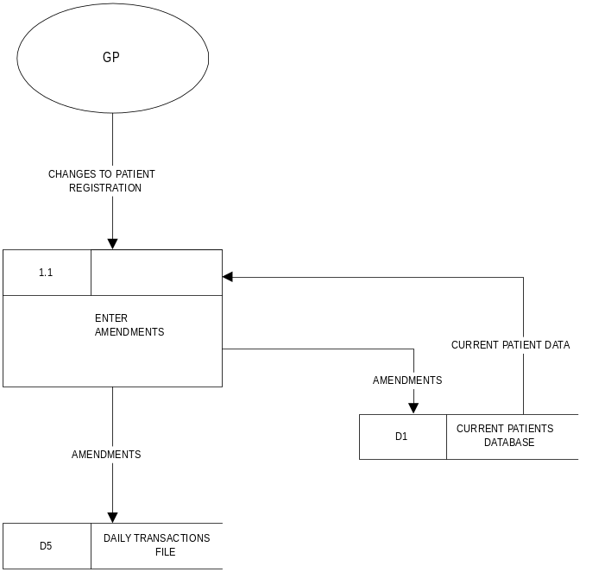

Processing Description and Further Mandatory Requirements

An Amendment to any of the following data items for a patient on the GP System MUST be captured for transmission to the HA responsible for that patient:
Surname
First Forename
Second Forename
Other Forenames
Previous Surname
Title
Sex
Date of Birth
Address - 5 fields
Postcode
Drugs Dispensed Marker
RPP Mileage
Blocked Route/Special District Marker
Walking Units
Residential Institute Code

Amendments to any other items of patient information will not be advised to an HA.

If any of the Forename fields are amended, then the values within all three Forename fields (where a value exists) MUST be included in the Amendment transaction.

The GP System MUST NOT allow for any Amendments to be made to any of the data items listed above for a patient for which a "Freeze" flag is set (see section 4.3.3 for further details).

The GP System NOT allow any manual changes to be made to a patient's NHS number unless:
- The GP System is set to "manual" for the patient's responsible HA.
- A change is required for some reason if the GP System is set to "linked" for the patient's responsible HA. In this case, the change may only be made using the relevant "security-controlled" system action - see section 2.2.29.

In either case, the change of NHS Number will not be advised to the patient's responsible HA.

Note: As part of the rollout of the "New NHS Number", GP Systems will be required to accept changes to patient's NHS Numbers by a number of different means. This Specification does not preclude the application of these to the GP System Patient database.

The GP System MUST NOT allow for any manual changes to be made to a patient's responsible HA unless the GP System is set to "manual" for the patient's responsible HA.

If the GP System is set to "linked" for a patient's responsible HA, the GP System MUST only allow for that patient's responsible HA to be amended to another, different HA by the receipt of a Deduction transaction with a Reason for Deduction of "New HA/Same GP" (see sections 2.2.25, 3.6 and 3.14).

If the GP System is set to "manual" for a patient's responsible HA, the GP System MUST allow for that patient's responsible HA to be amended to another, different HA. If such a change is made, the GP System MUST generate an Acceptance to be advised to the patient's new responsible HA (see sections 2.2.25 and 3.3).

An input field (GP Notes) MUST be provided to allow the GP to enter an item of free text (non-mandatory) to accompany any Amendment.

The patient Amendment details MUST be validated at the point of data entry. This data entry validation will ensure that no Amendments to be sent across the Network will fail the process of translation to/from EDIFACT format and that the Amendment details may always be applied to the HA database without alteration.

The items of information that may be included within an out-going Amendment are listed in section 3.5.4.

All the "New" information fields MUST only hold values (and hence, for transactions to be sent across the Network, MUST only be included within an EDIFACT message) if they have been amended by the GP.

At least one of the "New" fields MUST contain a non-null value.

If at least one of the Address - Locality, Address - Post Town and Address - County fields is amended for a patient, then the values held for all three of these fields MUST be advised to the HA within the Amendment. This will assist in the process of "address coding" on the HA system.

A field containing a single "%" character MUST be used to represent a particular type of amended field - its purpose being to erase the existing contents of the corresponding field at the HA for that patient (as opposed to a null field indicating that no change to that field is required) - the GP having removed a field from a patient record on the GP System.

Only certain fields MUST be able to contain a single "%" character. The data fields stored for a patient on the HA system corresponding to those fields within an Amendment that cannot contain a single "%" character cannot be erased by an Amendment; they can only be replaced by another, non-null value. The fields that may contain a single "%" character within an Amendment are indicated by an "*" in section 3.5.4.

Note that only one Amendment will be required per patient irrespective of the number of data items being amended for that patient.

If a GP amends the details of a patient, and then further amends that patient's details, the GP System may:
- Store these two Amendments separately within the "Daily Transactions" file, and advise the HA of them as two separate Amendment transactions (for a Practice that is "linked" with that HA) or on two separate Amendment standard forms (for a Practice that is "manual" with that HA). Note that the correct Transaction Numbers MUST be given to these two Amendments in order to ensure that they are processed in the correct order.
- Store these two Amendments separately within the "Daily Transactions" file and amalgamate them at the time of transmission in order to create just one Amendment transaction (for a Practice that is "linked" with that HA) or just one Amendment standard form (for a Practice that is "manual" with that HA).
or
- Amalgamate these two Amendments within the "Daily Transactions" file at the time of data capture in order to create just one Amendment transaction (for a Practice that is "linked" with that HA) or just one Amendment standard form (for a Practice that is "manual" with that HA) at the time of transmission.

Note that the GP System may allow for the details of a newly-registered patient to be amended up until the time that the Acceptance for that patient is removed from the "Daily Transactions" file by the transmission process (see section 3.3.3). Any changes made MUST, of course, be included within the Acceptance.

Details of the captured Amendment MUST be stored within the "Daily Transactions" file awaiting subsequent transmission.

It is recommended that the following information is stored for each patient Amendment within the "Daily Transactions" file:
Transaction Type
GP Code
Patient's Responsible HA Cipher
NHS Number
New Surname
New First Forename
New Second Forename
New Other Forenames
New Previous Surname
New Title
New Sex
New Date of Birth
New Address - 5 fields
New Postcode
New Drugs Dispensed Marker
New RPP Mileage
New Blocked Route/Special District Marker
New Walking Units
New Residential Institute Code
Note: This NHS Number will be the existing, most up-to-date NHS Number of the patient on the GP System.

Additionally, it is recommended that the following extra information is also stored for each patient Amendment within the "Daily Transactions" file (this information will be required to complete the standard form summary should the Amendment be advised to an HA by the use of an Amendment standard form):
Existing Surname
Existing Forename(s)
Existing Date of Birth

During the transmission process, each Amendment will either generate an Amendment transaction to be advised to an HA over the Network or will be printed on an Amendment standard form.

Additionally, as part of this transmission process, details of Amendments advised to an HA within Amendment transactions across the Network MUST be copied to the "Completed Transactions" file.

It is recommended that, in addition to the information listed above, the following additional information is stored for each patient Amendment within the "Completed Transactions" file:
Transaction Date
Transaction Time
Transaction Number

The format of Amendments within the "Daily Transactions" file and the "Completed Transactions" file is not being dictated by this Specification. However, it is strongly recommended that data is stored within these files in the format that it MUST be sent to the HAs and stored within subsequent Archive files.

Amendments within the Archive files MUST be in the exact format specified in Appendix A and MUST meet the validation requirements listed in section 3.5.4. (an Archive file is generated each time an Archive process is undertaken on the "Completed Transactions" file).

Data Fields - Format/Validation - Mandatory Requirements

The following information may be included within an Amendment. Fields marked (M) are mandatory and MUST always contain a valid, non-null value; fields marked (N-M) are non-mandatory and may or may not contain a non-null value. Fields marked with an asterisk "*" may contain a single "%" character.

Transaction Type (M)
Within Archive files, the Transaction Type MUST equal "AMG".
All out-going Amendment transactions generated by the transmission process for a "linked" HA MUST be combined within one EDIFACT message.

Existing GP Code (M)
Within EDIFACT Amendment transactions, Amendment standard forms and Archive files, the Existing GP Code MUST be the valid GMC National code for the patient's GP concatenated with “,” concatenated with the “local” code for the patient's GP as known by the destination HA (see section 4.3.7). The Existing GP Code MUST:
- Have alphanumeric and “,” characters only.
- Have a maximum length of 14 characters in the following format:
Characters 1-7 = Fixed 7 numeric character GMC National GP code
Character 8 = comma (",")
Characters 9-14 = 1-6 alphanumeric character Local GP code
- Have alphabetic characters in upper case.

Destination HA Cipher (M)
Within EDIFACT Amendment transactions, Amendment standard forms and Archive files, the Destination HA Cipher MUST:
- Be the Cipher of the patient's responsible HA.
- Be a valid HA Cipher; i.e. be a current live England and Wales code from the Table of Valid HA Ciphers (see Appendix D). As such, the Destination HA Cipher MUST:
- Have alphanumeric characters only.
- Have a maximum length of 3 characters.
- Have alphabetic characters in upper case.

Transaction Date and Time (M)
Within Archive files, the Transaction Date MUST be in the format "CCYYMMDD" and the Transaction Time in the format "HHMM".
All out-going Amendment transactions generated by the transmission process for a "linked" HA MUST be combined within one EDIFACT message with a Transaction Date and Time qualifier "137", format "203" - "CCYYMMDDHHMM" within a DTM segment.

Transaction Number (M)
Within EDIFACT Amendment transactions and Archive files, the Transaction Number MUST:
- Have numeric characters only.
- Have a maximum length of 7 characters.
- Have a value of a positive integer.

NHS Number (M)
Within EDIFACT Amendment transactions, Amendment standard forms and Archive files, the NHS Number MUST be the existing, most up-to-date NHS Number of the patient and MUST be in one of the acceptable formats detailed in Appendix F. As such, the NHS Number MUST:
- Have alphanumeric, "?" or "/" characters only.
- Have a maximum length of 15 characters.
- Have alphabetic characters in upper case.
or MUST be an all-numeric Number of 10 digits including a check digit (the 10th and final digit in the Number).

New Surname (N-M)
Within EDIFACT Amendment transactions, Amendment standard forms and Archive files, the New Surname MUST:
- Have alphabetic, SPACE, "'" and "-" characters only.
- Have a maximum length of 35 characters (Surnames of more than 35 characters MUST be truncated for these purposes).
- Have alphabetic characters in upper case.

New First Forename (N-M) *
Within EDIFACT Amendment transactions, Amendment standard forms and Archive files, the New First Forename MUST:
- Have alphabetic, SPACE, "'" "," "-" and "." characters only (or a single "%" character).
- Have a maximum length of 35 characters (First Forenames of more than 35 characters MUST be truncated for these purposes).
- Have alphabetic characters in upper case.
If the value of New First Forename is a single “%” character, this will have the effect of deleting the entire set of forenames for the patient on the HA system.

New Second Forename (N-M)
Within EDIFACT Amendment transactions, Amendment standard forms and Archive files, the New Second Forename MUST:
- Have alphabetic, SPACE, "'" "," "-" and "." characters only.
- Have a maximum length of 35 characters (Second Forenames of more than 35 characters MUST be truncated for these purposes).
- Have alphabetic characters in upper case.

New Other Forenames (N-M)
Within EDIFACT Amendment transactions, Amendment standard forms and Archive files, the New Other Forenames MUST:
- Have alphabetic, SPACE, "'" "," "-" and "." characters only.
- Have a maximum length of 35 characters (Other Forenames totalling more than 35 characters MUST be truncated for these purposes).
- Have alphabetic characters in upper case.

New Previous Surname (N-M) *
Within EDIFACT Amendment transactions, Amendment standard forms and Archive files, the New Previous Surname MUST:
- Have alphabetic, SPACE, "'" and "-" characters only (or a single "%" character).
- Have a maximum length of 35 characters (Previous Surnames of more than 35 characters MUST be truncated for these purposes).
- Have alphabetic characters in upper case.

New Title (N-M) *
Within EDIFACT Amendment transactions, Amendment standard forms and Archive files, the New Title MUST:
- Have alphabetic, SPACE, "'" and "-" characters only (or a single "%" character).
- Have a maximum length of 35 characters (Titles of more than 35 characters MUST be truncated for these purposes).
- Have alphabetic characters in upper case.
If either of the New Title or New Sex fields contains a non-null value, the value(s) entered MUST be checked to ensure that no conflict arises between a patient's Title and Sex. For example, a patient cannot be given a new Title of "MR" when the existing Sex is "Female".

New Sex (N-M)
Within Amendment standard forms and Archive files, the New Sex MUST be "M" for Male, "F" for Female, "I" for Indeterminate/Not Known or "S" for Not Specified.
Within EDIFACT Amendment transactions, the New Sex MUST be "1" for Male, "2" for Female or "0" for Indeterminate/Not Known or "9" for Not Specified within the New Sex data element.

New Date of Birth (N-M)
Within Amendment standard forms, the New Date of Birth MUST be in the format "DD/MM/CCYY".
Within Archive files, the New Date of Birth MUST be in the format "CCYYMMDD".
Within EDIFACT Amendment transactions, the New Date of Birth MUST have qualifier "329", format "102" - "CCYYMMDD" within a DTM segment.
For all these, the Date of Birth MUST NOT be in the future.

New Address - House Name (N-M) *
Within EDIFACT Amendment transactions, Amendment standard forms and Archive files, the New Address - House Name MUST:
- Have alphanumeric, SPACE, "'", "-", "." and "," characters only (or a single "%" character).
- Have a maximum length of 35 characters (House Names of more than 35 characters MUST be truncated for these purposes).
- Have alphabetic characters in upper case.
The New Address - House Name MUST only contain the flat number or name of a property (if one exists).
Either the Address - House Name or the Address - Number/Road Name must be present.

New Address - Number/Road Name (N-M) *
Within EDIFACT Amendment transactions, Amendment standard forms and Archive files, the New Address – Number/Road Name MUST:
- Have alphanumeric, SPACE, "'", "-", "." and "," characters only (or a single "%" character).
- Have a maximum length of 35 characters (House Names of more than 35 characters MUST be truncated for these purposes).
- Have alphabetic characters in upper case.
The New Address - Number/Road Name MUST only contain the property number (if one exists) and the road/street name for the patient.
Either the Address - House Name or the Address - Number/Road Name must be present.

New Address - Locality (N-M) *
Within EDIFACT Amendment transactions, Amendment standard forms and Archive files, the New Address –Locality Name MUST:
- Have alphanumeric, SPACE, "'", "-", "." and "," characters only (or a single "%" character).
- Have a maximum length of 35 characters (Localities of more than 35 characters MUST be truncated for these purposes).
- Have alphabetic characters in upper case.
The New Address - Locality MUST only contain the first village/town name/area (if one exists) if different to the property's post town name.

New Address - Post Town (N-M)
Within EDIFACT Amendment transactions, Amendment standard forms and Archive files, the New Address - Post Town MUST:
- Have alphanumeric, SPACE, "'", "-", "." and "," characters only.
- Have a maximum length of 35 characters (Post Towns of more than 35 characters MUST be truncated for these purposes).
- Have alphabetic characters in upper case.
The New Address - Post Town MUST only contain the post town name of the property.

New Address - County (N-M) *
Within EDIFACT Amendment transactions, Amendment standard forms and Archive files, the New Address - County MUST:
- Have alphanumeric, SPACE, "'", "-", "." and "," characters only (or a single "%" character).
- Have a maximum length of 35 characters (Counties of more than 35 characters MUST be truncated for these purposes).
- Have alphabetic characters in upper case.
The New Address - County MUST only contain the county of the property (if one exists).

New Address - Postcode (N-M) *
Within EDIFACT Amendment transactions, Amendment standard forms and Archive files, the New Address - Postcode MUST:
- Have alphanumeric and SPACE characters only (or a single "%" character).
- Have alphabetic characters in upper case.
- Have a fixed length of 8 characters and be in one of the following six formats:
"AN NAA" For postcodes of the format "AN NAA"
"ANN NAA" For postcodes of the format "ANN NAA"
"AAN NAA" For postcodes of the format "AAN NAA"
"AANN NAA" For postcodes of the format "AANN NAA"
"ANA NAA" For postcodes of the format "ANA NAA"
"AANA NAA" For postcodes of the format "AANA NAA"
with the exception of the case of a single "%" character

New Drugs Dispensed Marker (N-M) *
Within EDIFACT Amendment transactions, Amendment standard forms and Archive files, the New Drugs Dispensed Marker MUST only contain a single upper case "Y" character if being set "on" and a single "%" character if being set "off".

New RPP Mileage (N-M) *
Within EDIFACT Amendment transactions, Amendment standard forms and Archive files, the New RPP Mileage MUST:
- Have numeric characters only (or a single "%" character).
- Have a maximum length of 2 characters.
- Have a value of a positive integer in the range 3 to 50 (or a single "%" character).

New Blocked Route/Special District Marker (N-M) *
Within EDIFACT Amendment transactions, Amendment standard forms and Archive files, the New Blocked Route/Special District Marker MUST contain a single upper case "B" or "S" character if being set to "Blocked Route" or "Special District", respectively and a single "%" character if being set "off".

New Walking Units (N-M) *
Within EDIFACT Amendment transactions, Amendment standard forms and Archive files, the New Walking Units MUST:
- Have numeric characters only (or a single "%" character).
- Have a maximum length of 2 characters.
- Have a value of a positive integer in the range 3 to 99 and be exactly divisible by 3 (or a single "%" character).
The GP System MUST ensure that a non-zero value for Walking Units may only be held for a patient if a non-zero value for RPP Mileage is also held for that patient.

New Residential Institute Code (N-M) *
Within EDIFACT Amendment transactions, Amendment standard forms and Archive files, the New Residential Institute Code MUST:
- be a valid Residential Institute Code; i.e. the Code MUST be within the Table of Valid Residential Institute Codes for the patient's responsible HA (see section 4.3.4). As such, the New Residential Institute Code MUST:
- Have alphanumeric characters only (or a single "%" character).
- Have a maximum length of 2 characters.
- Have alphabetic characters in upper case.

GP Notes (N-M)
Within EDIFACT Amendment transactions, Amendment standard forms and Archive files, the GP Notes MUST:
- Only contain characters within the EDIFACT Level A character set.
- Have a maximum length of 60 characters.
- Have alphabetic characters in upper case.

OUT-GOING GENERATED ACCEPTANCES (following receipt of a deduction)

Overview

As well as Acceptances to HAs being created by the manual entry of patient details into the GP System, the GP System MUST be able to generate Acceptances as a result of the receipt of certain transactions from HAs.

Two such occasions when this may arise are following the receipt of a Deduction transaction from an HA with which the GP Practice is "linked":
- If a GP receives a Deduction transaction from an HA with which he/she does not agree, he/she MUST be able to re-accept the patient. This MUST have the effect of creating an Acceptance for transmission back to the HA responsible for that patient in order to re-instate the patient on the HA database.
- If a GP receives a Deduction transaction from an HA for a patient who has changed address into a different HA area but is staying with the same GP within the same GP Practice (Reason for Deduction "6 - New HA/Same GP"), he/she MUST be forced by the GP System to re-accept the patient. This MUST have the effect of creating an Acceptance for transmission to the new HA responsible for that patient. An Acceptance Code of "S" will be allocated by the GP System.

Note, however, that mandatory fields required for that Acceptance Type MUST be entered if so required.

In both these cases: if, at the time of transmission, the destination HA for the generated Acceptance is "linked" with the GP Practice, the Acceptance MUST be transmitted to that HA within an Acceptance transaction. If, at the time of transmission, the HA is "manual" with the GP Practice, the Acceptance MUST be advised to that HA by the use of the Acceptance standard form.

Processing Diagrams

Out-going Acceptances

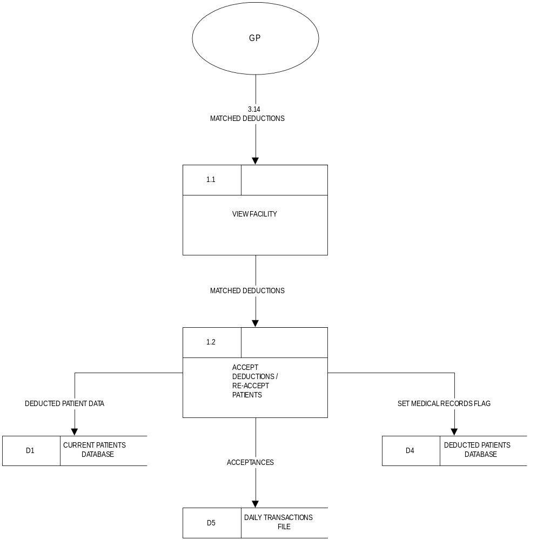

"New HA/Same GP" Processing – FP22 Entry

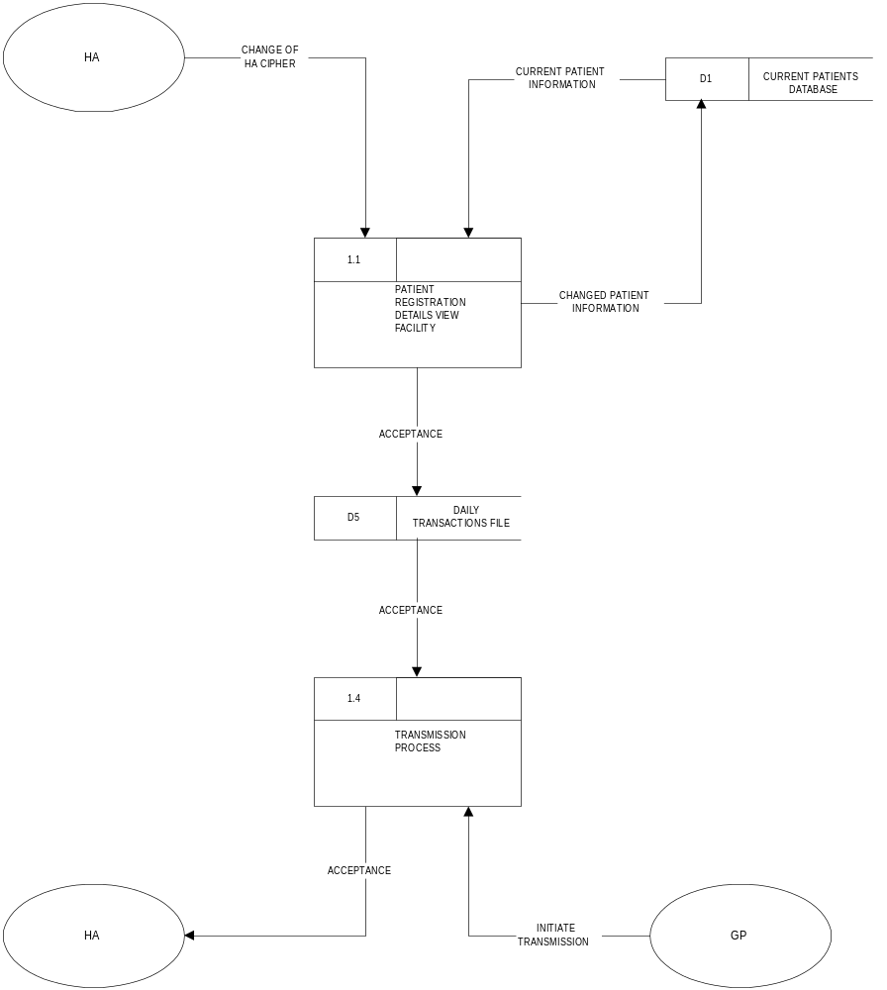

"New HA/Same GP" Processing – Deduction

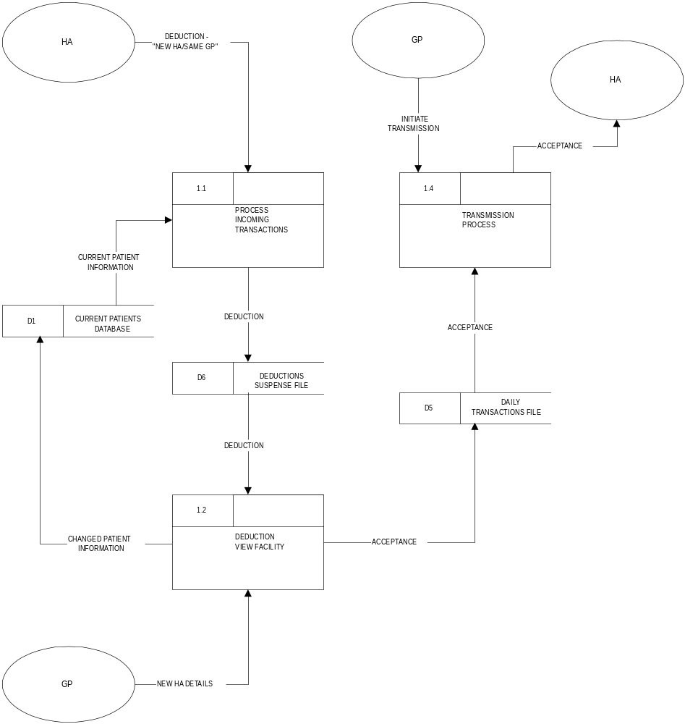

For details of in-coming deductions transactions, see section 3.14.

Processing Description and Further Mandatory Requirements

As will be discussed in section 3.14.3, the GP System MUST be capable of generating an Acceptance whenever a GP opts to re-accept a patient following the receipt of a Deduction transaction (with a Reason for Deduction of any value other than "6" -"New HA/Same GP") or is forced to re-accept a patient following the receipt of a Deduction with a Reason for Deduction of "6 - New HA/Same GP".

If a GP opts to re-accept a patient following the receipt of a Deduction transaction with a Reason for Deduction of any value other than "6 - New HA/Same GP", the GP System MUST create an Acceptance for transmission back to the HA responsible for that patient in order to re-instate the patient on the HA database. For such a generated Acceptance:
- If the Reason for Deduction in the Deduction transaction is either "2 - Removal" or "3 - Internal Transfer", the Acceptance Type MUST equal "3" (Transfer In). For all other Reasons for Deduction, the Acceptance Type MUST equal "2" (1st Acceptance).
- If the Acceptance Type equals "3" (Transfer In):
- The patient's current address MUST be included within the Previous Address fields. A Previous Address field may only contain a non-null value if all of the preceding Previous Address fields also contain non-null values.
- The patient's current responsible GP's name MUST be included within the Previous GP Name field.
- The patient's responsible HA's Cipher MUST be included within the Previous HA Cipher field.
- The Acceptance MUST be allocated an Acceptance Code of "D" - this will signify to the HA that the Acceptance was generated at the GP Practice as a result of the receipt of a Deduction transaction.

If a GP is forced to re-accept a patient following the receipt of a Deduction transaction with a Reason for Deduction of "6 - New HA/Same GP", the GP System MUST create an Acceptance for transmission to the patient's new responsible HA. For such a generated Acceptance:
- The Acceptance Type MUST equal "3" (Transfer In).
- The patient's previous address (within the patient's previous responsible HA's area) MUST be included within the Previous Address fields. A Previous Address field may only contain a non-null value if all of the preceding Previous Address fields also contain non-null values.
- The patient's current responsible GP's name MUST be included within the Previous GP Name field.
- The patient's previous responsible HA's Cipher MUST be included within the Previous HA Cipher field.

- The New HA field stored within the "Completed Transactions" file for the matched Deduction must be that received within the Deduction transaction (not necessarily that of the destination HA for the generated Acceptance).
- The Acceptance MUST be allocated an Acceptance Code of "S" if the Acceptance is being re-accepted to a different HA from which the corresponding Deduction originated; otherwise, the Acceptance MUST be allocated an Acceptance Code of "D".

Irrespective of whether the GP opts to re-accept the patient or is forced by the GP System to re-accept the patient, for such a generated Acceptance:
- The patient's NHS Number MUST be included if known unless the NHS Number commences with a "?" character and, hence, represents a Query NHS Number. If the patient does have a Query NHS Number, this MUST be removed on the GP System and no NHS Number included within the Acceptance.
Note that this NHS Number may be in any valid format for NHS Numbers, and will be the most up-to-date NHS Number of the patient on the GP System.
- Any values held for any of the following items of information MUST also be included within the generated Acceptance:
* Surname
Previous Surname
First Forename
Second Forename
Other Forenames
Title
* Sex
Date of Birth
* Present Address excluding Postcode
Postcode
Place of Birth [mandatory if NHS Number not known]
Drugs Dispensed Marker
RPP Mileage
Blocked Route/Special District Marker
Walking Units
Residential Institute Code
(* = Mandatory field)
- Completion of the GP Notes field will be mandatory if the patient is being re-accepted to the same HA; it is not, however, mandatory if the patient is being accepted to a different HA following the receipt of a Deduction with a Reason for the Deduction of "6 - New HA/Same GP".

- The GP System MUST set a "Freeze" flag against the Registration details for the patient. If the GP System allows for the details of a newly-registered patient to be amended up until the time that the Acceptance for that patient is removed from the "Daily Transactions" file by the transmission process, this "Freeze" flag MUST be set as part of the transmission process. If not, the "Freeze" flag MUST be set at the time of the patient Registration. This "Freeze" flag is discussed in greater detail in section 4.3.3.

It is recommended that the GP System does not allow the GP to amend patient Registration information at the time of re-accepting a patient following the receipt of a Deduction. If the GP System does allow this, then the patient details MUST be validated at the point of data entry - this data entry validation will ensure that no Acceptances to be sent across the Network will fail the process of translation to/from EDIFACT format and that the Acceptance details may always be applied to the HA database without alteration.

Details of the generated Acceptance MUST be stored within the "Daily Transactions" file awaiting subsequent transmission.

It is recommended that the same information is stored (where known) within the "Daily Transactions" file for an Acceptance generated as a result of the receipt of a Deduction transaction as for a manually-entered Acceptance.

The items of information to be included within an out-going, generated Acceptance following the receipt of a Deduction are the same as those within a manually-entered Acceptance.

Data Fields - Format/Validation - Mandatory Requirements

The information that may be included within an Acceptance following the receipt of a Deduction is identical to that which may be included within a manually-entered Acceptance with the following exceptions. Fields marked (M) are mandatory and MUST always contain a valid, non-null value; fields marked (N-M) are non-mandatory and may or may not contain a non-null value.

Acceptance Type (M)
Within Acceptance standard forms, the Acceptance Type for an Acceptance following the receipt of a Deduction MUST be one of the following:
- 2 (1ST ACCEPTANCE).
- 3 (TRANSFER IN).
Within EDIFACT Acceptance transactions and Archive files, the Acceptance Type for an Acceptance following the receipt of a Deduction MUST:
- Have a single numeric character only.
- Have a value of a positive integer in the range 2 to 3 where:
- 2 represents a 1st Acceptance.
- 3 represents a Transfer In.
The Acceptance Type will be dependent on the original Reason for Deduction included within the Deduction transaction.

Acceptance Code (M)
Within EDIFACT Acceptance transactions and Archive files, the Acceptance Code for an Acceptance following the receipt of a Deduction MUST contain a single upper case "D" character if the Acceptance is being re-accepted back to the same HA from which the corresponding Deduction originated.
For Acceptance transactions generated by the GP System to be sent to a different HA following the receipt of either:
- an FP22 printout from the patient's previous responsible HA containing an entry for that patient with a reason for deduction of "New HA/Same GP" or
- a Deduction transaction with a Deduction Code of "6 - New HA/Same GP",
the Acceptance Code MUST contain a single upper case "S" character.

OUT-GOING GENERATED ACCEPTANCES (following receipt of a rejection)

Overview

As well as Acceptances to HAs being created by the manual entry of patient details into the GP System, the GP System MUST be able to generate Acceptances as a result of the receipt of certain transactions from HAs.

Two such occasions (following the receipt of a Deduction transaction) were discussed in the previous section.

One further such occasion when this may arise is following the receipt of a Rejection (Wrong HA) transaction from an HA with which the GP Practice is "linked":
- If a GP receives a Rejection (Wrong HA) transaction from an HA in response to a previously submitted Acceptance transaction, he/she MUST be able to amend the previous Acceptance details in order to create a new Acceptance for transmission to an HA.

If, at the time of transmission, the destination HA for the generated Acceptance is "linked" with the GP Practice, the Acceptance MUST be transmitted to that HA within an Acceptance transaction. If, at the time of transmission, the HA is "manual" with the GP Practice, the Acceptance MUST be advised to that HA by the use of the Acceptance standard form.

Processing Diagram

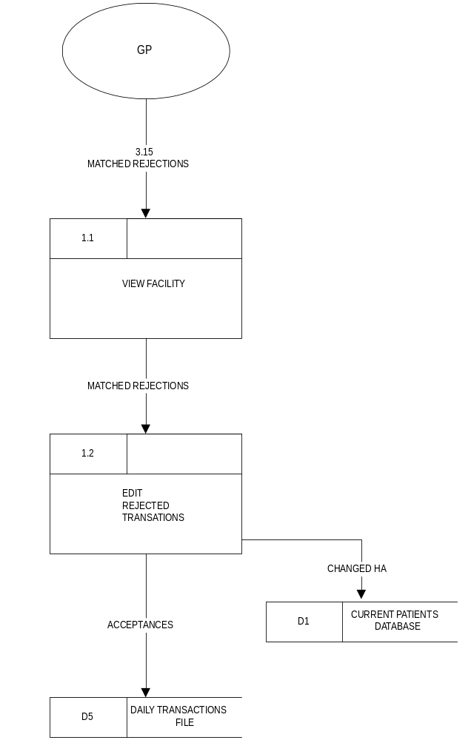

Processing Description and Further Mandatory Requirements

As will be discussed in section 3.15.3, the GP System MUST be capable of generating an Acceptance whenever a GP is forced to re-accept a patient following the receipt of a Rejection (Wrong HA) transaction.

If a GP is forced to re-accept a patient following the receipt of a Rejection (Wrong HA) transaction, the GP System MUST create an Acceptance for transmission to the patient's true responsible HA. For such a generated Acceptance:
- All the patient details MUST be identical to those within the original Acceptance with the exception of the patient's responsible HA which may be amended to a different value.
- The Acceptance Type MUST equal that included within the original Acceptance. It is appreciated that the Acceptance Type might no longer follow from the algorithm detailed in section 3.3.3.a.
- The Acceptance MUST be allocated an Acceptance Code of "R". This will signify to the HA that the Acceptance was generated at the GP Practice as a result of the receipt of a Rejection (Wrong HA) transaction.
- The "Freeze" flag, set for the patient at the time of the original Acceptance MUST be retained.

It is recommended that the GP System does not allow the GP to amend patient Registration information at the time of re-accepting a patient following the receipt of a Rejection (Wrong HA). If the GP System does allow this, then the patient details MUST be validated at the point of data entry - this data entry validation will ensure that no Acceptances to be sent across the Network will fail the process of translation to/from EDIFACT format and that the Acceptance details may always be applied to the HA database without alteration.

Details of the generated Acceptance MUST be stored within the "Daily Transactions" file awaiting subsequent transmission.

It is recommended that the same information is stored (where known) within the "Daily Transactions" file for an Acceptance generated as a result of the receipt of a Rejection (Wrong HA) as for a manually-entered Acceptance.

The items of information to be included within an out-going, generated Acceptance following the receipt of a Rejection (Wrong HA) are the same as those within a manually-entered Acceptance.

Data Fields - Format/Validation - Mandatory Requirements

The information that may be included within an Acceptance following the receipt of a Rejection (Wrong HA) is identical to that which may be included within a manually-entered Acceptance with the following exceptions:
- Fields marked (M) are mandatory and MUST always contain a valid, non-null value.
- Fields marked (N-M) are non-mandatory and may or may not contain a non-null value.

Acceptance Code (M)
Within EDIFACT Acceptance transactions and Archive files, the Acceptance Code for an Acceptance following the receipt of a Rejection (Wrong HA) MUST contain a single upper case "R" character.

OUT-GOING GENERATED AMENDMENTS

Overview

As well as Amendments to HAs being created by the manual entry of patient details into the GP System, the GP System MUST be able to generate Amendments as a result of the receipt of transactions from HAs.

Two such occasions when this may arise are following the receipt of an Amendment transaction from an HA with which the GP Practice is "linked":
- If a GP receives an Amendment transaction from an HA containing changes with which he/she disagrees, the GP System may allow for the GP to reject the transaction. This MUST have the effect of automatically creating an Amendment for transmission back to the HA responsible for that patient; the fields within this out-going Amendment corresponding to those containing a non-null value within the received Amendment MUST contain the original, equivalent values held on the GP System for that patient.
- If a GP receives an Amendment transaction from an HA which he/she wishes to further amend, the GP System may allow for the GP to amend the received information when viewed. Any amendments made by the GP MUST be captured and advised to the HA responsible for that patient by means of an Amendment.

This may also arise in response to an incoming FP69 transaction. If a GP receives an FP69 transaction from an HA, and the patient information in the transaction contains inaccuracies, the GP System may allow for the GP to amend the received information when viewed. Any amendments made by the GP MUST be captured and advised to the HA responsible for that patient by means of an Amendment.

In all cases: if, at the time of transmission, the destination HA for the generated Amendment is "linked" with the GP Practice, the Amendment MUST be transmitted to that HA within an Amendment transaction. If, at the time of transmission, the HA is "manual" with the GP Practice, the Amendment MUST be advised to that HA by the use of the Amendment standard form.

Processing Diagram

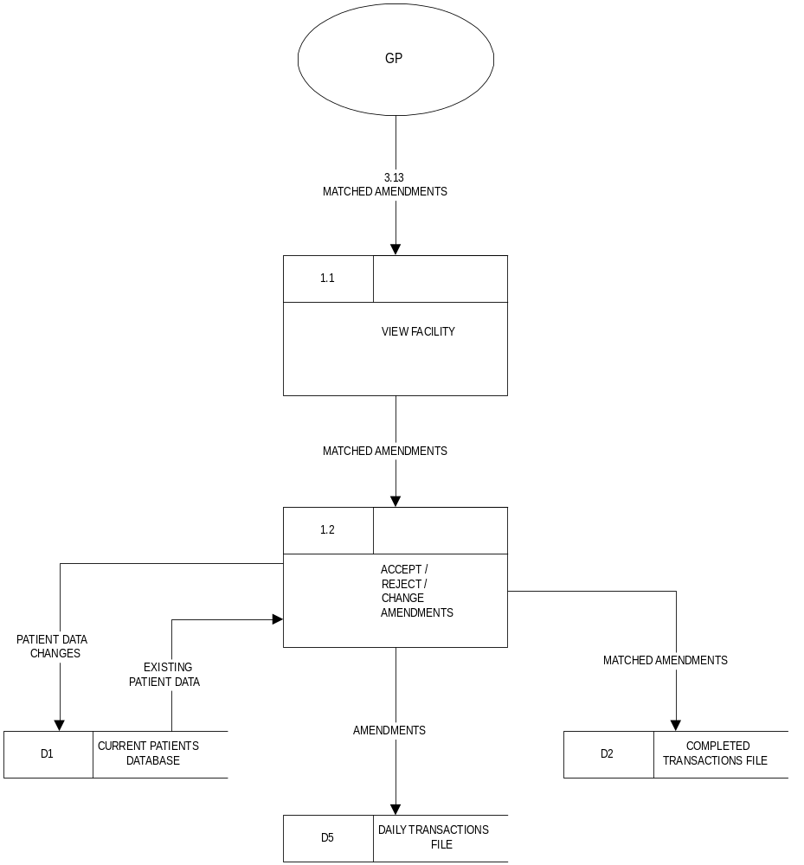

Processing Description and Further Mandatory Requirements

As will be discussed in section 3.13.3, the GP System may allow for the rejection of a received Amendment transaction. For each change contained within the received Amendment transaction, the out-going Amendment MUST contain the corresponding existing value for that patient from the "Current Patients" database. At the HA, therefore, this Amendment will have the effect of "resetting" any changes included within the original Amendment transaction.

If such a facility is included, a free text field (GP Notes) MUST be provided allowing the GP to enter additional information - completion of this field will be mandatory if the Amendment is to be rejected.

Note that, if the received Amendment is rejected, the "Current Patients" database within the GP System MUST NOT be updated by the Amendment transaction unless the Amendment includes a change to the patient's NHS Number - in this case, the change to the patient's NHS Number MUST still be applied to the "Current Patients" database.

As will also be discussed in section 3.13.3, the GP System may also allow for the GP to amend the information within a received Amendment transaction before it is used to update the "Current Patients" database.

If such a facility is included, any amendments made by the GP MUST be captured and advised to the HA responsible for that patient by means of an Amendment.

As for manually-entered Amendments, if at least one of the Address - Locality, Address - Post Town and Address - County fields is amended for a patient, then the values held for all three of these fields MUST be advised to the HA within the generated Amendment. This will assist in the process of "address coding" on the HA system.

Details of the generated Amendment MUST be stored within the "Daily Transactions" file awaiting subsequent transmission.

It is recommended that the same information is stored (where known) within the "Daily Transactions" file for an Amendment generated as a result of the receipt of an Amendment as for a manually-entered Amendment.

The items of information to be included within an out-going, generated Amendment following the receipt of an Amendment are the same as those within a manually-entered Amendment.

Data Fields - Format/Validation - Mandatory Requirements

The information that may be included within a System-generated Amendment is identical to that which may be included within a manually-entered Amendment.

OUT-GOING GENERATED REMOVAL (OUT OF AREA) TRANSACTIONS

Overview

The GP System MUST be able to generate Removals (Out of Area) as a result of the receipt of Amendment transactions from an HA including a change of address taking the corresponding patients outside the area covered by the Practice.

The HA will interpret from the Removal (Out of Area) that the GP wishes the HA to write to the patient concerned asking him/her to change GP.

The one occasion when this may arise is following the receipt of an Amendment transaction from an HA with which the GP Practice is "linked":
- If a GP receives an Amendment transaction including a change to the patient's address (that is a non-null value [other than a "%" character] is received within at least one of the five address fields), the GP System MUST allow the GP to remove (out of area) the patient corresponding to the received Amendment. This MUST have the effect of automatically creating a Removal (Out of Area) for transmission back to the HA responsible for that patient.

If, at the time of transmission, the destination HA for the generated Removal (Out of Area) is "linked" with the GP Practice, the Removal (Out of Area) MUST be transmitted to that HA within a Removal (Out of Area) transaction. If, at the time of transmission, the HA is "manual" with the GP Practice, the Rejection (Out of Area) MUST be printed out at the GP Practice and manually advised to the HA using existing procedures.

Processing Diagram

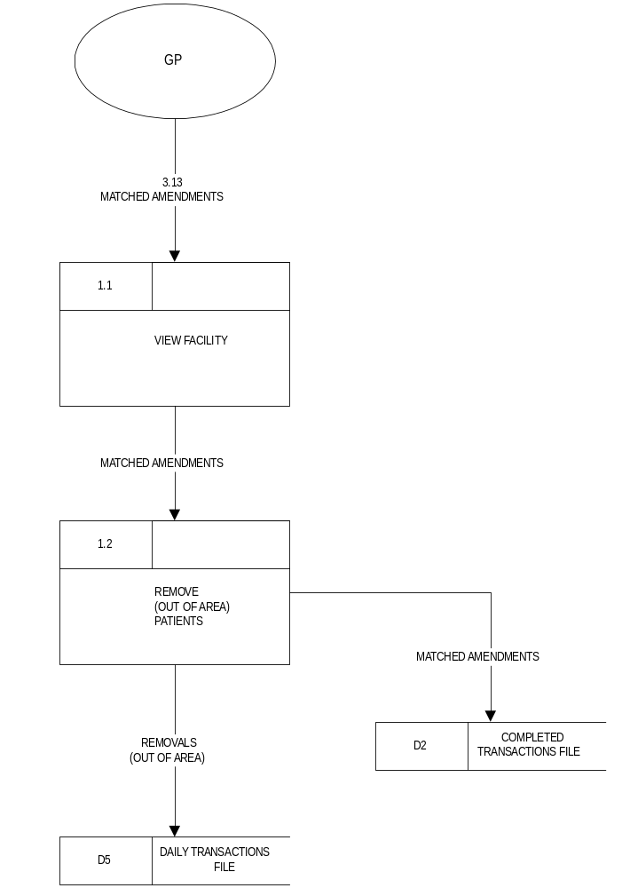

Processing Description and Further Mandatory Requirements

As will be discussed in section 3.13.3, the GP System MUST allow for the removal (out of area) of the patient corresponding to a received Amendment transaction.

A free text field (GP Notes) MUST be provided allowing the GP to enter the precise reason for the Removal (Out of Area). Completion of this field will be mandatory if the patient corresponding to the Amendment is to be removed (out of area).

Note that, if the patient corresponding to the received Amendment is removed (out of area), the "Current Patients" database within the GP System MUST still be updated by the Amendment transaction.

Details of the generated Removal (Out of Area) MUST be stored within the "Daily Transactions" file awaiting subsequent transmission.

It is recommended that the following information is stored for each Removal (Out of Area) within the "Daily Transactions" file:
- Transaction Type
- GP Code
- Patient's Responsible HA Cipher
- NHS Number
- Reason for Removal

Note that the NHS Number may be in any valid format for NHS Numbers, and will be the most up-to-date NHS Number of the patient on the GP System.

During the transmission process, each Removal (Out of Area) will either generate a Removal (Out of Area) transaction to be advised to an HA over the Network or will be printed out at the GP Practice and manually advised to the HA using existing procedures.

Additionally, as part of this transmission process, details of Removals (Out of Area) advised to an HA within Removal (Out of Area) transactions across the Network MUST be copied to the "Completed Transactions" file.

It is recommended that, in addition to the information listed above, the following additional information is stored for each Removal (Out of Area) within the "Completed Transactions" file:
- Transaction Date
- Transaction Time
- Transaction Number

The format of Removals (Out of Area) within the "Daily Transactions" file and the "Completed Transactions" file is not being dictated by this Specification. However, it is strongly recommended that data is stored within these files in the format that it MUST be sent to the HAs and stored within subsequent Archive files.

Removals (Out of Area) within the Archive files MUST be in the exact format specified in Appendix A and MUST meet the validation requirements listed in section 3.9.4. (an Archive file is generated each time an Archive process is undertaken on the "Completed Transactions" file).

Data Fields - Format/Validation - Mandatory Requirements

The following information MUST be included within a Removal (Out of Area). Fields marked (M) are mandatory and MUST always contain a valid, non-null value; fields marked (N-M) are non-mandatory and may or may not contain a non-null value.

Transaction Type (M)
Within Archive files, the Transaction Type MUST equal "REG".
All out-going Removal (Out of Area) transactions generated by the transmission process for a "linked" HA MUST be combined within one EDIFACT message.

GP Code (M)
Within EDIFACT Removal (Out of Area) transactions and Archive files, the GP Code MUST be the valid GMC National code for the patient's GP concatenated with "," concatenated with the "local" code for the patient's GP as known by the destination HA (see section 4.3.7). As such, the GP Code MUST:
- Have alphanumeric and "," characters only.
- Have a maximum length of 14 characters, in the following format:
Characters 1-7 = Fixed 7 numeric character GMC National GP code
Character 8 = comma (",")
Characters 9-14 = 1-6 alphanumeric character Local GP code.
- Have alphabetic characters in upper case.

Destination HA Cipher (M)
Within EDIFACT Removal (Out of Area) transactions and Archive files, the Destination HA Cipher MUST:
- Be the Cipher of the patient's responsible HA.
- Be a valid HA Cipher; i.e. be a current live England and Wales code from the Table of Valid HA Ciphers (see Appendix D). As such, the Destination HA Cipher MUST:
- Have alphanumeric characters only.
- Have a maximum length of 3 characters.
- Have alphabetic characters in upper case.

Transaction Date and Time (M)
Within Archive files, the Transaction Date MUST be in the format "CCYYMMDD" and the Transaction Time in the format "HHMM".
All out-going Removal (Out of Area) transactions generated by the transmission process for a "linked" HA MUST be combined within one EDIFACT message with a Transaction Date and Time qualifier "137", format "203" - "CCYYMMDDHHMM" within a DTM segment.

Transaction Number (M)
Within EDIFACT Removal (Out of Area) transactions and Archive files, the Transaction Number MUST:
- Have numeric characters only.
- Have a maximum length of 7 characters.
- Have a value of a positive integer.

NHS Number (M)
Within EDIFACT Removal (Out of Area) transactions and Archive files, the NHS Number MUST be the existing, most up-to-date NHS Number of the patient and MUST be in one of the acceptable formats detailed in Appendix F. As such, the NHS Number MUST:
- Have alphanumeric, "?" or "/" characters only.
- Have a maximum length of 15 characters.
- Have alphabetic characters in upper case.
or MUST be an all-numeric Number of 10 digits including a check digit (the 10th and final digit in the Number).

Reason for Removal (M)
Within EDIFACT Removal (Out of Area) transactions and Archive files, the Reason for Removal MUST:
- Only contain characters within the EDIFACT Level A character set.
- Have a maximum length of 60 characters.
- Have alphabetic characters in upper case.

OUT-GOING GENERATED DOWNLOAD TRANSACTIONS

Overview

Before a GP Practice is allowed to join the link for the transmission and receipt of patient Registration information with an HA, the GP System patient database (for patients within an HA area) and the equivalent subset of that HA's database for that GP Practice must be brought fully in-line. In other words, the two database subsets must fully match on the following items of Registration information for all patients within each subset:
- GP Code
- NHS Number
- Surname
- First Forename
- Second Forename
- Other Forenames
- Previous Surname
- Title
- Sex
- Date of Birth
- Address (5 fields)
- Postcode
- Drugs Dispensed Marker
- RPP Mileage
- Blocked Route/Special District Marker
- Walking Units
- Residential Institute Code

This may be achieved using the database reconciliation system developed by the NHS Information Authority and the GP System Suppliers, or using existing database reconciliation software. The requirements on GP Systems in respect of the NHS Information Authority database reconciliation system is discussed in this section (for the Download from the GP Practice to the HA) and in section 3.19 (for the Upload from the HA to the GP Practice).

It is strongly recommended that the NHS Information Authority database reconciliation system is used for all database reconciliation (although this is not be a mandatory requirement). The GP System MUST, however, be capable of using the database reconciliation method as described in this section and section 3.19.

The NHS Information Authority reconciliation system consists of a download from the GP System - either within EDIFACT messages across the Network or within a flat ASCII file using a floppy disk (depending on the Practice size) - of a fixed subset (i.e. selection of fields) of the patient database (for patients within an HA area). This download will only include patients whose responsible HA is that for which the download is being produced; this will not necessarily be the entire GP Practice patient database.

This download will then be compared on the HA system with that GP Practice's subset of the HA system Registration database either on all the fields downloaded by the GP Practice or just the six key patient fields: GP Code, NHS Number, Surname, Forename(s), Date of Birth and Sex.

Patient records matching on either NHS number or Surname, Forename(s) and Date of Birth will be batched for subsequent viewing/update. Such a facility will allow for the automatic update, under HA control, of the HA system Registration database with patient details included within the download transactions or records from the GP System.

Additionally, the HA system will generate Upload transactions or records, as necessary (usually when changes are made to the download information received for a patient), to be transmitted back to the GP Practice. These will, individually, either be used at the GP Practice to automatically update the GP System patient database or printed off for manual reconciliation with the HA and subsequent update of the appropriate system.

An Upload transaction or record will represent a means by which amendments made by an HA to the patient details enclosed within a Download transaction or record may be advised back to the originating GP Practice.

Patient records apparently on the GP System and not on the HA system will be printed off on the HA system for manual reconciliation with the GP Practice and subsequent manual update of the appropriate system.

Similarly, patient records apparently on the HA system and not on the GP System will be printed off on the HA system for manual reconciliation with the GP Practice and subsequent manual update of the appropriate system.

It is proposed that the reconciliation process be undertaken at regular intervals (say, every six months) to monitor the HA/GP link performance and to ensure continuing 100% data integrity between the systems.

Processing Diagram

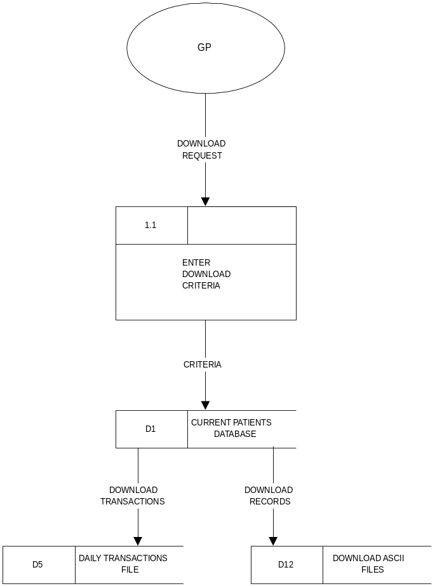

Processing Description and Further Mandatory Requirements

The GP System MUST be capable of creating a Download of a subset of the entire GP System patient database. In this respect, the GP System MUST be capable of producing a Download for:
- A subset for just one HA for all GPs in the GP Practice.
- A subset for just one HA and just one specified GP in the GP Practice.

The GP System MUST also be capable of producing the Download to be transmitted to the HA via one of two different media:
- Using Download transactions to be transmitted over the Network.
- Via a flat ASCII file on a floppy disk in DOS format.

The items of information to be included within an out-going Download transaction across the Network or an out-going Download record within a flat ASCII file are listed in section 3.10.4. The format of the flat ASCII file record layout for Download records to be sent to an HA via a floppy disk is detailed in this section.

It is recognised that it may not be practical for some GP Practices to download their database subset for an HA across the network owing to the size of their patient list. It is for these Practices that the use of a floppy disk should prove beneficial.

For other Practices, it is recognised that it may not be practical to download their database subset for an HA across the network in just one transmission; hence, the facility to transmit Download transactions for just one GP in the Practice. For these Practices, it is anticipated that the full download would be achieved over a number of transmissions - one GP per transmission.

The agreement as to how a Practice will download its patient database to an HA will be mutually agreed between the HA and the Practice at the time of the reconciliation.

The Download process MUST collate the following fields of existing patient Registration data for each patient matching the Download requirement for transmission to the appropriate HA:
- GP Code
- NHS Number
- Surname
- First Forename
- Second Forename
- Other Forenames
- Previous Surname
- Title
- Sex
- Date of Birth
- Address (5 fields)
- Postcode
- Drugs Dispensed Marker
- RPP Mileage
- Blocked Route/Special District Marker
- Walking Units
- Residential Institute Code

Note that the NHS Number may be in any valid format for NHS Numbers, and will be the most up-to-date NHS Number of the patient on the GP System.

It is strongly recommended that the GP System validates, at application level, the existing patient Registration data to be advised to the HA for each patient. Whenever an invalid value is encountered for a field, a null value will be sent to the HA in the place of this invalid value. This validation will ensure that no Uploads to be sent to an HA will fail the process of translation/validation at the HA.

One of the main purposes of the Download facility is to reconcile the databases for capitation. Attention should, therefore, be given to determining which patients are to be included within such a patient Download - for example:
- A patient marked on the GP System as having been reported as deceased MUST still be included within a Download if no Notification of Deduction has yet been received for that patient from the HA.
- A patient marked on the GP System as being treated as a Temporary Resident MUST NOT be included within a Download.
- A patient registered on the GP System for which no Acknowledgement has yet been received MUST be included within a Download.

Each Download transaction or record MUST be allocated a unique Transaction or Record Number. This will represent a unique identifier for that transaction or record. An Upload transaction or record raised at an HA during the processing of a Download will be given the same Transaction or Record Number as the corresponding Download transaction or record.

This Transaction or Record Number may be:
- From the sequence of Registration Transaction Numbers used for Acceptances, Amendments, etc.
- From a separate sequence of Download Transaction Numbers.
or
- A unique numeric identifier already stored against a patient on the GP System conforming to the validation requirements.

Irrespective of which method is used, the one-to-one relationship between Transaction or Record Number and patient MUST be retained within the GP System for the possible receipt of corresponding Upload transactions.

If the Download is to be transmitted to an HA over the Network, the Transaction Numbers may be allocated to the Download transactions either at the time of their generation within the "Daily Transactions" file or at the time of transmission.

If the Download is to be transmitted to an HA over the Network, as part of the translation process, a Transaction Date and Time MUST be allocated to all the Download transactions. The Transaction Date and Time MUST be combined within the Download EDIFACT message, and MUST be the date and time that the first transaction to be transmitted was successfully translated.

If the Download is to be sent to an HA within a flat ASCII file on a floppy disk, a Record Date and Time MUST be allocated to each Download record. These MUST be the same for every Download record and MUST be the date and time that the Download was undertaken.

If the Download is to be transmitted to the HA over the Network, details of the Download MUST be stored within the "Daily Transactions" file awaiting subsequent transmission.

If the Download is to be sent to the HA within a flat ASCII file on a floppy disk, it is recommended that the details of the Download be written to disk at this stage.

Irrespective of whether the Download is to be transmitted across the Network or sent to the HA within a flat ASCII file on a floppy disk, the patient Download information MUST meet the format requirements listed in section 3.10.4.

Before the Download records within the ASCII file, the GP System MUST create a header record containing the characters "503\*". If the Download is split into more than one flat ASCII file, only the first of these files should contain a header record (that is the file with a DOS filename extension ending in the character "A").

Within the Download records in the ASCII file, the GP System MUST ensure that the First Forename, Second Forename and Other Forenames fields are combined to make one overall Patient Forename. This overall Patient Forename should then be the value within the Download record.

Download records to be sent within a flat ASCII file MUST be physically stored as two records within the file as follows:

Record 1
* Record Type = "DOW"
* Record 1 = "1"
* GP Code
* Destination HA Cipher
* Record Date
* Record Time
* Record Number
NHS Number
Surname
Forename(s) - comprising First Forename, Second Forename and Other Forenames
Previous Surname
Title
Sex
Date of Birth
Address - House Name
Address - Number/Road Name

Record 2
* Record Type = "DOW"
* Record 2 = "2"
Address - Locality
Address - Post Town
Address - County
Address - Postcode
Drugs Dispensed Marker
RPP Mileage
Blocked Route/Special District Marker
Walking Units
Residential Institute Code

All fields MUST be delimited by the "~" character with the exception of the first and last fields for each physical record which MUST be only suffixed and prefixed by a "~" character, respectively.

Trailing "~" characters MUST be present.

Fields marked with an asterisk ("*") MUST contain a non-null value.

Fields not containing a value MUST be null.

On the floppy disk, each Download file MUST be named as follows:

GPR4AAA1.XYZ where:

- AAA is the HA Cipher of the HA for which the Download is being undertaken.

- X is a "month indicator" - the month in which the Download is being undertaken - "A" representing January, "B" representing February, ... ,"L" representing December.

- Y is a "day indicator" - the day of the month in which the Download is being undertaken - "1" representing the 1st, ... ,"9" representing the 9th, "A" representing the 10th, ... ,"V" representing the 31st.

- Z is an incrementing sequence of alphabetic characters starting at "A" if the Download is being split into a number of files. For example, if separate Download files are created for each GP in a Practice, Z MUST be "A" for the first Download file, "B" for the second Download file, and so on. If more than one floppy disk is required for a Download, each file on each disk MUST be allocated a unique filename.

As an example, if a Download via disk is requested for two different GPs in a Practice for the HA, BRS on 31st March, two Download files will be created on the disk - GPR4BRS1.CVA and GPR4BRS1.CVB.

Note that:
- The format of Download transactions within the "Daily Transactions" file is not being dictated by this specification. However, it is strongly recommended that data is stored within this file in the format that it MUST be sent to the HA.
- As part of the transmission process, the Download transactions MUST be deleted from the "Daily Transactions" file. They MUST NOT be copied to the "Completed Transactions" file, and MUST NOT, therefore, appear within any Archive files. Additionally, it is recommended that Download transactions are not copied to the application level "Transaction Backup" file.

Data Fields - Format/Validation - Mandatory Requirements

The following information may be included within a Download transaction or record. Fields marked (M) are mandatory and MUST always contain a valid, non-null value; fields marked (N-M) are non-mandatory and may or may not contain a non-null value.

Transaction/Record Type (M)
Within ASCII Download records, the Record Type MUST equal "DOW".
All out-going Download transactions generated by the transmission process MUST be combined within one EDIFACT message.

GP Code (M)
Within EDIFACT Download transactions and ASCII Download records, the GP Code MUST be the valid GMC National code for the patient's GP concatenated with "," concatenated with the "local" code for the patient's GP as known by the destination HA. This will be obtained from the Table of Valid GP Codes (see section 4.3.7). As such, the GP Code MUST:
- Have alphanumeric and "," characters only.
- Have a maximum length of 14 characters in the following format:
Characters 1-7 = Fixed 7 numeric character GMC National GP code
Character 8 = comma (,)
Characters 9-14 = 1-6 alphanumeric character Local GP code
- Have alphabetic characters in upper case.

Destination HA Cipher (M)
Within EDIFACT Download transactions and ASCII Download records, the Destination HA Cipher MUST:
- Be the Cipher of the patient's responsible HA.
- Be a valid HA Cipher, i.e. be a current live England and Wales code from the Table of Valid HA Ciphers (see Appendix D). As such, the Destination HA Cipher MUST:
- Have alphanumeric characters only.
- Have a maximum length of 3 characters.
- Have alphabetic characters in upper case.
Clearly, the Destination HA Cipher MUST be identical for all patients within a single Download.

Transaction/Record Date and Time (M)
Within ASCII Download records, the Record Date MUST be in the format "CCYYMMDD" and the Record Time in the format "HHMM".
All out-going Download transactions generated by the transmission process MUST be combined within one EDIFACT message with a Transaction Date and Time qualifier "137", format "203" - "CCYYMMDDHHMM" within a DTM segment.

Transaction/Record Number (M)
Within EDIFACT Download transactions and ASCII Download records, the Transaction/Record Number MUST:
- Have numeric characters only.
- Have a maximum length of 7 characters.
- Have a value of a positive integer.

NHS Number (N-M)
Within EDIFACT Download transactions and ASCII Download records, the NHS Number MUST be the existing, most up-to-date NHS Number of the patient and MUST be in one of the acceptable formats detailed in Appendix F. As such, the NHS Number MUST:
- Have alphanumeric, "?" or "/" characters only.
- Have a maximum length of 15 characters.
- Have alphabetic characters in upper case.
or MUST be an all-numeric Number of 10 digits including a check digit (the 10th and final digit in the Number).

Surname (N-M)
Within EDIFACT Download transactions and ASCII Download records, the Surname MUST:
- Have alphabetic, SPACE, "'" and "-" characters only.
- Have a maximum length of 35 characters (Surnames of more than 35 characters MUST be truncated for these purposes).
- Have alphabetic characters in upper case.

First Forename (N-M)
Within EDIFACT Download transactions, the First Forename MUST:
- Have alphabetic, SPACE, "'" "," "-" and "." characters only.
- Have a maximum length of 35 characters (First Forenames of more than 35 characters MUST be truncated for these purposes).
- Have alphabetic characters in upper case.

Second Forename (N-M)
Within EDIFACT Download transactions, the Second Forename MUST:
- Have alphabetic, SPACE, "'" "," "-" and "." characters only.
- Have a maximum length of 35 characters (Second Forenames of more than 35 characters MUST be truncated for these purposes).
- Have alphabetic characters in upper case.

Other Forenames (N-M)
Within EDIFACT Download transactions, the Other Forenames MUST:
- Have alphabetic, SPACE, "'" "," "-" and "." characters only.
- Have a maximum length of 35 characters (Other Forenames totalling more than 35 characters MUST be truncated for these purposes).
- Have alphabetic characters in upper case.

Previous Surname (N-M)
Within EDIFACT Download transactions and ASCII Download records, the Previous Surname MUST:
- Have alphabetic, SPACE, "'" and "-" characters only.
- Have a maximum length of 35 characters (Previous Surnames of more than 35 characters MUST be truncated for these purposes).
- Have alphabetic characters in upper case.

Title (N-M)
Within EDIFACT Download transactions and ASCII Download records, the Title MUST:
- Have alphabetic, SPACE, "'" and "-" characters only.
- Have a maximum length of 35 characters (Titles of more than 35 characters MUST be truncated for these purposes).
- Have alphabetic characters in upper case.

Sex (N-M)
Within EDIFACT Download transactions and ASCII Download records, the Sex MUST be "1" for Male, "2" for Female, "0" for Indeterminate/Not Known or "9" for Not Specified.

Date of Birth (N-M)
Within ASCII Download records, the Date of Birth MUST be in the format "CCYYMMDD".
Within EDIFACT Download transactions, the Date of Birth MUST have qualifier "329", format "102" - "CCYYMMDD" within a DTM segment.
For both, the Date of Birth MUST NOT be in the future.

Address - House Name (N-M)
Within EDIFACT Download transactions and ASCII Download records, the Address - House Name MUST:
- Have alphanumeric, SPACE, "'", "-", "." and "," characters only.
- Have a maximum length of 35 characters (House Names of more than 35 characters MUST be truncated for these purposes).
- Have alphabetic characters in upper case.
The Address - House Name MUST only contain the flat number or name of a property (if one exists).

Address - Number/Road Name (N-M)
Within EDIFACT Download transactions and ASCII Download records, the Address – Number/Road Name MUST:
- Have alphanumeric, SPACE, "'", "-", "." and "," characters only.
- Have a maximum length of 35 characters (Number/Road Names of more than 35 characters MUST be truncated for these purposes).
- Have alphabetic characters in upper case.
The Address - Number/Road Name MUST only contain the property number (if one exists) and the road/street name of the property.

Address - Locality (N-M)
Within EDIFACT Download transactions and ASCII Download records, the Address –Locality MUST:
- Have alphanumeric, SPACE, "'", "-", "." and "," characters only.
- Have a maximum length of 35 characters (Localities of more than 35 characters MUST be truncated for these purposes).
- Have alphabetic characters in upper case.
The Address - Locality MUST only contain the first village/town name/area (if one exists) if different to the property's post town name.

Address - Post Town (N-M)
Within EDIFACT Download transactions and ASCII Download records, the Address - Post Town MUST:
- Have alphanumeric, SPACE, "'", "-", "." and "," characters only.
- Have a maximum length of 35 characters (Post Towns of more than 35 characters MUST be truncated for these purposes).
- Have alphabetic characters in upper case.
The Address - Post Town MUST only contain the post town name of the property.

Address - County (N-M)
Within EDIFACT Download transactions and ASCII Download records, the Address - County MUST:
- Have alphanumeric, SPACE, "'", "-", "." and "," characters only.
- Have a maximum length of 35 characters (Counties of more than 35 characters MUST be truncated for these purposes).
- Have alphabetic characters in upper case.
The Address - County MUST only contain the county of the property (if one exists).

Address - Postcode (N-M)
Within EDIFACT Download transactions and ASCII Download records, the Address - Postcode MUST:
- Have alphanumeric and SPACE characters only.
- Have alphabetic characters in upper case.
- Have a fixed length of 8 characters and be in one of the following six formats:
"AN NAA" For postcodes of the format "AN NAA"
"ANN NAA" For postcodes of the format "ANN NAA"
"AAN NAA" For postcodes of the format "AAN NAA"
"AANN NAA" For postcodes of the format "AANN NAA"
"ANA NAA" For postcodes of the format "ANA NAA"
"AANA NAA" For postcodes of the format "AANA NAA"

Drugs Dispensed Marker (N-M)
Within EDIFACT Download transactions and ASCII Download records, the Drugs Dispensed Marker MUST only contain a single upper case "Y" character if set "on".

RPP Mileage (N-M)
Within EDIFACT Download transactions and ASCII Download records, the RPP Mileage MUST:
- Have numeric characters only.
- Have a maximum length of 2 characters.
- Have a value of a positive integer in the range 3 to 50.

Blocked Route/Special District Marker (N-M)
Within EDIFACT Download transactions and ASCII Download records, the Blocked Route/Special District Marker MUST contain a single upper case "B" or "S" character if being set to "Blocked Route" or "Special District", respectively.

Walking Units (N-M)
Within EDIFACT Download transactions and ASCII Download records, the Walking Units MUST:
- Have numeric characters only.
- Have a maximum length of 2 characters.
- Have a value of a positive integer in the range 3 to 99 and be exactly divisible by 3.
The GP System MUST ensure that a non-zero value for Walking Units may only be held for a patient if a non-zero value for RPP Mileage is also held for that patient.

Residential Institute Code (N-M)
Within EDIFACT Download transactions and ASCII Download records, the Residential Institute Code MUST:
- be a valid Residential Institute Code; i.e. the Code MUST be within the Table of Valid Residential Institute Codes for the patient's responsible HA (see section 4.3.4). As such, the Residential Institute Code MUST:
- Have alphanumeric characters only.
- Have a maximum length of 2 characters.
- Have alphabetic characters in upper case.

OUT-GOING DEDUCTION REQUESTS

Overview

The GP System must be capable of generating Deduction Request transactions for patients registered with a "linked" HA. This specification does not require that Deduction Requests must be able to be entered for patients with an HA with which that GP Practice is "manual"; however, for a GP Practice that is "linked" with an HA, the GP System must allow for Deduction Requests to be entered for patients with that HA, and these must be captured and advised to this HA within Deduction Request transactions.

HAs will have the option to either update or reject the Deduction Request transaction. Update of the transaction will lead to a Deduction transaction (see section 3.14) being notified back to the Practice. Rejection of the transaction will lead to a Deduction Request Rejection transaction (see section 3.23) being notified back to the Practice.

Processing Diagram

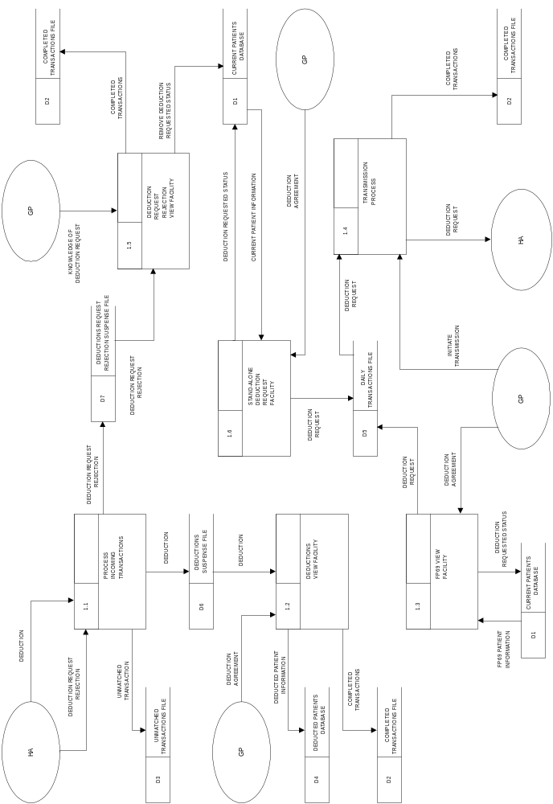

Processing Description

The facility allowing a GP to request of an HA that a patient is deducted from his/her list must be available within the following functional areas on the GP System:
- As a "stand-alone" function.
- From within the FP69 View Facility (see sections 3.21 and 3.22).

It is left up to individual GP System Suppliers to decide into what other areas of their System this function may be sensibly introduced. For example, a GP System Supplier may wish to allow a GP to request that a patient is deducted from his/her list from the view facility on in-coming Amendment transactions from HAs.

Within each of these areas, if a GP requests that a particular patient is removed from his/her list, the GP System must allow the following additional information to be entered:
- A Deduction Date
- A Reason for the Deduction
- GP Notes to accompany the transaction

Completion of the Deduction Date will be mandatory. For a death, this should be the date of death of the patient; for an Embarkation/Left Area this should be the date that the patient moved away. If this information is not known, an approximate, valid date should be entered, and free text should be entered in the GP Notes field indicating that the given date is an estimate of the exact date.

Completion of the Reason for the Deduction will also be mandatory and must be one of the following:
- Patient Death
- Patient Embarkation
- Patient "left area"

Completion of the GP Notes field will be mandatory if the entered Reason for the Deduction is either:
- Patient Embarkation, or
- Patient "left area".

Otherwise, completion of the GP Notes field will be optional.

Details of the captured Deduction Request must be stored within the "Daily Transactions" file awaiting subsequent transmission.

It is recommended that the following information is stored for each Deduction Request within the "Daily Transactions" file:
- Transaction Type
- GP Code
- Patient's Responsible HA
- NHS Number
- Date of Deduction
- Reason for Deduction
- GP Notes

During the transmission process, each Deduction Request will generate a Deduction Request transaction to be advised to an HA over the Network. Additionally, as part of this transmission process, details of these Deduction Requests must be copied to the "Completed Transactions" file.

It is recommended that, in addition to the information listed above, the following additional information is stored for each Deduction Request within the "Completed Transactions" file:
- Transaction Date
- Transaction Time
- Transaction Number

The GP System must provide a view facility on all patients within the GP System having a "Deduction Requested" status. The GP System must allow a GP to be able to manually remove the "Deduction Requested" status against a patient from this screen; there is no requirement for any security to control this action.

The format of Deduction Requests within the "Daily Transactions" file and the "Completed Transactions" file is not being dictated by this Specification. However, it is strongly recommended that data is stored within these files in the format in which it must be stored within subsequent Archive files.

Deduction Requests within the Archive files must be in the exact format specified in Appendix A, and must meet the validation requirements listed in section 3.11.4.

Data Fields – Format/Validation

The following information may be included within a Deduction Request. Fields marked (M) are mandatory, and must always contain a valid, non-null value. Fields marked (N-M) are non-mandatory, and may or may not contain a non-null value.

Transaction Type (M)
Within Archive files, the Transaction Type must equal "DER".
All out-going Deduction Request transactions generated by the transmission process for a "linked" HA must be combined within their own EDIFACT message.

GP Code (M)
Within EDIFACT Deduction Request transactions and Archive files, the GP Code MUST be the valid GMC National code for the patient's GP concatenated with "," concatenated with the "local" code for the patient's GP as known by the destination HA. The GP Code MUST:
- Have alphanumeric and "," characters only.
- Have a maximum length of 14 characters in the following format:
Characters 1-7 = Fixed 7 numeric character GMC National GP code
Character 8 = comma (,)
Characters 9-14 = 1-6 alphanumeric character Local GP code
- Have alphabetic characters in upper case.

Destination HA Cipher (M)
Within EDIFACT Deduction Request transactions and Archive files, the Destination HA Cipher MUST:
- Be the Cipher of the patient's responsible HA.
- Be a valid HA Cipher, i.e. be a current live England and Wales code from the Table of Valid HA Ciphers (see Appendix D). As such, the Destination HA Cipher MUST:
- Have alphanumeric characters only.
- Have a maximum length of 3 characters.
- Have alphabetic characters in upper case.

Transaction Date and Time (M)
Within Archive files, the Transaction Date MUST be in the format "CCYYMMDD", and the Transaction Time MUST be in the format "HHMM".
All out-going Deduction Request transactions generated by the transmission process for a "linked" HA MUST be combined within one EDIFACT message with a Transaction Date and Time qualifier "137", format "203" - "CCYYMMDDHHMM" within a DTM segment.

Transaction Number (M)
Within EDIFACT Deduction Request transactions and Archive files, the Transaction Number must:
- Have numeric characters only.
- Have a maximum length of 7 characters.
- Have a value of a positive integer.

NHS Number (M)
Within EDIFACT Deduction Request transactions and Archive files, the NHS Number must be the existing, most up-to-date NHS Number of the patient and must be in one of the acceptable formats detailed in Appendix F. As such, the NHS Number must:
- Have alphanumeric, "?" or "/" characters only.
- Have a maximum length of 15 characters.
- Have alphabetic characters in upper case.
or MUST be an all-numeric Number of 10 digits including a check digit (the 10th and final digit in the Number).

Date of Deduction (M)
Within Archive files, the Date of Deduction must be in the format "CCYYMMDD".
All out-going Deduction Request transactions to an HA must contain a Date of Deduction with a qualifier "961", format "102" - "CCYYMMDD" within a DTM segment.
For both of these, the Date of Deduction must not be in the future.

Reason for Deduction (M)
Within EDIFACT Deduction Request transactions and Archive files, the Reason for Deduction must:
- Have numeric characters only.
- Have a maximum length of 2 characters.
- Have one of the following values:
1 Death
5 Embarkation
13 Left Area

GP Notes (N-M)
Within EDIFACT Deduction Request transactions and Archive files, the GP Notes must:
- Only contain characters within the EDIFACT Level A character set.
- Have a maximum length of 60 characters.
- Have alphabetic characters in upper case.

STANDARD IN-COMING REGISTRATION TRANSACTION PROCESSING

Overview

This section describes the initial processing which should be carried out on all in-coming Registration transactions received across the Network within EDIFACT messages.

In addition, it details those areas of the standard processing which are mandatory. This section, therefore, alleviates the need to repeat this processing in the following sections which deal with the individual in-coming Registration transactions.

Processing Diagram

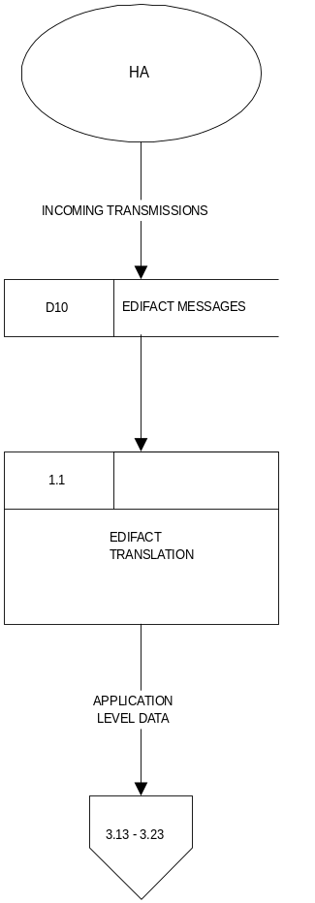

Processing Description and Further Mandatory Requirements

Having retrieved any files of in-coming transactions for the GP Practice from the Network, the GP System MUST translate them from EDIFACT format to application level transactions.

For each field received within an in-coming Registration transaction, the GP System MUST translate that field to a format to be used at application level. The format used to store these fields at application level will not (in general) be dictated by this document. However, it is strongly recommended that data is stored within the "Completed Transactions" file in the format that it MUST be stored within subsequent Archive files.

Once the transactions have been successfully translated, it is envisaged that the GP System will then automatically undertake as much initial processing of all the transactions for each transaction type as possible.

It is recommended that this initial processing is undertaken in the following order:
- Firstly, for each HA for which transactions have been received, the Approval and Rejection (Wrong HA) transactions will be processed in Transaction Number order.
- Then, for each HA for which transactions have been received, the Amendment, Deduction, Medical Records Sent, FP69 Prior Notification, FP69 Flag Removal and Deduction Request Rejection transactions will be processed in Transaction Number order.
- Finally, for each HA for which transactions have been received, the Medical Records Flag Removal transactions will be processed in Transaction Number order.

Note that:
- An Approval for a patient and an Amendment for that same patient may be received within the same Interchange.
- An Amendment for a patient and a Deduction for that same patient may be received within the same Interchange. The Transaction Number of the Amendment will, however, always be less than that of the Deduction.
- A Deduction for a patient and the corresponding Medical Records Flag Removal may be received within the same Interchange.
- More than one Amendment may be received for a patient within the same Interchange.

It is important, therefore, that the GP System MUST ensure that, when a GP is looking at the details of the received transactions:
- Amendment transactions for a patient are processed in Transaction Number order; i.e. if two Amendments for a patient are to be found within the "Amendments Suspense" file, the GP System MUST ensure that these two Amendments are processed by the GP in strict numeric order.
- If both an Amendment and a Deduction transaction exist for a patient, the GP System MUST ensure that the Amendment is processed by the GP before the Deduction.
- If both an FP69 Prior Notification and FP69 Flag Removal transaction exist for a patient, the GP System MUST ensure that the FP69 Prior Notification is processed before the FP69 Flag Removal.

IN-COMING AMENDMENT TRANSACTIONS

Overview

Any Amendments made to any of the following fields within the patient Registration database at an HA (other than when the Amendment has originated from a GP Practice) will automatically be "captured" and transmitted to the appropriate GP Practice (that is, the corresponding patient's GP's Practice):
- NHS Number
- Surname
- First Forename
- Second Forename
- Other Forenames
- Previous Surname
- Title
- Sex
- Date of Birth
- Address (5 fields)
- Postcode
- Drugs Dispensed Marker
- RPP Mileage
- Blocked Route/Special District Marker
- Walking Units
- Residential Institute Code

For HAs with which the GP Practice is "linked", Amendments will be advised to the GP Practice by means of Amendment transactions across the Network.

For HAs with which the GP Practice is "manual", Amendments will be advised to the GP Practice by means of paper forms. Patient detail Amendments will only be regularly received in paper format from HAs with which that GP Practice has been "linked" but is now temporarily "manual" and from HAs with which that GP Practice is in the process of reconciling their database.

The GP may have the option to reject an Amendment transaction if the Amendment received contains changes with which the GP disagrees; in this case, the GP System MUST automatically generate an Amendment to be returned to the HA. The GP System MUST force the GP to supply an item of free text to accompany the Amendment. At the HA, the Amendment will have the effect of "resetting" any changes included within the original Amendment.

Note that, if the GP rejects a received Amendment transaction, no changes will be made to the GP System patient database unless the original Amendment includes a change to the patient's NHS Number. In this case, the change to the patient's NHS Number MUST still be applied to the GP System patient database.

The GP System may also allow the GP to further amend Amendment transactions received from HAs. Any such changes MUST be automatically "captured" and transmitted back to the HA within an Amendment.

The GP System MUST also allow for a GP to "remove (out of area)" the patient corresponding to an in-coming Amendment transaction from an HA if that Amendment includes a change to the patient's home address. See section 2.2.21 for an explanation of the "removal (out of area)" process.

If the GP System status is "manual" with an HA, patient detail Amendments will be received from that HA on paper forms (typically, only if the GP Practice was previously "linked" with that HA or the GP Practice and the HA are in the process of reconciling their databases). These should be manually entered into the GP System. The GP System MUST allow for any of the patient data fields above to be amended for patients with an HA with which that GP Practice is "manual". As the amendment details have originated from an HA, the entering of the details into the GP System MUST NOT generate an Amendment to be transmitted to the HA.

Processing Diagram

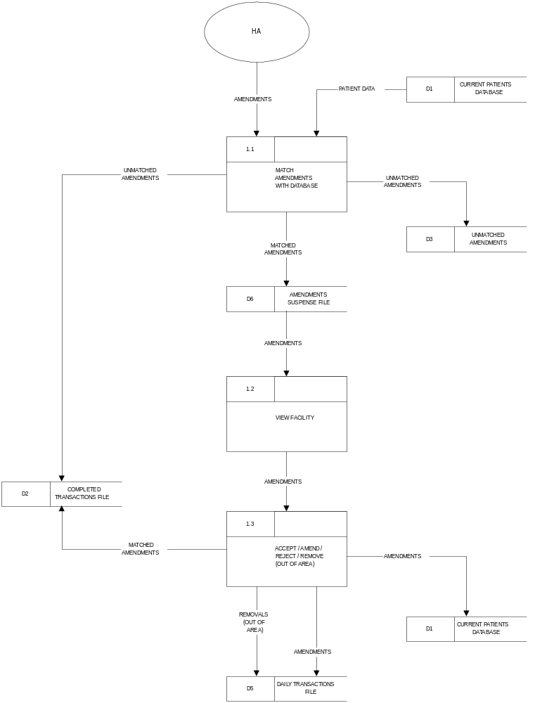

Processing Description and Further Mandatory Requirements

The GP System MUST be capable of receiving and processing Amendment transactions generated by an HA.

The items of information within an Amendment transaction from an HA are listed in section 3.13.4.

All the "New" information fields will only hold values, and hence will only be included within an EDIFACT message if they have been amended by the HA.

At least one of the "New" fields will contain a non-null value.

If at least one of the Address - Locality, Address - Post Town and Address - County fields is amended for a patient on the HA system, then the values held for all three of these fields will be advised to the GP Practice within the Amendment. It is hoped that this might assist in the process of "address coding" on the GP System.

A field containing a single "%" character will be considered to be a particular type of amended field, its purpose being to erase the existing contents of the corresponding field at the GP Practice for that patient (as opposed to a null field indicating that no change to that field is required).

Only certain fields will be able to contain a single "%" character. The data fields stored for a patient on the GP System corresponding to those fields within an Amendment that cannot contain a single "%" character cannot be erased by an Amendment transaction; they can only be replaced by another, non-null value. The fields that may contain a single "%" character within an Amendment are indicated by an asterisk ("*") in section 3.13.4.

If an HA amends the details of a patient, and then further amends that patient's details, the HA System will store these two Amendments separately and advise the GP Practice of them as two separate Amendment transactions. More than one Amendment transaction may, therefore, be received by a GP Practice for a particular patient within the same Interchange.

The Amendment transactions received MUST be matched (by patient NHS Number; or by HA Cipher and NHS Number if the NHS number commences with the "?" character and, hence, represents a Query NHS number) directly with the existing, most up-to-date NHS Number for all patients within the "Current Patients" database within the GP System (see section 4.3.14 for an explanation of Query NHS Numbers).

For each Amendment transaction, if the transaction is matched with the "Current Patients" database, the following processing MUST occur:
- The resulting matched Amendment (an amalgamation of the Amendment transaction and the existing information on the corresponding patient in the "Current Patients" database) MUST be batched by GP within the "Amendments Suspense" file for subsequent viewing and processing.

If the Amendment transaction cannot be matched (for some reason) with the "Current Patients" database, the following processing MUST occur:
- The unmatched Amendment transaction MUST be copied to an error file for investigation by the GP. A view facility on this file MUST be provided (see section 4.3.19).
- The unmatched Amendment transaction MUST be copied to and marked as "unmatched" within the "Completed Transactions" file.

The GP MUST be able to see how many matched Amendment transactions he/she has (which he/she has not yet viewed and then deleted) within the "Amendments Suspense" file as a line on the "Transactions View" Screen.

The GP MUST be able to opt to view the Amendment transactions within the "Amendments Suspense" file, probably from this "Transactions View" Screen.

Having opted to view any Amendment transactions, the details of each transaction MUST be displayed: probably one screen per transaction.

It is recommended that, on this screen, the patient's existing details from the "Current Patients" database are displayed together with the changes included within the Amendment transaction.

It is further recommended that, on this screen, the GP System allows for the GP to:
- Amend the received information fields (with the exception of the patient NHS Number). Any changes made to the information received MUST, of course, be captured and sent back to the HA within an Amendment. If such a facility is included, a free text field (GP Notes) MUST be provided allowing the GP to enter additional information; completion of this field will not be mandatory.
- Reject the Amendment. A default of NO is recommended. If such a facility is included, a free text field (GP Notes) MUST be provided allowing the GP to enter additional information; completion of this field will be mandatory if the Amendment is to be rejected.
Note that, if the received Amendment is rejected, the "Current Patients" database within the GP System MUST NOT be updated by the Amendment transaction unless the Amendment includes a change to the patient's NHS Number. In this case, the change to the patient's NHS Number MUST still be applied to the "Current Patients" database.

- Remove (Out of Area) the patient corresponding to the received Amendment if the Amendment transaction includes a change to the patient's address: i.e. a non-null value (other than a "%" character) is received within at least one of the five address fields. A default of NO is recommended. A free text field (GP Notes) MUST be provided allowing the GP to enter additional information; completion of this field will be mandatory if the patient corresponding to the Amendment is to be "removed (out of area)". Note that the GP System MUST NOT allow for both an Amendment to be rejected and the patient corresponding to the Amendment to be "removed (out of area)".
The provision of a facility allowing a GP to remove (out of area) the patient corresponding to a received Amendment transaction is mandatory and, therefore, MUST be in place. Additionally, the GP System MUST only allow for the patient corresponding to a received Amendment transaction to be removed (out of area) if the Amendment transaction includes a change to the patient's address: i.e. a non-null value (other than a "%" character) is received within at least one of the five address fields.
- Authorise the received Amendment to update the "Current Patients" database. A default of YES is recommended.

If the GP opts to reject the received Amendment:
- The GP System MUST create an out-going Amendment - see section 3.8 for further details. For each change contained within the received Amendment transaction, the out-going Amendment MUST contain the corresponding existing value for that patient from the "Current Patients" database. At the HA, therefore, this Amendment will have the effect of "resetting" any changes included within the original Amendment transaction.
- The original matched Amendment MUST be copied to and marked as "rejected" within the "Completed Transactions" file.
- The Amendment within the "Amendments Suspense" file MUST be deleted.

If the GP opts to remove (out-of-area) the patient corresponding to the received Amendment:
- The GP System MUST create an out-going Removal (Out of Area) - see section 3.9 for further details. At the HA, this Removal (Out of Area) will be interpreted as a request for the patient to be allocated to a different Practice, as the patient has moved outside the area normally covered by the Practice.
- The patient details within the "Current Patients" database MUST be updated by the information within the Amendment transaction together with any changes made at the GP Practice.
- The original matched Amendment MUST be copied to and marked as "removed (out of area)" within the "Completed Transactions" file.

- If the GP has further amended the received Amendment transaction, the details of the changes MUST be captured and included within an out-going Amendment to be returned to the patient's responsible HA - see section 3.8 for further details. Additionally, the original matched Amendment MUST be marked as "further amended" within the "Completed Transactions" file.
- The Amendment within the "Amendments Suspense" file MUST be deleted.

If the GP authorises that the Amendment transaction within the "Amendments Suspense" file may now be used to update the "Current Patients" database:
- The patient details within the "Current Patients" database MUST be updated by the information within the Amendment transaction together with any changes made at the GP Practice.
- The original matched Amendment MUST be copied to the "Completed Transactions" file.
- If the GP has further amended the received Amendment transaction, the details of the changes MUST be captured and included within an out-going Amendment to be returned to the patient's responsible HA - see section 3.8 for further details. Additionally, the original matched Amendment MUST be marked as "further amended" within the "Completed Transactions" file.
- The Amendment within the "Amendments Suspense" file MUST be deleted.

It is recommended that Amendment transactions continue to be displayed, one transaction at a time, until the "Amendments Suspense" file has been emptied.

It should be noted that more than one Amendment may be stored for a patient within the "Amendments Suspense" file at any one time. The GP System MUST, therefore, ensure that Amendment transactions for a patient may only be processed in Transaction Number order; i.e. if two Amendments for a patient are to be found within the "Amendments Suspense" file, the GP System MUST ensure that these two Amendments are processed by the GP in strict numeric order.

If an Amendment transaction is received containing changes which have already been applied to the "Current Patients" database (i.e. the Amendment will not change the patient's Registration details in any way), it is strongly recommended that the transaction does not have to be viewed by the Practice staff; however, the Amendment MUST still be copied to the "Completed Transactions" file

It is recommended that the following information is stored for each received Amendment transaction within the "Completed Transactions" file:
- Transaction Type
- Existing GP Code
- Sending HA Cipher
- Transaction Date
- Transaction Time
- Transaction Number
- Existing NHS Number
- Amended NHS Number
- New Surname
- New First Forename
- New Second Forename
- New Other Forenames
- New Previous Surname
- New Title
- New Sex
- New Date of Birth
- New Address - 5 fields
- New Postcode
- New Drugs Dispensed Marker
- New RPP Mileage
- New Blocked Route/Special District Marker
- New Walking Units
- New Residential Institute Code
- Unmatched Marker (indicating whether the received transaction was matched or unmatched on receipt)
- Further Amended Marker (indicating whether further changes were made to the Amendment by the GP Practice)
- Rejected Marker (indicating whether the received transaction was rejected)
- Removed (out of area) Marker (indicating whether the patient corresponding to the received transaction was "Removed (out of area)"

Data Fields - Format - Mandatory Requirements

The following information will be contained within an Amendment transaction. Fields marked (M) are mandatory and will always contain a valid, non-null value; fields marked (N-M) are non-mandatory and may or may not contain a non-null value. Fields marked with an "*" may contain a single "%" character.

Transaction Type (M)
All in-coming Amendment transactions received from an HA will be combined within one EDIFACT message.
Within Archive files, the Transaction Type MUST equal "AMF".

Existing GP Code (M)
Within EDIFACT Amendment transactions, the Existing GP Code will be the valid GMC National code for the patient's GP concatenated with "," concatenated with the "local" code for the patient's GP as known by the sending HA (see section 4.3.7). As such, the Existing GP Code will:
- Have alphanumeric and "," characters only.
- Have a maximum length of 14 characters in the following format:
Characters 1-7 = Fixed 7 numeric character GMC National GP code
Character 8 = comma (,)
Characters 9-14 = 1-6 alphanumeric character Local GP code
- Have alphabetic characters in upper case.
Within Archive files, the Existing GP Code will be that received within the Amendment transaction.

Sending HA Cipher (M)
Within EDIFACT Amendment transactions, the Sending HA Cipher will:
- Be the Cipher of the patient's responsible HA.
- Be a valid HA Cipher, i.e. be a current live England and Wales code from the Table of Valid HA Ciphers (see Appendix D). As such, the Sending HA Cipher will:
- Have alphanumeric characters only.
- Have a maximum length of 3 characters.
- Have alphabetic characters in upper case.
Within Archive files, the Sending HA Cipher MUST be that received within the Amendment transaction.

Transaction Date and Time (M)
All in-coming Amendment transactions received from an HA will have been combined within one EDIFACT message with a Transaction Date and Time qualifier "137", format "203" - "CCYYMMDDHHMM" within a DTM segment.
Within Archive files, the Transaction Date MUST be in the format "CCYYMMDD" and the Transaction Time in the format "HHMM".

Transaction Number (M)
Within EDIFACT Amendment transactions, the Transaction Number will:
- Have numeric characters only.
- Have a maximum length of 7 characters.
- Have a value of a positive integer.
Within Archive files, the Transaction Number MUST be that received within the Amendment transaction.

Existing NHS Number (M)
Within EDIFACT Amendment transactions, the Existing NHS Number will be in one of the acceptable formats detailed in Appendix F. As such, the Existing NHS Number will:
- Have alphanumeric, "?" or "/" characters only.
- Have a maximum length of 15 characters.
- Have alphabetic characters in upper case.
or will be an all-numeric Number of 10 digits including a check digit (the 10th and final digit in the Number).
Within Archive files, the Existing NHS Number MUST be that received within the Amendment transaction.

Amended NHS Number (N-M)
Within EDIFACT Amendment transactions, the Amended NHS Number will be in one of the acceptable formats detailed in Appendix F. As such, the Amended NHS Number will:
- Have alphanumeric, "?" or "/" characters only.
- Have a maximum length of 15 characters.
- Have alphabetic characters in upper case.
or will be an all-numeric Number of 10 digits including a check digit (the 10th and final digit in the Number).
Within Archive files, the Amended NHS Number MUST be that received within the Amendment transaction.

New Surname (N-M)
Within EDIFACT Amendment transactions, the New Surname will:
- Have alphabetic, SPACE, "'" and "-" characters only.
- Have a maximum length of 35 characters.
- Have alphabetic characters in upper case.
Within Archive files, the New Surname MUST be that received within the Amendment transaction.

New First Forename (N-M) *
Within EDIFACT Amendment transactions, the New First Forename will:
- Have alphabetic, SPACE, "'", "-" and "." characters only (or a single "%" character).
- Have a maximum length of 35 characters.
- Have alphabetic characters in upper case.
If the value of the New First Forename is a single "%" character, this MUST have the effect of deleting the entire set of Forenames for the patient on the GP system.
Within Archive files, the New First Forename MUST be that received within the Amendment transaction.

New Second Forename (N-M)
Within EDIFACT Amendment transactions, the New Second Forename will:
- Have alphabetic, SPACE, "'", "-" and "." characters only.
- Have a maximum length of 35 characters.
- Have alphabetic characters in upper case.
Within Archive files, the New Second Forename MUST be that received within the Amendment transaction.

New Other Forenames (N-M)
Within EDIFACT Amendment transactions, the New Other Forenames will:
- Have alphabetic, SPACE, "'", "-" and "." characters only.
- Have a maximum length of 35 characters.
- Have alphabetic characters in upper case.
Within Archive files, the New Other Forenames MUST be that received within the Amendment transaction.

New Previous Surname (N-M) *
Within EDIFACT Amendment transactions, the New Previous Surname will:
- Have alphabetic, SPACE, "'" and "-" characters only (or a single "%" character).
- Have a maximum length of 35 characters.
- Have alphabetic characters in upper case.
Within Archive files, the New Previous Surname MUST be that received within the Amendment transaction.

New Title (N-M) *
Within EDIFACT Amendment transactions, the New Title will:
- Have alphabetic, SPACE, "'" and "-" characters only (or a single "%" character).
- Have a maximum length of 35 characters.
- Have alphabetic characters in upper case.
Within Archive files, the New Title MUST be that received within the Amendment transaction.

New Sex (N-M)
Within EDIFACT Amendment transactions, the New Sex will be "1" for Male, "2" for Female, "0" for "Indeterminate/Unknown" or "9" for Not Specified within the Sex data element.
Within Archive files, the New Sex MUST have a value of "M" for Male, "F" for Female, "I" for Indeterminate/Unknown or "S" for Not Specified.

New Date of Birth (N-M)
Within EDIFACT Amendment transactions, the New Date of Birth will have qualifier "329", format "102" - "CCYYMMDD" within a DTM segment.
Within Archive files, the New Date of Birth MUST be that received within the Amendment transaction and in the format "CCYYMMDD".
The received Date of Birth will not be in the future.

New Address - House Name (N-M) *
Within EDIFACT Amendment transactions, the New Address - House Name will:
- Have alphanumeric, SPACE, "'", "-", "." and "," characters only (or a single "%" character).
- Have a maximum length of 35 characters.
- Have alphabetic characters in upper case.
The New Address - House Name will only contain the flat number or name of a property (if one exists).
Within Archive files, the New Address - House Name MUST be that received within the Amendment transaction.

New Address - Number/Road Name (N-M) *
Within EDIFACT Amendment transactions, the New Address – Number/Road Name will:
- Have alphanumeric, SPACE, "'", "-", "." and "," characters only (or a single "%" character).
- Have a maximum length of 35 characters.
- Have alphabetic characters in upper case.
The New Address - Number/Road Name will only contain the property number (if one exists) and the road/street name for the patient.
Within Archive files, the New Address - Number/Road Name MUST be that received within the Amendment transaction.

New Address - Locality (N-M) *
Within EDIFACT Amendment transactions, the New Address - Locality will:
- Have alphanumeric, SPACE, "'", "-", "." and "," characters only (or a single "%" character).
- Have a maximum length of 35 characters.
- Have alphabetic characters in upper case.
The New Address - Locality will only contain the first village/town name/area (if one exists) if different to the property's post town name.
Within Archive files, the New Address - Locality MUST be that received within the Amendment transaction.

New Address - Post Town (N-M)
Within EDIFACT Amendment transactions, the New Address – Post Town will:
- Have alphanumeric, SPACE, "'", "-", "." and "," characters only.
- Have a maximum length of 35 characters.
- Have alphabetic characters in upper case.
The New Address - Post Town will only contain the post town name of the property.
Within Archive files, the New Address - Post Town MUST be that received within the Amendment transaction.

New Address - County (N-M) *
Within EDIFACT Amendment transactions, the New Address - County will:
- Have alphanumeric, SPACE, "'", "-", "." and "," characters only (or a single "%" character).
- Have a maximum length of 35 characters.
- Have alphabetic characters in upper case.
The New Address - County will only contain the county of the property.
Within Archive files, the New Address - County MUST be that received within the Amendment transaction.

New Address - Postcode (N-M) *
Within EDIFACT Amendment transactions, the New Address - Postcode will:
- Have alphanumeric and SPACE characters only (or a single "%" character).
- Have alphabetic characters in upper case.
- Have a fixed length of 8 characters and be in one of the following six formats:
"AN NAA" For postcodes of the format "AN NAA"
"ANN NAA" For postcodes of the format "ANN NAA"
"AAN NAA" For postcodes of the format "AAN NAA"
"AANN NAA" For postcodes of the format "AANN NAA"
"ANA NAA" For postcodes of the format "ANA NAA"
"AANA NAA" For postcodes of the format "AANA NAA"
with the exception of the case of a single "%" character
Within Archive files, the New Address - Postcode MUST be that received within the Amendment transaction.

New Drugs Dispensed Marker (N-M) *
Within EDIFACT Amendment transactions, the New Drugs Dispensed Marker will contain a single upper case "Y" character if being set "on" and a single "%" character if being set "off".
Within Archive files, the New Drugs Dispensed Marker MUST be that received within the Amendment transaction.

New RPP Mileage (N-M) *
Within EDIFACT Amendment transactions, the New RPP Mileage will:
- Have numeric characters only (or a single "%" character).
- Have a maximum length of 2 characters.
- Have a value of a positive integer in the range 3 to 50 (or a single "%" character).
Within Archive files, the New RPP Mileage MUST be that received within the Amendment transaction.

New Blocked Route/Special District Marker (N-M) *
Within EDIFACT Amendment transactions, the New Blocked Route/Special District Marker will contain a single upper case "B" or "S" character if being set to "Blocked Route" or "Special District", respectively and a single "%" character if being set "off".
Within Archive files, the New Blocked Route/Special District Marker MUST be that received within the Amendment transaction.

New Walking Units (N-M) *
Within EDIFACT Amendment transactions, the New Walking Units will:
- Have numeric characters only (or a single "%" character).
- Have a maximum length of 2 characters.
- Have a value of a positive integer in the range 3 to 99 and be exactly divisible by 3 (or a single "%" character).
Within Archive files, the New Walking Units MUST be that received within the Amendment transaction.

New Residential Institute Code (N-M) *
Within EDIFACT Amendment transactions, the New Residential Institute Code will:
- be a valid Residential Institute Code; i.e. the Code will be within the Table of Valid Residential Institute Codes for the patient's responsible HA (see section 4.3.4). As such, the New Residential Institute Code will:
- Have alphanumeric characters only (or a single "%" character).
- Have a maximum length of 2 characters.
- Have alphabetic characters in upper case.
Within Archive files, the New Residential Institute Code MUST be that received within the Amendment transaction.

IN-COMING DEDUCTION TRANSACTIONS

Overview

Any patient Deductions made at an HA will automatically be "captured" and transmitted to the appropriate GP Practice (that is, the corresponding patient's GP's Practice).

For HAs with which the GP Practice is "linked", Deductions will be advised to the GP Practice by means of Deduction transactions across the Network. See section 4.2.

For HAs with which the GP Practice is "manual", Deductions will be advised to the GP Practice by means of FP22 printouts.

The GP System MUST be capable of receiving Deduction transactions from "linked" HAs, automatically "flagging for Deduction" the corresponding patients on the GP System patient database and storing the Deductions for subsequent viewing and processing.

If a GP receives a Deduction transaction from an HA with which he/she does not agree, he/she MUST be able to re-accept the patient. This MUST have the effect of automatically creating an Acceptance transaction for transmission back to the HA responsible for that patient in order to re-instate the patient on the HA database.

Additionally, if a GP receives a Deduction transaction from an HA for a patient who has changed address into a different HA area but is staying with the same GP in the same GP Practice, he/she MUST be forced by the GP System to re-accept the patient. This, again, MUST have the effect of automatically creating an Acceptance transaction for transmission to the new HA responsible for that patient.

It is assumed that the GP System stores a "status" for each patient within the "Current Patients" database. Typical statuses might be:
- "Registered awaiting Acknowledgement"
- "Registration acknowledged by HA"
- "Removed awaiting HA Deduction"
- "Deducted by HA"

A Deduction transaction removing a patient from a GP's list, if accepted by the GP, MUST have the effect of amending this status for the corresponding patient to "Deducted by HA" - indicating that the patient has been deducted, for capitation purposes, by the HA.

If the GP System status is "manual" with an HA, patient Deductions will be received from that HA on FP22 printouts. These MUST be manually entered into the GP System. The GP System MUST allow for the manual Deduction of patients with an HA with which that GP Practice is "manual".

All patient Deductions on the GP System MUST always originate from an HA.

The GP System MUST NOT allow for a patient to be deducted manually by a GP unless:
- The patient's responsible HA is "manual" with the GP Practice.
- A Deduction of a patient is required (where the patient's responsible HA is "linked") in order to bring the HA and GP Practice databases back in-line for capitation purposes (using the appropriate "security-controlled" system action).

For the purpose of capitation counts, patient downloads, etc., all patients on a GP’s list for whom neither a Notification of Deduction nor a "Security-controlled Deduction" has been processed should still be considered to be registered with their responsible HA.

Processing Diagram

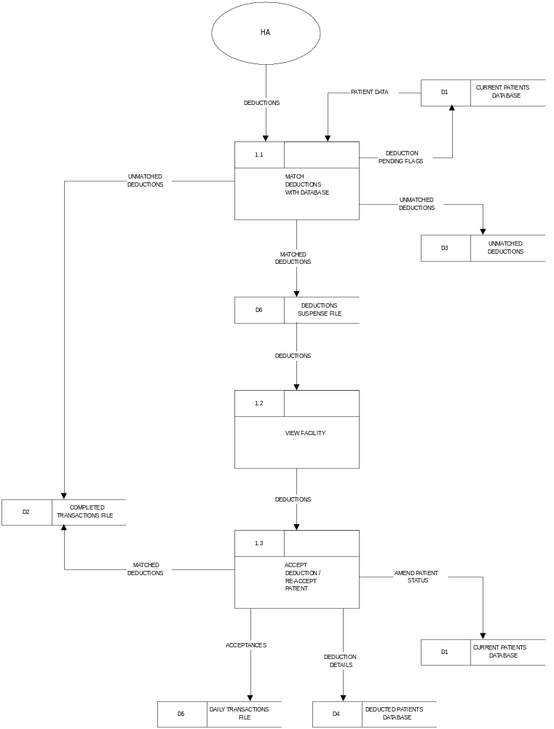

Processing Description and Further Mandatory Requirements

The GP System MUST be capable of receiving and processing Deduction transactions generated by an HA.

The items of information within a Deduction transaction from an HA are listed in section 3.14.4.

The Deduction transactions received MUST be matched (by patient NHS Number, or by HA Cipher and NHS Number if the NHS number commences with the "?" character and hence represents a Query NHS number) directly with the existing, most up-to-date NHS Number for all patients within the "Current Patients" database within the GP System (see section 4.3.14 for an explanation of Query NHS Numbers).

For a Deduction transaction containing a Reason for Deduction of "16 - Internal Transfer within Partnership" which has matched with the "Current Patients" database, the following MUST occur:
- The matched Deduction MUST be copied to the "Completed Transactions" file.
- Further Deduction processing MUST NOT be performed, as the patient should not be removed from the GP System.

For a Deduction transaction containing a Reason for Deduction of "16 - Internal Transfer within Partnership" which cannot be matched (for some reason) with the "Current Patients" database, the unmatched transaction MUST be copied to an error file (the "Unmatched Deductions" file) for investigation by the GP.

For each Deduction transaction, if the transaction is matched with the "Current Patients" database, the following processing MUST occur:
- A "Deduction Pending" flag MUST be set for the patient (this flag set for a patient will indicate that, although the patient is still on the "Current Patients" database, an HA Deduction transaction is outstanding for that patient).
- The resulting matched Deduction MUST be batched by GP within the "Deductions Suspense" file for subsequent viewing and processing.

If the Deduction transaction cannot be matched (for some reason) with the "Current Patients" database the following processing MUST occur:
- The unmatched Deduction transaction MUST be copied to an error file for investigation by the GP. A view facility on this file MUST be provided (see section 4.3.20).
- The unmatched Deduction transaction MUST be copied to and marked as "unmatched" within the "Completed Transactions" file.

The GP MUST be able to see how many matched Deduction transactions he/she has (which he/she has not yet viewed and then deleted) within the "Deductions Suspense" file as a line on the "Transactions View" Screen.

The GP MUST be able to opt to view the Deduction transactions within the "Deductions Suspense" file, probably from this "Transactions View" Screen.

Having opted to view any Deduction transactions, the details of each transaction MUST be displayed - probably one screen per transaction.

It is recommended that, on this screen, some of the patient's details from the "Current Patients" database are displayed (to identify the patient) together with the information included within the Deduction transaction. This MUST include any value received within the New HA Cipher field.

The New HA Cipher will always be (and only) included in Deductions with a Reason for Deduction of either "2 - Removal to New HA" or "6 - New HA/Same GP". This field MUST be amendable for Deductions with a Reason for Deduction of "6 - New HA/Same GP" and MUST be read-only for Deductions with a Reason for Deduction of "2 - Removal to New HA".

An additional, free text field (GP Notes) MUST be provided. If the patient is to be re-accepted, this will allow the GP to enter some free text to accompany the Acceptance. Completion of this field will be mandatory if the patient is to be re-accepted back to the same HA from which the Deduction originated.

It is further recommended that, on this screen, the GP System allows for the GP to either:
- Authorise the received Deduction to update the "Current Patients" database (a default of YES is recommended).
or
- Re-accept the patient (a default of NO is recommended).

In summary form, the GP System MUST:
- Allow for a patient to be re-accepted back to the same HA whatever the Reason for Deduction included within the Deduction transaction.
- Force the GP to re-accept a patient if the Reason for Deduction included within the Deduction transaction is "6 - New HA/Same GP".
or
- Allow for the received Deduction to update the "Current Patients" database.

If the GP authorises that the Deduction transaction within the "Deductions Suspense" file may be used to update the "Current Patients" database:
- The status of the patient within the "Current Patients" database MUST be amended to "Deducted by HA".
- Any FP69 status which may exist for the patient MUST be removed.
- A "Medical Records" flag MUST be set for that patient, and the date when this flag was established MUST also be recorded.
- The HA Cipher and Transaction Number from the Deduction MUST be recorded for that patient within the "Deducted Patients" database. These will subsequently be used to match a Medical Records Flag Removal transaction from the HA with the original Deduction transaction.
- The matched Deduction MUST be copied to the "Completed Transactions" file.
- The Deduction within the "Deductions Suspense" file MUST be deleted.

If the GP opts to re-accept a patient following the receipt of a Deduction transaction with a Reason for Deduction of any value except "6 - New HA/Same GP":
- The "Deduction Pending" flag established against the patient at the time of the receipt of the Deduction MUST be removed.
- A new out-going Acceptance transaction MUST be generated. The Acceptance MUST:
- Be directed to the same HA from which the Deduction transaction was received.
- Be given an Acceptance Code of "D": this will signify to the HA that the Acceptance was generated at the GP Practice as a result of the receipt of a Deduction transaction.
- Be given Acceptance Type dependent on the original Reason for Deduction.
- Contain a mandatory item of free text - the GP Notes field.
See section 3.6 for further details.
- The matched Deduction MUST be copied to and marked as "re-accepted" within the "Completed Transactions" file.
- The Deduction within the "Deductions Suspense" file MUST be deleted.

If the GP is forced to re-accept a patient by the GP System - the Deduction transaction having a Reason for Deduction of "6 - New HA/Same GP":
- The "Deduction Pending" flag established against the patient at the time of the receipt of the Deduction MUST be removed.
- A new out-going Acceptance transaction MUST be generated. The Acceptance MUST:
- Be directed to the HA indicated by the New HA Cipher field displayed and possibly amended on the screen.
- Be given an Acceptance Code of "S".
- Be given Acceptance Type of "3" (Transfer In).
- Contain a mandatory item of free text - the GP Notes field - if the GP specifies that the Acceptance is to be directed to the same HA from which the Deduction originated.
- The matched Deduction MUST be copied to and marked as "re-accepted" within the "Completed Transactions" file. The New HA field stored within the "Completed Transactions" file MUST be that received within the Deduction transaction - not that of the destination HA for the generated Acceptance.
- The Deduction within the "Deductions Suspense" file MUST be deleted.

It is recommended that Deduction transactions continue to be displayed, one transaction at a time, until the "Deductions Suspense" file has been emptied.

It should be noted that an Amendment may be stored for a patient within the "Amendments Suspense" file at the same time as a Deduction being stored for that same patient within the "Deductions Suspense" file. The GP System MUST ensure that any such Amendment transactions for a patient be processed before the Deduction transaction.

It is recommended that the following information is stored for each received Deduction transaction within the "Completed Transactions" file:
- Transaction Type
- GP Code
- Sending HA Cipher
- Transaction Date
- Transaction Time
- Transaction Number
- NHS Number
- Date of Deduction
- Reason for Deduction
- New HA Cipher
- Unmatched Marker (indicating whether the received transaction was matched or unmatched on receipt)
- Re-accepted Marker (indicating whether the patient corresponding to the received transaction was re-accepted)

Data Fields - Format - Mandatory Requirements

The following information will be contained within a Deduction transaction. Fields marked (M) are mandatory and will always contain a valid, non-null value; fields marked (N-M) are non-mandatory and may or may not contain a non-null value.

Transaction Type (M)
All in-coming Deduction transactions received from an HA will be combined within one EDIFACT message.
Within Archive files, the Transaction Type MUST equal "DEF".

GP Code (M)
Within EDIFACT Deduction transactions, the GP Code will be the valid GMC National code for the deducted patient's GP concatenated with "," concatenated with the "local" code for the deducted patient's GP as known by the sending HA (see section 4.3.7). As such, the GP Code will:
- Have alphanumeric and "," characters only.
- Have a maximum length of 14 characters in the following format:
Characters 1-7 = Fixed 7 numeric character GMC National GP code
Character 8 = comma (,)
Characters 9-14 = 1-6 alphanumeric character Local GP code
- Have alphabetic characters in upper case.
Within Archive files, the GP Code MUST be that received within the Deduction transaction.

Sending HA Cipher (M)
Within EDIFACT Deduction transactions, the Sending HA Cipher will:
- Be the Cipher of the deducted patient's responsible HA.
- Be a valid HA Cipher, i.e. be a current live England and Wales code from the Table of Valid HA Ciphers (see Appendix D). As such, the Sending HA Cipher will:
- Have alphanumeric characters only.
- Have a maximum length of 3 characters.
- Have alphabetic characters in upper case.
Within Archive files, the Sending HA Cipher MUST be that received within the Deduction transaction.

Transaction Date and Time (M)
All in-coming Deduction transactions received from an HA will have been combined within one EDIFACT message with a Transaction Date and Time qualifier "137", format "203" - "CCYYMMDDHHMM" within a DTM segment.
Within Archive files, the Transaction Date MUST be in the format "CCYYMMDD" and the Transaction Time in the format "HHMM".

Transaction Number (M)
Within EDIFACT Deduction transactions, the Transaction Number will:
- Have numeric characters only.
- Have a maximum length of 7 characters.
- Have a value of a positive integer.
Within Archive files, the Transaction Number MUST be that received within the Deduction transaction.

NHS Number (M)
Within EDIFACT Deduction transactions, the NHS Number will identify the patient to be deducted, and will be in one of the acceptable formats detailed in Appendix F. As such, the NHS Number will:
- Have alphanumeric, "?" or "/" characters only.
- Have a maximum length of 15 characters.
- Have alphabetic characters in upper case.
or will be an all-numeric Number of 10 digits including a check digit (the 10th and final digit in the Number).
Within Archive files, the NHS Number MUST be that received within the Deduction transaction.

Date of Deduction (M)
Within EDIFACT Deduction transactions, the Date of Deduction will have qualifier "961", format "102" - "CCYYMMDD" within a DTM segment.
The Date of Deduction will not be in the future.
Within Archive files, the Date of Deduction MUST be that received within the Deduction transaction and in the format "CCYYMMDD".

Reason for Deduction (M)
Within EDIFACT Deduction transactions, the Reason for Deduction will:
- Have numeric characters only.
- Have a maximum length of 2 characters.
- Have a value of a positive integer in the range 1 to 22.
Within Archive files, the Reason for Deduction MUST be that received within the Deduction transaction.
See Appendix G for a complete list of possible Reasons for Deduction.

New HA Cipher (N-M)
Within EDIFACT Deduction transactions, the New HA Cipher will contain a non-null value for Deductions with a Reason for Deduction of either "2" or "6". As such, the New HA Cipher will:
- Have alphanumeric characters only.
- Have a maximum length of 3 characters.
- Have alphabetic characters in upper case.
Within Archive files, the New HA Cipher MUST be that received within the Deduction transaction - not that of the destination HA for the generated Acceptance.

IN-COMING REJECTION (WRONG HA) TRANSACTIONS

Overview

When a GP accepts a new patient onto his/her list, he/she forwards to the appropriate HA for that patient (determined by the patient's registered address) an Acceptance. As previously discussed in section 2.2.6, for a GP Practice that is "linked" with an HA, the details of the patient Acceptance MUST be transmitted to that HA within an Acceptance. Similarly, for a GP Practice that is "manual" with an HA, the details of the patient Acceptance MUST be advised to that HA by the use of an Acceptance standard form.

A patient Acceptance forwarded to an HA either within an Acceptance transaction or on an Acceptance standard form may only be rejected by the receiving HA if that is the incorrect HA for that patient - that is, not the patient's responsible HA.

For HAs with which the GP Practice is "linked", Rejections (Wrong HA) will be advised to the GP Practice by means of Rejection (Wrong HA) transactions across the Network.

For HAs with which the GP Practice is "manual", Rejections (Wrong HA) will be advised to the GP Practice by means of paper forms.

As discussed in section 2.2.2, any patient Acceptances notified to an HA on an Acceptance standard form will always be replied to by the HA using a printout/form. Similarly, patient Acceptances notified to an HA within an Acceptance transaction across the Network will always be replied to by the HA using a transaction.

Until a Rejection (Wrong HA) is processed by a GP using the GP System, the patient databases at the HA and within the GP System are out of line. It is important, therefore, for Rejection (Wrong HA) transactions to be processed swiftly.

Processing Diagram

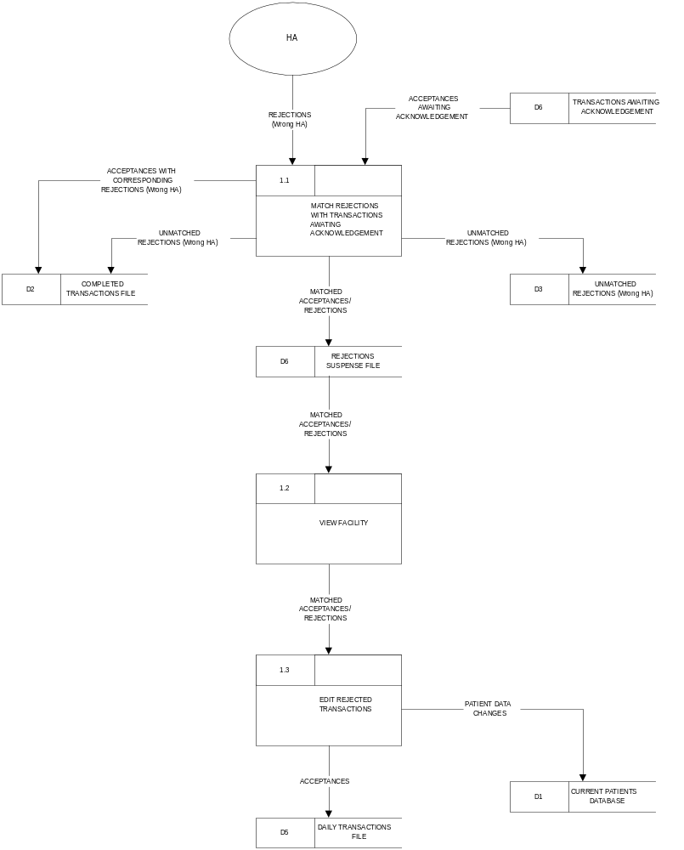

Processing Description and Further Mandatory Requirements

The GP System MUST be capable of receiving and processing Rejection (Wrong HA) transactions generated by an HA in response to previously transmitted patient Acceptance transactions.

The items of information within a Rejection (Wrong HA) transaction from an HA are listed in section 3.15.4.

Rejection (Wrong HA) transactions will not contain the information included within the original Acceptance transaction. However, the Transaction Number of a Rejection (Wrong HA) will be an exact copy of the Transaction Number of the corresponding Acceptance transaction. The GP System will, therefore, have to obtain the original Acceptance transaction details from data stored at the time of the original transmission.

The Rejection (Wrong HA) transactions received MUST, therefore, be matched (by GP System Transaction Number) directly with the "Transactions awaiting Acknowledgement" file.

For each Rejection (Wrong HA) transaction, if the transaction is matched with the "Transactions awaiting Acknowledgement" file, the following processing MUST occur:
- The resulting matched Rejection (Wrong HA) (an amalgamation of the information on the original Acceptance transaction and the corresponding Rejection [Wrong HA] transaction) MUST be copied to the "Completed Transactions" file and batched by GP within the "Rejections (Wrong HA) Suspense" file for subsequent viewing and processing.
- The corresponding record within the "Transactions awaiting Acknowledgement" file MUST be removed.

If the Rejection (Wrong HA) transaction cannot be matched (for some reason) with the "Transactions awaiting Acknowledgement" file, the following processing MUST occur:
- The unmatched Rejection (Wrong HA) transaction MUST be copied to an error file for investigation by the GP. A view facility on this file MUST be provided (see section 4.3.23).
- The unmatched Rejection (Wrong HA) transaction MUST be copied to the "Completed Transactions" file.

The GP MUST be able to see how many matched Rejection transactions he/she has (which he/she has not yet viewed and then deleted) within the "Rejections (Wrong HA) Suspense" file as a line on the "Transactions View" Screen.

The GP MUST be able to opt to view the Rejection (Wrong HA) transactions within the "Rejections (Wrong HA) Suspense" file, probably from this "Transactions View" Screen.

Having opted to view any Rejection (Wrong HA) transactions, the details of each transaction MUST be displayed - probably one screen per transaction.

It is recommended that, on this screen, the full details of the original Acceptance transaction are displayed together with the Rejection Details received back from the HA.

The Rejection Details within the Rejection (Wrong HA) transaction will advise the GP that the Acceptance was rejected (wrong HA) because an incorrect HA was allocated to the patient at the time of the original patient Registration, and hence the corresponding Acceptance transaction was forwarded to the wrong HA. It may also include a suggested correct HA Name or Cipher added by the HA within this same free text field.

It is recommended that: all the patient information fields entered at the time of the original Acceptance be available for amendment on this screen; and that, when the screen is displayed, the field detailing the patient's responsible HA contains details of the "incorrect" HA.

The field containing the patient's responsible HA MUST be available for amendment by the GP. The contents of this field MUST be amended by the GP to the "correct" HA for that patient's address. Note that an HA may have rejected (wrong HA) the original Acceptance transaction in error; the GP MUST, therefore, be permitted by the GP System to re-enter the same HA as previously entered.

A free text field (GP Notes) MUST be available for completion by the GP on this screen. Completion of this field will not be mandatory (except when the same HA is being used as on the original Acceptance, in which case the GP System MUST force the free text field to be completed).

Any patient Acceptance details entered on this screen MUST be validated at the point of data entry. This data entry validation will ensure that no Acceptances to be sent across the Network will fail the process of translation to/from EDIFACT format, and that the Acceptance details may always be applied to the HA database without alteration.

Once a new HA has been entered, a new out-going Acceptance MUST be created: see section 3.7 for further details. As part of this process, the corresponding Rejection (Wrong HA) within the "Rejections (Wrong HA) Suspense" file MUST be deleted.

It is recommended that Rejection (Wrong HA) transactions continue to be displayed, one transaction at a time, until the "Rejections (Wrong HA) Suspense" file has been emptied.

It is recommended that the following information is stored for each received Rejection (Wrong HA) transaction within the "Completed Transactions" file:
- Transaction Type
- GP Code
- Sending HA Cipher
- Transaction Date
- Transaction Time
- Transaction Number
- Rejection Details

It is also recommended that matched Rejection (Wrong HA) transactions are stored together with their corresponding Acceptance transactions within the "Completed Transactions" file.

Within Archive files, matched Rejection (Wrong HA) transactions MUST be stored as part of their corresponding Acceptance transaction.

Data Fields - Format - Mandatory Requirements

The following information will be contained within a Rejection (Wrong HA) transaction. Fields marked (M) are mandatory and will always contain a valid, non-null value; fields marked (N-M) are non-mandatory and may or may not contain a non-null value.

Transaction Type (M)
All in-coming Rejection (Wrong HA) transactions received from an HA will be combined within one EDIFACT message.
Within Archive files, the Transaction Type MUST equal "REF" - the Rejection (Wrong HA) transaction being stored as part of the original Acceptance transaction.

GP Code (M)
Within EDIFACT Rejection (Wrong HA) transactions, the GP Code will be the valid GMC National code for the patient's existing GP concatenated with "," concatenated with the "local" code for the patient's GP as known by the sending HA (see section 4.3.7). As such, the GP Code will:
- Have alphanumeric and "," characters only.
- Have a maximum length of 14 characters in the following format:
Characters 1-7 = Fixed 7 numeric character GMC National GP code
Character 8 = comma (,)
Characters 9-14 = 1-6 alphanumeric character Local GP code
- Have alphabetic characters in upper case.
Within Archive files, the GP Code MUST be that received within the Rejection (Wrong HA) transaction.

Sending HA Cipher (M)
Within EDIFACT Rejection (Wrong HA) transactions, the Sending HA Cipher will:
- Be the Cipher of the patient's responsible HA as originally entered on the GP System at the time of the patient Registration.
- Be a valid HA Cipher; i.e. be a current live England and Wales code from the Table of Valid HA Ciphers (see Appendix D). As such, the Sending HA Cipher will:
- Have alphanumeric characters only.
- Have a maximum length of 3 characters.
- Have alphabetic characters in upper case.
Within Archive files, the Sending HA Cipher MUST be that received within the Rejection (Wrong HA) transaction.

Transaction Date and Time (M)
All in-coming Rejection (Wrong HA) transactions received from an HA will have been combined within one EDIFACT message with a Transaction Date and Time qualifier "137", format "203" - "CCYYMMDDHHMM" within a DTM segment.
Within Archive files, the Transaction Date MUST be in the format "CCYYMMDD" and the Transaction Time in the format "HHMM".

Transaction Number (M)
Within EDIFACT Rejection (Wrong HA) transactions, the Transaction Number will:
- Have numeric characters only.
- Have a maximum length of 7 characters.
- Have a value of a positive integer.
- Be the Transaction Number of the corresponding Acceptance transaction.
Within Archive files, the Transaction Number MUST be that received within the Rejection (Wrong HA) transaction.

Rejection Details (M)
Within EDIFACT Rejection (Wrong HA) transactions, the Rejection Details will specify why the corresponding Acceptance transaction has been rejected (wrong HA). As such, the Rejection Details will:
- Only contain characters within the EDIFACT Level A character set.
- Have a maximum length of 60 characters.
- Have alphabetic characters in upper case.
Within Archive files, the Rejection Details MUST be those received within the Rejection (Wrong HA) transaction.

IN-COMING APPROVAL TRANSACTIONS

Overview

When a GP accepts a new patient onto his/her list, he/she forwards an Acceptance for that patient to the appropriate HA (determined by the patient's registered address). As previously discussed in section 2.2.6, for a GP Practice that is "linked" with an HA, the details of the patient Acceptance MUST be transmitted to that HA within an Acceptance. Similarly, for a GP Practice that is "manual" with an HA, the details of the patient Acceptance MUST be advised to that HA by the use of an Acceptance standard form.

At the HA, this Acceptance is validated and, if accepted, the patient added to the HA patient database. An Approval is returned to the GP by the HA indicating to him/her that the patient has been accepted.

For HAs with which the GP Practice is "linked", Approvals will be advised to the GP Practice by means of Approval transactions across the Network.

For HAs with which the GP Practice is "manual", Approvals will be advised to the GP Practice by means of Z68 printouts.

As discussed in section 2.2.2, any patient Acceptances notified to an HA on an Acceptance standard form will always be replied to by the HA using a printout/form - in this case, for an Approval, by a Z68 printout. Similarly, patient Acceptances notified to an HA within an Acceptance transaction across the Network will always be replied to by the HA using a transaction.

If a patient is unable to provide his/her NHS number when he/she first registers with a GP, the original Acceptance will be sent to the appropriate HA without an NHS Number.

If the patient is already known to that HA, the existing NHS Number for that patient will be returned to the GP Practice as part of the Approval notification.

If the patient is not already known to that HA, a temporary Query NHS number will be assigned to that patient by the HA and returned to the GP Practice within the Approval notification. In the meantime, the HA will establish that patient's true NHS Number from the NHSCR and this will be subsequently transmitted to the GP Practice within an Amendment.

Hence, if a GP is unable to provide an HA with a patient's NHS Number at the time of the patient Registration, he/she will receive back from the HA an NHS Number within the Approval notification. This will either be the patient's true NHS number or a temporary Query NHS number.

Processing Diagram

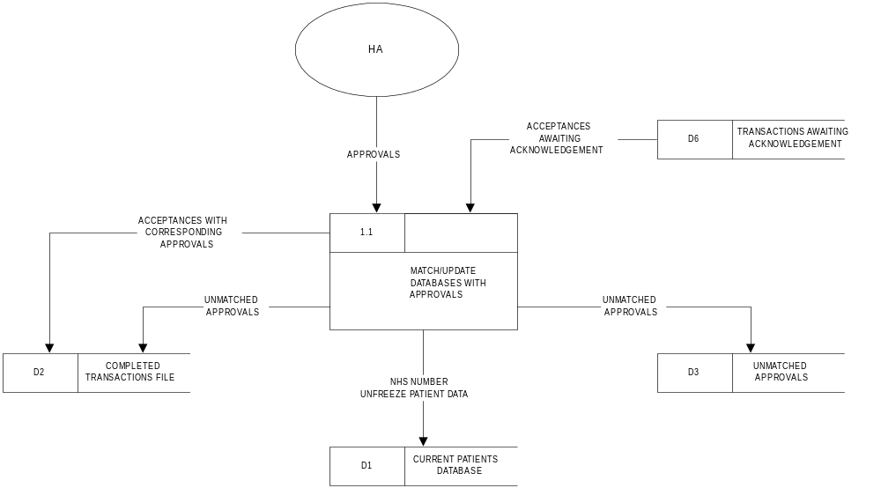

Processing Description and Further Mandatory Requirements

The GP System MUST be capable of receiving and processing Approval transactions generated by an HA in response to previously transmitted patient Acceptance transactions.

The items of information within an Approval transaction from an HA are listed in section 3.16.4.

Approval transactions will not contain the information included within the original Acceptance transaction. However, the Transaction Number of an Approval will be an exact copy of the Transaction Number of the corresponding Acceptance transaction. The GP System will, therefore, have to obtain the original Acceptance transaction details from data stored at the time of the original transmission.

The Approval transactions received MUST be matched (by GP System Transaction Number) directly with the "Transactions awaiting Acknowledgement" file.

For each Approval transaction, if the transaction is matched with the "Transactions awaiting Acknowledgement" file, the following processing MUST occur:
- The resulting matched Approval (an amalgamation of the information on the original Acceptance transaction and the corresponding Approval transaction) MUST be copied to the "Completed Transactions" file.
- The corresponding record within the "Transactions awaiting Acknowledgement" file MUST be removed.
- The "Freeze" flag for the patient within the "Current Patients" database (previously set "on" at the time of the original patient acceptance) MUST be set to "off".
- If the Approval transaction includes an NHS Number, this number MUST be assigned to the patient within the "Current Patients" database.
Note that, after any NHS Number included within the Approval transaction has been applied on the GP System, this NHS Number will be the most up-to-date NHS Number of the patient on the GP System and will, therefore, be used to identify the patient in any subsequent transactions.

If the Approval transaction cannot be matched (for some reason) with the "Transactions awaiting Acknowledgement" file, the following processing MUST occur:
- The unmatched Approval transaction MUST be copied to an error file for investigation by the GP. A view facility on this file MUST be provided (see section 4.3.22).
- The unmatched Approval transaction MUST be copied to the "Completed Transactions" file.

It is recommended that the following information is stored for each received Approval transaction within the "Completed Transactions" file:
- Transaction Type
- GP Code
- Sending HA Cipher
- Transaction Date
- Transaction Time
- Transaction Number
- NHS Number

It is also recommended that matched Approval transactions are stored together with their corresponding Acceptance transactions within the "Completed Transactions" file.

Within Archive files, matched Approval transactions MUST be stored as part of their corresponding Acceptance transaction.

Data Fields - Format - Mandatory Requirements

The following information will be contained within an Approval transaction. Fields marked (M) are mandatory and will always contain a valid, non-null value; fields marked (N-M) are non-mandatory and may or may not contain a non-null value.

Transaction Type (M)
All in-coming Approval transactions received from an HA will be combined within one EDIFACT message.
Within Archive files, the Transaction Type MUST equal "APF" - the Approval transaction being stored as part of the original Acceptance transaction.

GP Code (M)
Within EDIFACT Approval transactions, the GP Code will be the valid GMC National code for the patient's existing GP concatenated with "," concatenated with the "local" code for the patient's GP as known by the sending HA (see section 4.3.7). As such, the GP Code will:
- Have alphanumeric and "," characters only.
- Have a maximum length of 14 characters in the following format:
Characters 1-7 = Fixed 7 numeric character GMC National GP code
Character 8 = comma (,)
Characters 9-14 = 1-6 alphanumeric character Local GP code
- Have alphabetic characters in upper case.
Within Archive files, the GP Code MUST be that received within the Approval transaction.

Sending HA Cipher (M)
Within EDIFACT Approval transactions, the Sending HA Cipher will:
- Be the Cipher of the patient's responsible HA.
- Be a valid HA Cipher; i.e. be a current live England and Wales code from the Table of Valid HA Ciphers (see Appendix D). As such, the Sending HA Cipher will:
- Have alphanumeric characters only.
- Have a maximum length of 3 characters.
- Have alphabetic characters in upper case.
Within Archive files, the Sending HA Cipher MUST be that received within the Approval transaction.

Transaction Date and Time (M)
All in-coming Approval transactions received from an HA will have been combined within one EDIFACT message with a Transaction Date and Time qualifier "137", format "203" - "CCYYMMDDHHMM" within a DTM segment.
Within Archive files, the Transaction Date MUST be in the format "CCYYMMDD" and the Transaction Time in the format "HHMM".

Transaction Number (M)
Within EDIFACT Approval transactions, the Transaction Number will:
- Have numeric characters only.
- Have a maximum length of 7 characters.
- Have a value of a positive integer.
- Be the Transaction Number of the corresponding Acceptance transaction.
Within Archive files, the Transaction Number MUST be that received within the Approval transaction.

NHS Number (N-M)
Within EDIFACT Approval transactions, there may be included an NHS Number (an NHS Number will be included within every Approval transaction for which a different NHS Number was allocated to the patient by the HA when compared to the corresponding Acceptance transaction). This NHS Number will be in one of the acceptable formats detailed in Appendix F, and as such will:
- Have alphanumeric, "?" or "/" characters only.
- Have a maximum length of 15 characters.
- Have alphabetic characters in upper case.
or will be an all-numeric Number of 10 digits including a check digit (the 10th and final digit in the Number).
Within Archive files, the NHS Number MUST be that received within the Approval transaction.

IN-COMING MEDICAL RECORDS FLAG REMOVAL TRANSACTIONS

Overview

When a patient is deducted from a GP's list following the receipt of a Deduction transaction across the Network from that patient's responsible HA, the GP System MUST also automatically "set" a "Medical Records" flag for that patient (unless either: the patient has been Internally Transferred to a different GP in the Partnership; or the patient is remaining within the same Practice, but changing responsible HA following a change of address). This flag, set for a deducted patient, will indicate that the patient's medical records are to be sent to that HA.

The flag MUST remain as "set" on the GP System for that patient until the corresponding Medical Records Flag Removal transaction is received (indicating that the HA has received the medical records from the GP) or removed manually using the relevant "security-controlled" system action (see section 2.2.29).

Medical Records Flag Removal transactions will only be received from HAs with which that GP Practice is "linked" and only if the corresponding patient Deductions were also received by means of Deduction transactions across the Network.

If a GP Practice receives a Deduction transaction for a patient across the Network from an HA, but (for some reason) the HA is unable to send a corresponding Medical Records Flag Removal transaction across the Network, the GP MUST, under advice from the HA, manually remove the "Medical Records" flag using the relevant "security-controlled" system action (see section 2.2.29).

Note that a Medical Records Flag Removal transaction may be received within the same Interchange as its corresponding Deduction transaction. This will occur when an HA deduct a patient having already got possession of that patient's medical records. The GP System MUST be able to handle this situation.

Processing Diagram

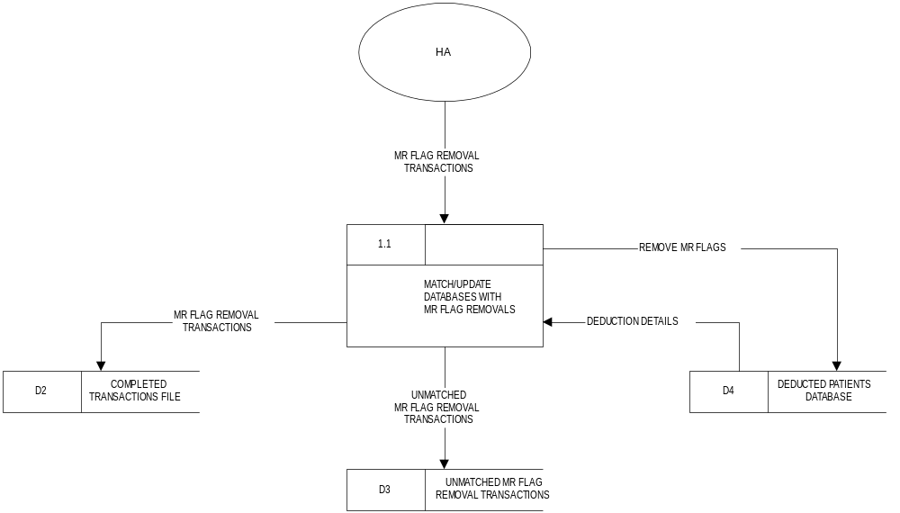

Processing Description and Further Mandatory Requirements

The GP System MUST be capable of receiving and processing Medical Records Flag Removal transactions generated by an HA.

The items of information within a Medical Records Flag Removal transaction from an HA are listed in section 3.17.4.

The Medical Records Flag Removal transactions received MUST be matched (by HA Cipher and HA System Transaction Number of the original Deduction) directly with the "Deducted Patients" database.

For each Medical Records Flag Removal transaction, if the transaction is matched with the "Deducted Patients" database, the following processing MUST occur:
- For the patient corresponding to the received Medical Records Flag Removal transaction, the "Medical Records" flag MUST be removed.
- The matched Medical Records Flag Removal transaction MUST be copied to the "Completed Transactions" file.

If the Medical Records Flag Removal transaction cannot be matched (for some reason) with the "Deducted Patients" database, the following processing MUST occur:
- The unmatched Medical Records Flag Removal transaction MUST be copied to an error file for investigation by the GP. A view facility on this file MUST be provided (see section 4.3.24).
- The unmatched Medical Records Flag Removal transaction MUST be copied to and marked as "unmatched" within the "Completed Transactions" file.

It is recommended that the following information is stored for each received Medical Records Flag Removal transaction within the "Completed Transactions" file:
- Transaction Type
- GP Code
- Sending HA Cipher
- Transaction Date
- Transaction Time
- Transaction Number (equal to the Transaction Number of the corresponding Deduction transaction)
- NHS Number
- Unmatched Marker (indicating whether the received transaction was matched or unmatched on receipt).

The GP System MUST, in some way, report to a GP at regular intervals those deducted patients on the GP System for which a "Medical Records" flag is set in order to prompt the GP to forward the medical records for these patients to the appropriate HAs (see section 4.2).

It should be noted that, if the GP System performs archives on the "Deducted Patients" database, patient records with the "Medical Records" flag set "on" MUST NOT be archived (otherwise the subsequent Medical Records Flag Removal transactions will not locate the corresponding patients on the "Deducted Patients" database).

Data Fields - Format - Mandatory Requirements

The following information will be contained within a Medical Records Flag Removal transaction. Fields marked (M) are mandatory and will always contain a valid, non-null value; fields marked (N-M) are non-mandatory and may or may not contain a non-null value.

Transaction Type (M)
All in-coming Medical Records Flag Removal transactions received from an HA will be combined within one EDIFACT message.
Within Archive files, the Transaction Type MUST equal "MRF".

GP Code (M)
Within EDIFACT Medical Records Flag Removal transactions, the GP Code will be the valid GMC National code for the deducted patient's GP concatenated with "," concatenated with the "local" code for the deducted patient's GP as known by the sending HA (see section 4.3.7). As such, the GP Code will:
- Have alphanumeric and "," characters only.
- Have a maximum length of 14 characters in the following format:
Characters 1-7 = Fixed 7 numeric character GMC National GP code
Character 8 = comma (,)
Characters 9-14 = 1-6 alphanumeric character Local GP code
- Have alphabetic characters in upper case.
Within Archive files, the GP Code MUST be that received within the Medical Records Flag Removal transaction.

Sending HA Cipher (M)
Within EDIFACT Medical Records Flag Removal transactions, the Sending HA Cipher will:
- Be the Cipher of the deducted patient's responsible HA.
- Be a valid HA Cipher, i.e. be a current live England and Wales code from the Table of Valid HA Ciphers (see Appendix D). As such, the Sending HA Cipher will:
- Have alphanumeric characters only.
- Have a maximum length of 3 characters.
- Have alphabetic characters in upper case.
Within Archive files, the Sending HA Cipher MUST be that received within the Medical Records Flag Removal transaction.

Transaction Date and Time (M)
All in-coming Medical Records Flag Removal transactions received from an HA will have been combined within one EDIFACT message with a Transaction Date and Time qualifier "137", format "203" - "CCYYMMDDHHMM" within a DTM segment.
Within Archive files, the Transaction Date MUST be in the format "CCYYMMDD" and the Transaction Time in the format "HHMM".

Transaction Number (M)
Within EDIFACT Medical Records Flag Removal transactions, the Transaction Number will:
- Have numeric characters only.
- Have a maximum length of 7 characters.
- Have a value of a positive integer.
- Be the Transaction Number of the corresponding Deduction transaction.
Within Archive files, the Transaction Number MUST be that received within the Medical Records Flag Removal transaction.

NHS Number (M)
Within EDIFACT Medical Records Flag Removal transactions, the NHS Number will be the existing, most up-to-date NHS Number for that patient on the GP System, and will be in one of the acceptable formats detailed in Appendix F. As such, the NHS Number will:
- Have alphanumeric, "?" or "/" characters only.
- Have a maximum length of 15 characters.
- Have alphabetic characters in upper case.
or will be an all-numeric Number of 10 digits including a check digit (the 10th and final digit in the Number).
Within Archive files, the NHS Number MUST be that received within the Medical Records Flag Removal transaction.

IN-COMING MEDICAL RECORDS SENT TRANSACTIONS

Overview

When an HA receives the medical records for a patient from another HA and then forwards them to a GP Practice, the status of the medical records is recorded on the HA system as "Sent to GP".

The medical records are sometimes, accidentally, sent in error to an incorrect GP Practice, the correct GP Practice never knowing that the HA ever received the records from the patient's previous Practice, and the incorrect GP Practice not knowing that they have received the records in error. The "Medical Records Sent" transaction is intended to try to highlight these errors as they occur.

A "Medical Records Sent" transaction will be automatically generated by an HA system when the status of the medical records of a patient with a GP Practice with which that HA is "linked" is recorded on that system as "Sent to GP". This transaction will then be transmitted to the GP Practice where the medical records are to be sent.

The receipt of this transaction for a patient at the "linked" GP Practice MUST automatically set a "Medical Records Sent" flag for that patient (the date of the transaction MUST also be recorded). This flag will indicate that the patient's medical records are being sent to the Practice from the appropriate HA. The flag MUST remain as "set" on the GP System for that patient until manually reset by the GP, this being undertaken on receipt of the medical records.

Medical Records Sent transactions will only be received from HAs with which that GP Practice is "linked".

Processing Diagram

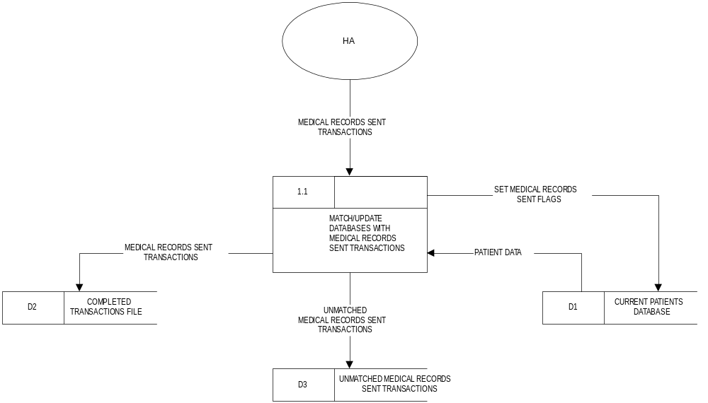

Processing Description and Further Mandatory Requirements

The GP System MUST be capable of receiving and processing Medical Records Sent transactions generated by an HA.

The items of information within a Medical Records Sent transaction from an HA are listed in section 3.18.4.

For each Medical Records Sent transaction, if the transaction is matched with the "Current Patients" database, the following processing MUST occur:
- The "Medical Records Sent" flag MUST be set to "on" for that patient, and the Transaction Date recorded. The flag will indicate that the patient's medical records are being sent to the Practice from the appropriate HA, and MUST remain as "set" on the GP System until manually reset by the GP.
- The matched Medical Records Sent transaction MUST be copied to the "Completed Transactions" file.

If the Medical Records Sent transaction cannot be matched (for some reason) with the "Current Patients" database, the following processing MUST occur:
- The unmatched Medical Records Sent transaction MUST be copied to an error file for investigation by the GP. A view facility on this file MUST be provided (see section 4.3.21).
- The unmatched Medical Records Sent transaction MUST be copied to and marked as "unmatched" within the "Completed Transactions" file.

It is recommended that the following information is stored for each received Medical Records Sent transaction within the "Completed Transactions" file:
- Transaction Type
- GP Code
- Sending HA Cipher
- Transaction Date
- Transaction Time
- Transaction Number
- NHS Number
- Unmatched Marker (indicating whether the received transaction was matched or unmatched on receipt).

A facility MUST be provided allowing the GP to reset the "Medical Records Sent" flag for a patient once he/she has received the medical records from the HA.

A facility MUST also be provided allowing the GP to list those patients having the "Medical Records Sent" flag set between a specified range of dates in order that he/she may establish those records which may have gone astray.

Data Fields - Format - Mandatory Requirements

The following information will be contained within a Medical Records Sent transaction. Fields marked (M) are mandatory and will always contain a valid, non-null value; fields marked (N-M) are non-mandatory and may or may not contain a non-null value.

Transaction Type (M)
All in-coming Medical Records Sent transactions received from an HA will be combined within one EDIFACT message.
Within Archive files, the Transaction Type MUST equal "MRS".

GP Code (M)
Within EDIFACT Medical Records Sent transactions, the GP Code will be the valid GMC National code for the patient's existing GP concatenated with "," concatenated with the "local" code for the patient's GP as known by the sending HA (see section 4.3.7). As such, the GP Code will:
- Have alphanumeric and "," characters only.
- Have a maximum length of 14 characters in the following format:
Characters 1-7 = Fixed 7 numeric character GMC National GP code
Character 8 = comma (,)
Characters 9-14 = 1-6 alphanumeric character Local GP code
- Have alphabetic characters in upper case.
Within Archive files, the GP Code MUST be that received within the Medical Records Sent transaction.

Sending HA Cipher (M)
Within EDIFACT Medical Records Sent transactions, the Sending HA Cipher will:
- Be the Cipher of the patient's responsible HA.
- Be a valid HA Cipher, i.e. be a current live England and Wales code from the Table of Valid HA Ciphers (see Appendix D). As such, the Sending HA Cipher will:
- Have alphanumeric characters only.
- Have a maximum length of 3 characters.
- Have alphabetic characters in upper case.
Within Archive files, the Sending HA Cipher MUST be that received within the Medical Records Sent transaction.

Transaction Date and Time (M)
All in-coming Medical Records Sent transactions received from an HA will have been combined within one EDIFACT message with a Transaction Date and Time qualifier "137", format "203" - "CCYYMMDDHHMM" within a DTM segment.
Within Archive files, the Transaction Date MUST be in the format "CCYYMMDD" and the Transaction Time in the format "HHMM".

Transaction Number (M)
Within EDIFACT Medical Records Sent transactions, the Transaction Number will:
- Have numeric characters only.
- Have a maximum length of 7 characters.
- Have a value of a positive integer.
Within Archive files, the Transaction Number MUST be that received within the Medical Records Sent transaction.

NHS Number (M)
Within EDIFACT Medical Records Sent transactions, the NHS Number will identify the patient to which the transaction belongs and will be in one of the acceptable formats detailed in Appendix F. As such, the NHS Number will:
- Have alphanumeric, "?" or "/" characters only.
- Have a maximum length of 15 characters.
- Have alphabetic characters in upper case.
or will be an all-numeric Number of 10 digits including a check digit (the 10th and final digit in the Number).
Within Archive files, the NHS Number MUST be that received within the Medical Records Sent transaction.

IN-COMING UPLOAD TRANSACTIONS

Overview

See section 3.10.1.

Processing Diagram

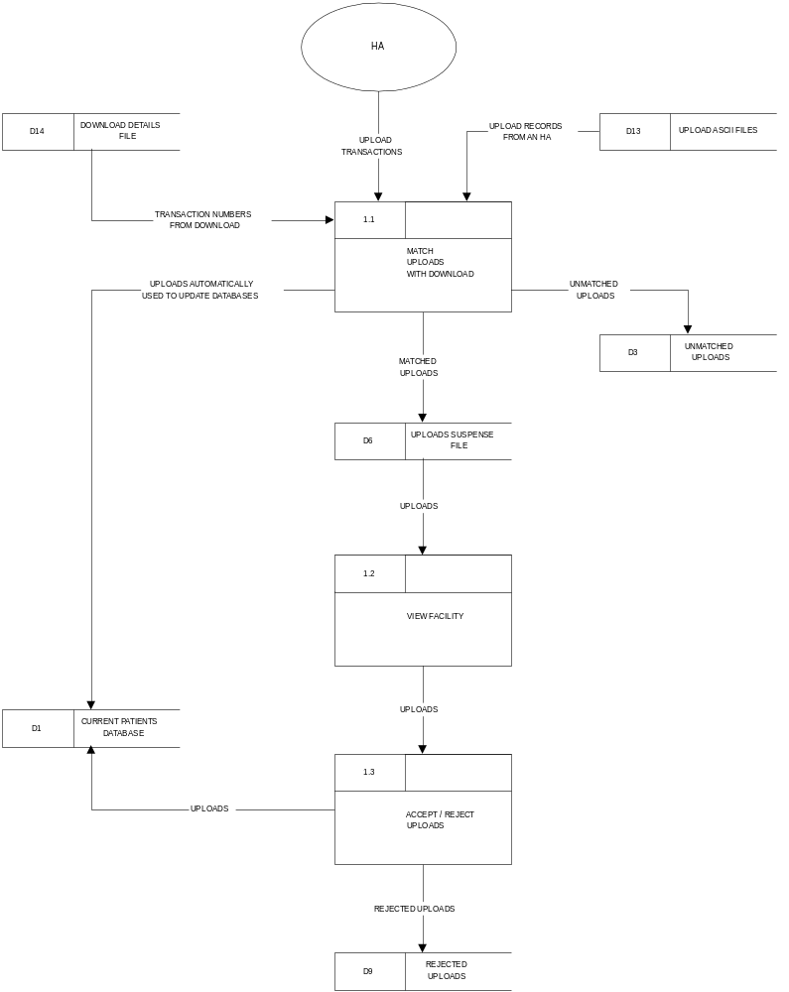

Processing Description and Further Mandatory Requirements

After undertaking a download of a GP Practice's patient database to an HA, that GP Practice will, almost certainly, subsequently receive back from that HA a number of Upload transactions or records.

As for the GP Practice and the download exercise, the HA will be capable of producing the upload to the GP Practice via one of two different media:
- using Upload transactions to be transmitted over the Network, or
- via a flat ASCII file on a floppy disk in DOS format.

The GP System MUST be capable of receiving and processing Upload records and transactions generated by an HA. These may be received over the Network or via floppy disk.

The items of information within an in-coming Upload transaction across the Network or an in-coming Upload record within a flat ASCII file are listed in section 3.19.4.

The format of the flat ASCII file record layout for Upload records to be sent from an HA via a floppy disk is detailed below.

The receipt of an Upload will be accompanied by a corresponding printout detailing all the changes in the Upload. It is envisaged that this printout will help the GP Practice with the task of processing the received Upload transactions/records.

It is recognised that it may not be practical for an HA to upload its reply transactions for a GP Practice across the Network owing to the number of transactions. It is for these occasions that it is recognised that the use of a floppy disk should prove beneficial.

As for in-coming Amendment transactions, for Upload transactions received over the Network, all the "New" information fields will only hold values and hence will only be included within an EDIFACT message if they have been amended by the HA. Similarly, for Upload records received from an HA via a floppy disk, all the "New" information fields will only hold values if they have been amended by the HA; otherwise they will be null.

At least one of the "New" fields will contain a non-null value.

A field containing a single "%" character will be considered to be a particular type of amended field, its purpose being to erase the existing contents of the corresponding field at the GP Practice for that patient (as opposed to a null field indicating that no change to that field is required).

Only certain fields will be able to contain a single "%" character. The data fields stored for a patient on the GP System, corresponding to those fields within an Upload transaction/record that cannot contain a single "%" character, cannot be erased by an Upload transaction/record; they can only be replaced by another, non-null value. The fields that may contain a single "%" character within an Upload transaction/record are indicated by an asterisk ("*") in section 3.19.4.

The Upload transactions/records received MUST be matched (by the original Download Transaction or Record Number) directly with the file where the one-to-one relationship between Download Transaction or Record Number and patient has been retained from the Download process.

For each Upload transaction/record, if the transaction/record is matched with this file, the following processing MUST occur:
- The GP System may, under certain conditions, allow the matched Upload transaction/record to automatically update the "Current Patients" database.
or
- The resulting matched Upload (an amalgamation of the Upload transaction/record and the existing information on the corresponding patient in the "Current Patients" database) MUST be batched by GP within the "Uploads Suspense" file for subsequent viewing and processing.

(It is recommended that the GP System does, under certain conditions, allow for matched Upload transactions/records to automatically update the GP System patient database).

If the Upload transaction/record cannot be matched (for some reason) with this file, the following processing MUST occur:
- The unmatched Upload transaction/record MUST be copied to an error file for investigation by the GP. A view facility on this file MUST be provided (see section 4.3.25).

The GP MUST be able to see how many matched Upload transactions/records he/she has (which he/she has not yet viewed and then deleted) within the "Uploads Suspense" file as a line on the "Transactions View" Screen.

The GP MUST be able to opt to view the Upload transactions/records within the "Uploads Suspense" file, probably from this "Transactions View" Screen.

Having opted to view any Upload transactions/records, the details of each transaction/record MUST be displayed - probably one screen per transaction.

It is recommended that, on this screen, the patient's existing details from the "Current Patients" database are displayed together with the changes included within the Upload transaction/record.

On this screen, the GP System MUST only allow for the GP to:
- Authorise the received Upload transaction/record to update the "Current Patients" database - a default of YES is recommended.
- Reject the received Upload transaction/record.

Note that, if the received Upload transaction/record is rejected, the "Current Patients" database within the GP System MUST NOT be updated by the Upload transaction/record.

If the GP authorises that the Upload transaction/record within the "Uploads Suspense" file may now be used to update the "Current Patients" database:
- The patient details within the "Current Patients" database MUST be updated by the information within the Upload transaction/record.
- The Upload transaction/record within the "Uploads Suspense" file MUST be deleted.

If the GP opts to reject the Upload transaction/record:
- The Upload transaction/record MUST be copied to an "Uploads Rejection" file for subsequent manual reconciliation with the HA. A view facility on this file MUST be provided. Additionally, it is recommended that the GP System allows for the information within this file to be printed as well as viewed. Also, the GP MUST have the facility to remove Upload transactions/records from this "Uploads Rejection" file.
- The Upload transaction/record within the "Uploads Suspense" file MUST be deleted.

It is recommended that Upload transactions/records continue to be displayed, one transaction/record at a time, until the "Uploads Suspense" file has been emptied.

Before the Upload records within an ASCII file, the HA System will create a header record containing the number of physical records within the file.

Upload records to be sent within a flat ASCII file will be physically stored as two records within the file as follows:

Record 1
* Record Type = "UPL"
* Record 1 = "1"
* Existing GP Code
* Destination HA Cipher
* Record Date
* Record Time
* Record Number
New GP Code
Amended NHS Number
New Surname
New First Forename ) combined
New Second Forename ) within one
New Other Forenames ) "Forenames" field
New Previous Surname
New Title
New Sex
New Date of Birth
New Address - House Name
New Address - Number/Road Name

Record 2
* Record Type = "UPL"
* Record 2 = "2"
New Address - Locality
New Address - Post Town
New Address - County
New Address - Postcode
New Drugs Dispensed Marker
New RPP Mileage
New Blocked Route/Special District Marker
New Walking Units
New Residential Institute Code

All fields will be delimited by the "~" character, with the exception of the first and last fields for each physical record which will be only suffixed and prefixed by a "~" character, respectively.

Trailing "~" characters will be present.

Fields marked with an asterisk ("*") will contain a non-null value.

Fields not containing a value will be null.

On the floppy disk, an Upload file will be named in the format AAA1GPR4.XYZ, where:
- AAA is the HA Cipher of the HA from which the Upload has originated.
- X is a "month indicator" (the month in which the Upload was generated), "A" representing January, "B" representing February, ... ,"L" representing December.
- Y is a "day indicator" (the day of the month in which the Upload was generated), "1" representing the 1st, ... ,"9" representing the 9th, "A" representing the 10th, ... ,"V" representing the 31st.
- Z is the character "A".

As an example, if an Upload via disk is produced on 31st March by the HA whose cipher is BRS, one Upload file will be created on the disk - BRS1GPR4.CVA.

Data Fields - Format - Mandatory Requirements

The following information will be contained within an Upload transaction or record. Fields marked (M) are mandatory and will always contain a valid, non-null value; fields marked (N-M) are non-mandatory and may or may not contain a non-null value. Fields marked with an "*" may contain a single "%" character.

Transaction/Record Type (M)
Within ASCII Upload records, the Record Type will equal "UPL".
All in-coming Upload transactions received from an HA will be combined within one EDIFACT message.

Existing GP Code (M)
Within EDIFACT Upload transactions and ASCII Upload records, the Existing GP Code will be the valid GMC National code for the patient's existing GP concatenated with "," concatenated with the "local" code for the patient's GP as known by the sending HA (see section 4.3.7). As such, the GP Code will:
- Have alphanumeric and "," characters only.
- Have a maximum length of 14 characters in the following format:
Characters 1-7 = Fixed 7 numeric character GMC National GP code
Character 8 = comma (,)
Characters 9-14 = 1-6 alphanumeric character Local GP code
- Have alphabetic characters in upper case.

Sending HA Cipher (M)
Within EDIFACT Upload transactions and ASCII Upload records, the Sending HA Cipher will:
- Be the Cipher of the patient's responsible HA.
- Be a valid HA Cipher; i.e. be a current live England and Wales code from the Table of Valid HA Ciphers (see Appendix D). As such, the Sending HA Cipher will:
- Have alphanumeric characters only.
- Have a maximum length of 3 characters.
- Have alphabetic characters in upper case.

Transaction/Record Date and Time (M)
Within ASCII Upload records, the Record Date will be in the format "CCYYMMDD" and the Record Time in the format "HHMM".
All in-coming Upload transactions received from an HA will have been combined within one EDIFACT message with a Transaction Date and Time qualifier "137", format "203" - "CCYYMMDDHHMM" within a DTM segment.

Transaction/Record Number (M)
Within EDIFACT Upload transactions and ASCII Upload records, the Transaction/Record Number will:
- Have numeric characters only.
- Have a maximum length of 7 characters.
- Have a value of a positive integer.
- Be an exact copy of the Transaction/Record Number within the corresponding Download transaction/record.

New GP Code (N-M)
Within EDIFACT Upload transactions and ASCII Upload records, the New GP Code will be the valid GMC National code for the patient's new GP concatenated with "," concatenated with the "local" code for the patient's GP as known by the sending HA (see section 4.3.7). As such, the GP Code will:
- Have alphanumeric and "," characters only.
- Have a maximum length of 14 characters in the following format:
Characters 1-7 = Fixed 7 numeric character GMC National GP code
Character 8 = comma (,)
Characters 9-14 = 1-6 alphanumeric character Local GP code
- Have alphabetic characters in upper case.

Amended NHS Number (N-M)
Within EDIFACT Upload transactions and ASCII Upload records, the Amended NHS Number will be in one of the acceptable formats detailed in Appendix F. As such, the New NHS Number will:
- Have alphanumeric, "?" or "/" characters only.
- Have a maximum length of 15 characters.
- Have alphabetic characters in upper case.
or will be an all-numeric Number of 10 digits including a check digit (the 10th and final digit in the Number).

New Surname (N-M)
Within EDIFACT Upload transactions and ASCII Upload records, the New Surname will:
- Have alphabetic, SPACE, "'" and "-" characters only.
- Have a maximum length of 35 characters.
- Have alphabetic characters in upper case.

New First Forename (N-M) *
Within EDIFACT Upload transactions, the New First Forename MUST:
- Have alphabetic, SPACE, "'", "-" and "." characters only (or a single "%" character).
- Have a maximum length of 35 characters.
- Have alphabetic characters in upper case.
If the value of New First Forename is a single "%" character, this will have the effect of deleting the entire set of Forenames for the patient on the GP system.

New Second Forename (N-M)
Within EDIFACT Upload transactions, the New Second Forename MUST:
- Have alphabetic, SPACE, "'", "-" and "." characters only.
- Have a maximum length of 35 characters.
- Have alphabetic characters in upper case.

New Other Forenames (N-M)
Within EDIFACT Upload transactions, the New Other Forenames MUST:
- Have alphabetic, SPACE, "'", "-" and "." characters only.
- Have a maximum length of 35 characters.
- Have alphabetic characters in upper case.

New Previous Surname (N-M) *
Within EDIFACT Upload transactions and ASCII Upload records, the New Previous Surname will:
- Have alphabetic, SPACE, "'" and "-" characters only (or a single "%" character).
- Have a maximum length of 35 characters.
- Have alphabetic characters in upper case.

New Title (N-M) *
Within EDIFACT Upload transactions and ASCII Upload records, the New Title will:
- Have alphabetic, SPACE, "'" and "." characters only (or a single "%" character).
- Have a maximum length of 35 characters.
- Have alphabetic characters in upper case.

New Sex (N-M)
Within EDIFACT Upload transactions and ASCII Upload records, the New Sex will be "1" for Male, "2" for "Female", "0" for Indeterminate/Unknown or "9" for Not Specified.

New Date of Birth (N-M)
Within ASCII Upload records, the New Date of Birth will be in the format "CCYYMMDD".
Within EDIFACT Upload transactions, the New Date of Birth will have qualifier "329", format "102" - "CCYYMMDD" within a DTM segment.
The received Date of Birth will not be in the future.

New Address - House Name (N-M) *
Within EDIFACT Upload transactions and ASCII Upload records, the New Address - House Name will:
- Have alphanumeric, SPACE, "'", "-", "." and "," characters only (or a single "%" character).
- Have a maximum length of 35 characters.
- Have alphabetic characters in upper case.
The New Address - House Name will only contain the flat number or name of a property (if one exists).

New Address - Number/Road Name (N-M) *
Within EDIFACT Upload transactions and ASCII Upload records, the New Address – Number/Road Name will:
- Have alphanumeric, SPACE, "'", "-", "." and "," characters only (or a single "%" character).
- Have a maximum length of 35 characters.
- Have alphabetic characters in upper case.
The New Address - Number/Road Name will only contain the property number (if one exists) and the road/street name of the property.

New Address - Locality (N-M) *
Within EDIFACT Upload transactions and ASCII Upload records, the New Address - Locality will:
- Have alphanumeric, SPACE, "'", "-", "." and "," characters only (or a single "%" character).
- Have a maximum length of 35 characters.
- Have alphabetic characters in upper case.
The New Address - Locality will only contain the first village/town name/area (if one exists) if different to the property's post town name.

New Address - Post Town (N-M)
Within EDIFACT Upload transactions and ASCII Upload records, the New Address – Post Town will:
- Have alphanumeric, SPACE, "'", "-", "." and "," characters only.
- Have a maximum length of 35 characters.
- Have alphabetic characters in upper case.
The New Address - Post Town will only contain the post town name of the property.

New Address - County (N-M) *
Within EDIFACT Upload transactions and ASCII Upload records, the New Address - County will:
- Have alphanumeric, SPACE, "'", "-", "." and "," characters only (or a single "%" character).
- Have a maximum length of 35 characters.
- Have alphabetic characters in upper case.
The New Address - County will only contain the county of the property.

New Address - Postcode (N-M) *
Within EDIFACT Upload transactions and ASCII Upload records, the New Address -Postcode will:
- Have alphanumeric and SPACE characters only (or a single "%" character).
- Have alphabetic characters in upper case.
- Have a fixed length of 8 characters and be in one of the following six formats:
"AN NAA" For postcodes of the format "AN NAA"
"ANN NAA" For postcodes of the format "ANN NAA"
"AAN NAA" For postcodes of the format "AAN NAA"
"AANN NAA" For postcodes of the format "AANN NAA"
"ANA NAA" For postcodes of the format "ANA NAA"
"AANA NAA" For postcodes of the format "AANA NAA"
with the exception of the case of a single "%" character

New Drugs Dispensed Marker (N-M) *
Within EDIFACT Upload transactions and ASCII Upload records, the New Drugs Dispensed Marker will contain a single upper case "Y" character if being set "on" and a single "%" character if being set "off".

New RPP Mileage (N-M) *
Within EDIFACT Upload transactions and ASCII Upload records, the New RPP Mileage will:
- Have numeric characters only (or a single "%" character).
- Have a maximum length of 2 characters.
- Have a value of a positive integer in the range 3 to 50 (or a single "%" character).

New Blocked Route/Special District Marker (N-M) *
Within EDIFACT Upload transactions and ASCII Upload records, the New Blocked Route/Special District Marker will contain a single upper case "B" or "S" character if being set to "Blocked Route" or "Special District", respectively and a single "%" character if being set "off".

New Walking Units (N-M) *
Within EDIFACT Upload transactions and ASCII Upload records, the New Walking Units will:
- Have numeric characters only (or a single "%" character).
- Have a maximum length of 2 characters.
- Have a value of a positive integer in the range 3 to 99 and be exactly divisible by 3 (or a single "%" character).

New Residential Institute Code (N-M) *
Within EDIFACT Upload transactions and ASCII Upload records, the New Residential Institute Code will:
- be a valid Residential Institute Code; i.e. the Code will be within the Table of Valid Residential Institute Codes for the patient's responsible HA (see section 4.3.4). As such, the New Residential Institute Code will:
- Have alphanumeric characters only (or a single "%" character).
- Have a maximum length of 2 characters.
- Have alphabetic characters in upper case.

IN-COMING CLOSE OF QUARTER NOTIFICATION

Overview

On the HA System, an HA will be able to indicate for each linked Practice whether or not that Practice's System is capable of receiving and processing electronic Close Quarter notifications.

If the HA System indicates that a particular "linked" Practice is capable of receiving and processing electronic Close Quarter transactions, when the Registration Quarter is closed on the HA System, this will be captured and notified to the Practice within a Close Quarter Notification transaction.

The Close of Quarter Processing consists of the Registration Close Quarter Notification (described in section 2.2.26), the Registration Quarterly Archives (section 2.2.27) and Quarterly Certificates and Capitation Reports (section 2.2.28).

Processing Diagram

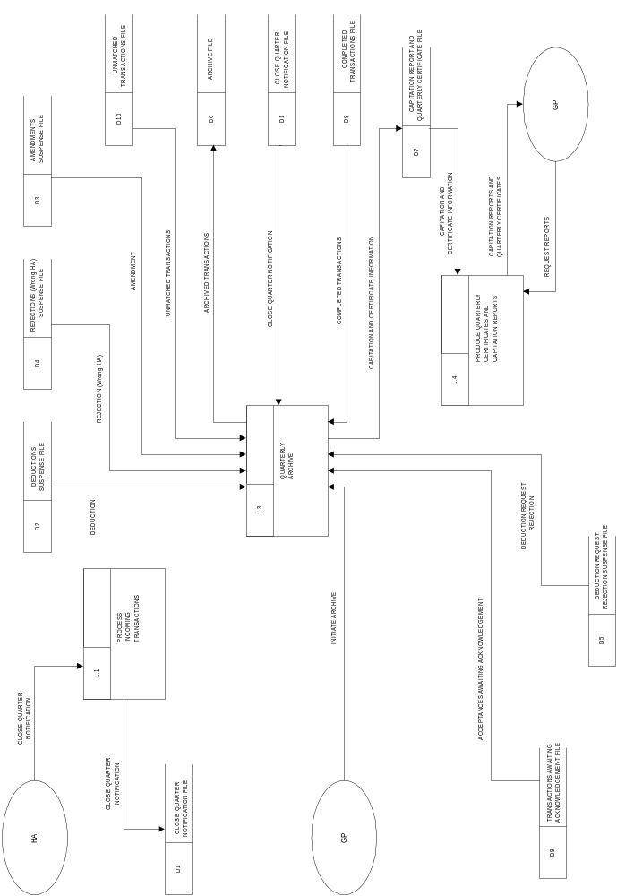

Processing Description and Further Mandatory Requirements

The GP System must be capable of receiving and processing Close Quarter Notification transactions from HAs.

The items of information within a Close Quarter Notification transaction from an HA are listed in section 3.20.4.

On receipt, a Close Quarter Notification transaction must be written to a "Close Quarter Notification" file.

If a Close Quarter Notification transaction from an HA exists within the "Close Quarter Notification" file, and at least one of the following is true, the GP System must advise all system users (either at logon or within some other appropriate part of the GP System) that a Close Quarter Notification has been received from that particular HA and list the reason(s) why the Quarterly Archive for that HA cannot yet be undertaken on the GP System:
- At least one Acceptance transaction exists within the "Transactions Awaiting Acknowledgement" file for a patient of that HA, with an Acceptance Date either prior to or equal to the second day of the new quarter.
- At least one Deduction transaction from that HA exists within the "Deductions Suspense" file with a Date of Deduction either prior to or equal to the last day of the quarter to be archived. All Deduction transactions generated by an HA System up to the time when the HA closes a particular Registration Quarter will always be dated in that old quarter.
- At least one Amendment transaction from that HA exists within the "Amendments Suspense" file, with a Transaction Date either prior to or equal to the second day of the new quarter.
- At least one Rejection (Wrong HA) transaction from that HA exists within the "Rejections (Wrong HA) Suspense" file, with a Transaction Date either prior to or equal to the second day of the new quarter.
- At least one Deduction Request Rejection transaction from that HA exists within the "Deduction Request Rejection Suspense" file, with a Transaction Date either prior to or equal to the second day of the new quarter.

- At least one transaction from that HA exists within one of the following files, with a Transaction Date either prior to or equal to the second day of the new quarter, and the GP System includes a facility allowing for the transaction to be "re-processed":
- "Unmatched Amendments" file.
- "Unmatched Rejections (Wrong HA)" file.
- "Unmatched Approvals" file.
- "Unmatched Medical Records Sent transactions" file.
- "Unmatched Medical Records Flag Removal transactions" file
- "Unmatched FP69 Prior Notification transactions" file
- "Unmatched FP69 Flag Removal transactions" file.
- "Unmatched Deduction Request Rejection transactions" file
- At least one transaction from that HA exists within the "Unmatched Deductions" file, with a Deduction Date either prior to or equal to the last day of the quarter to be archived, and the GP System includes a facility allowing for the transaction to be "re-processed".

If a Close Quarter Notification transaction from an HA exists within the "Close Quarter Notification" file, and none of the other conditions above are true, the GP System must advise all system users (either at logon or within some other appropriate part of the GP System) that the Close Quarter Notification has been received from that particular HA and that the Quarterly Archive for that HA must now be undertaken.

If the system date on the GP System is in the new quarter, the GP System must advise all system users (either at logon or within some other appropriate part of the GP System) of the HA(s) from which a Close Quarter Notification relating to the last quarter has not yet been received.

The GP System must ensure that a quarterly archive cannot be undertaken for an HA until a Close Quarter Notification transaction from that HA exists within the "Close Quarter Notification" file and none of the other conditions given above are true.

However, it is conceivable that a Close Quarter Notification will not be received from an HA (if that HA has not enabled the Close Quarter Notification switch on its system for that Practice). The GP System must, therefore, allow (under high-security) a quarterly archive to be undertaken for an HA without receipt of a Close Quarter Notification transaction; again, none of the other conditions given above must be true.

The GP System must be capable of performing individual quarterly archive processes of the "Completed Transactions" file for each of that Practice's linked HAs.

The quarterly archiving process must generate separate archive files for each HA.

The Registration Quarterly Archive process for a particular HA must write the following from the "Completed Transactions" file to an off-line storage medium:
- For each out-going Acceptance transaction for that HA with an Acceptance Date either prior to or equal to the second day of the new quarter:
- All the data transmitted to the HA from the GP Practice within that Acceptance.
- The associated acknowledgement details - either an Approval or a Rejection (Wrong HA) transaction or a "security-controlled" Approval.
- For each out-going Amendment, Removal (Out of Area) and Deduction Request transaction for that HA with a Transaction Date either prior to or equal to the second day of the new quarter:
- All the data transmitted to the HA from the GP Practice within that transaction.
- For each in-coming Amendment, Medical Records Flag Removal, Medical Records Sent, FP69 Prior Notification, FP69 Flag Removal, Deduction Request Rejection, unmatched Approval and unmatched Rejection (Wrong HA) transaction with a Transaction Date either prior to or equal to the second day of the new quarter:
- All the data transmitted to the GP Practice from the HA within that transaction.
- Any additional information obtained from the GP System patient database relating to the patient corresponding to the received transaction.
- For each in-coming Deduction transaction with a Deduction Date either prior to or equal to the last day of the quarter to be archived:
- All the data transmitted to the GP Practice from the HA within that transaction.
- Any additional information obtained from the GP System patient database relating to the patient corresponding to the received transaction.
- For each "security-controlled" system action dated either prior to or equal to the second day of the new quarter:
- All the data stored for that process.

In addition, the Registration Quarterly Archive process for a particular HA must:
- Remove the corresponding Close Quarter Notification transaction from the "Close Quarter Notification" file.
- Produce Quarterly Certificates. These Certificates represent a summary of the Links Registration activity on the GP System for each GP and each HA with which that GP Practice has registered patients. Each Certificate must exactly match the entries for each GP and each HA archived from the "Completed Transactions" file. The Certificates must match the required format (see Appendix B).
- Produce Quarterly Capitation Reports. These Reports represent a patient capitation breakdown on the GP System of each GP, for each HA with which that GP Practice has registered patients. The Reports must match the required format (see Appendix B).

Note the following:
- Details of every transaction or "security-controlled" system action must only be archived once.
- Although not mandatory, it is recommended that the archiving process physically removes archived transactions and "security-controlled" system actions from the "Completed Transactions" file. If the process does not remove such entries from the "Completed Transactions" file, they must be marked within this file as having been archived.
- Quarterly archives must be taken in sequence. For example, the GP System must prevent a quarter 2 archive for a particular HA being undertaken if the quarter 1 archive for that same HA is still outstanding.
- The archive files must be in "flat" ASCII format to aid portability.
- Entries within the archive files must match the required record formats detailed in Appendix A and in other sections throughout this specification.
- The order of the transactions within the archive files is not dictated by this specification.

It is imperative that the Capitation Reports generated by the GP System for an HA as part of the quarterly archive process exactly match the equivalent Capitation Reports on the HA System. In order that this may be achieved:
- The criteria determining whether or not to include a patient within the Capitation Report should be identical to the criteria determining whether or not a patient is included within a Download; for example:
- A patient marked on the GP System as having been reported as deceased must still be included within a Capitation Report if no Notification of Deduction has yet been received for that patient from the HA.
- A patient marked on the GP System as being treated as a Temporary Resident must not be included within a Capitation Report.
- Patients registered on the GP System with that HA with a Date of Acceptance after the second day of the new quarter must be excluded from the capitation counts (irrespective of whether or not a reply transaction for that patient has been received back from the HA).
This is most important. Immediately after an HA has closed a Registration Quarter, it will start to approve Acceptance transactions from linked Practices dated in the new quarter. It is quite probable, therefore, that a number of Acceptance transactions dated in the new quarter will have been approved on the GP System before the quarterly archive is run; these Acceptances (together with their corresponding replies) will not be archived, and the corresponding patients must not be included in the Capitation counts.
- Patients previously with that HA, and deducted from the GP System with a Date of Deduction either prior to or equal to the last day of the quarter being archived, must be excluded from the capitation counts.
Again, this is most important. Immediately after an HA has closed a Registration Quarter, it will start to generate Deduction transactions with a Deduction Date in the new Registration Quarter. It is quite probable, therefore, that a number of Deduction transactions with Deduction Dates in the new quarter will have been applied to the GP System before the quarterly archive is run; these Deductions will not be archived, and the corresponding patients must still be included in the Capitation counts.

Data Fields – Format/Validation – Mandatory Requirements

The following information will be contained within a Close Quarter Notification transaction. Fields marked (M) are mandatory and will always contain a valid, non-null value; fields marked (N-M) are non-mandatory and may or may not contain a non-null value.

Transaction Type (M)
An in-coming Close Quarter Notification transaction received from an HA will be contained within its own EDIFACT message.

Sending HA Cipher (M)
Within an EDIFACT Close Quarter Notification transaction, the Sending HA Cipher will:
- Be the Cipher of the source HA for the transaction.
- Be a valid HA Cipher; i.e. be a current live England and Wales code from the Table of Valid HA Ciphers (see Appendix D). As such, the Sending HA Cipher will:
- Have alphanumeric characters only.
- Have a maximum length of 3 characters.
- Have alphabetic characters in upper case.

Transaction Date and Time (M)
An in-coming Close Quarter Notification transaction received from an HA will be contained within one EDIFACT message with a Transaction Date and Time qualifier "137", format "203" - "CCYYMMDDHHMM" within a DTM segment.

Transaction Number (M)
Within an EDIFACT Close Quarter Notification transaction, the Transaction Number will:
- Have numeric characters only.
- Have a maximum length of 7 characters.
- Have a value of a positive integer.

Quarter End Date (M)
Within an EDIFACT Close Quarter Notification transaction, the Quarter End Date will not be in the future. and will be one of the following dates: "CCYY0331", "CCYY0630", "CCYY0930" or "CCYY1231". The Quarter End Date qualifier will be "206", format "102" - "CCYYMMDD" within a DTM segment.

Status Indicator (M)
Within an EDIFACT Close Quarter Notification transaction, the Status Indicator will contain the character "Q".

IN-COMING FP69 PRIOR NOTIFICATIONS

Overview

On the HA System, an FP69 status is allocated to a patient if, for some reason, there is some doubt as to whether that patient actually still lives within the area covered by that patient's GP's Practice. This may be as a result of any of the following:
- An item of mail from that HA for that patient (sent to the address stored for that patient on the HA System) has been returned by the Post Office's "Dead Letter" Office as "unable to be delivered".
- The patient fails to respond to correspondence sent by the HA.
- NHSCR are unable to trace a patient.
- The HA receives notification from the Post Office of the destruction of a property.
- A database reconciliation exercise.
- A patient has a temporary NHS Number on the HA System for a certain period of time.
- The HA is notified of the multiple occupancy of a place of residence.

For HAs with which the GP Practice is "linked", the establishment of an FP69 status may be advised to the GP Practice by a printed FP69 form and/or an FP69 Prior Notification transaction across the Network.

For HAs with which the GP Practice is "manual", the establishment of an FP69 status will be advised to the GP Practice via a printed FP69 form.

Based on any information received from the Practice, the HA will decide whether or not to remove the FP69 status against the patient or immediately deduct the patient from the HA System.

If the HA neither removes the FP69 status for the patient nor immediately deducts the patient when the FP69 Expiry Date for that patient elapses, he/she will be automatically deducted from the HA System. This deduction will be notified to the Practice within a Deduction transaction with a Deduction Code of "14 - Returned Undelivered".

Processing Diagrams

Overview of FP69 Processing

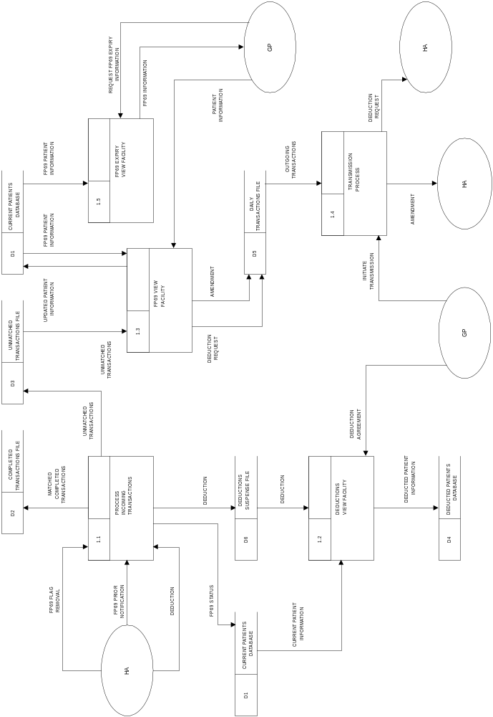

Processing Diagram

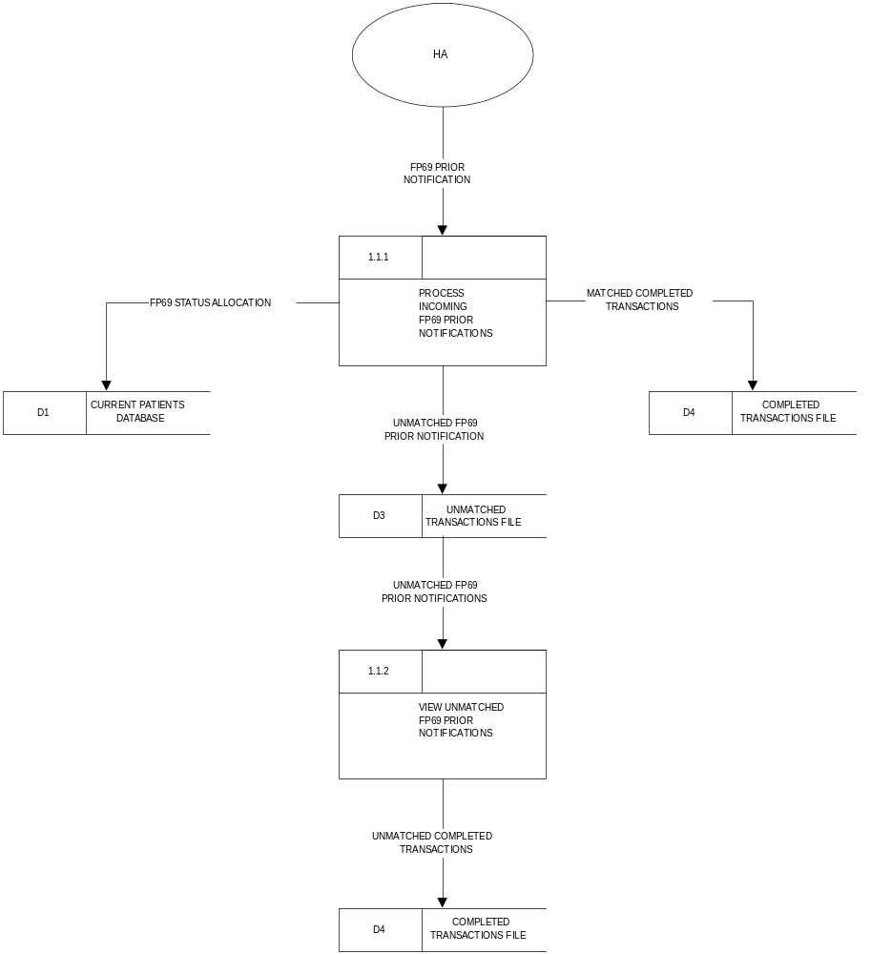

Processing Description and Further Mandatory Requirements

The GP System must be capable of receiving and processing FP69 Prior Notification transactions from HAs.

The items of information within an FP69 Prior Notification transaction from an HA are listed in section 3.21.4.

The received FP69 Prior Notification transactions must be matched (on HA Cipher and patient NHS Number) with the "Current Patients" database within the GP System.

For each FP69 Prior Notification transaction, if the transaction is matched with the "Current Patients" database, the following processing must occur:
- An FP69 status must be allocated to the patient corresponding to the FP69 Prior Notification transaction. The details included within the FP69 Prior Notification transaction must also be stored against the patient for subsequent use when displaying the details of patients on the GP System for which an FP69 status has been set.
- The matched FP69 Prior Notification transaction must be copied to the "Completed Transactions" file.

If the FP69 Prior Notification transaction cannot be matched (for some reason) with the "Current Patients" database, the following processing must occur:
- The unmatched FP69 Prior Notification transaction must be copied to an error file (the "Unmatched FP69 Prior Notifications transactions" file) for investigation by the GP.
A view facility on this file must be provided allowing a GP to list all the unmatched FP69 Prior Notification transactions within that file.
It is recommended that the GP System allows for:
- The unmatched FP69 Prior Notification transactions for all GPs to be displayed or for just one particular GP.
- The unmatched FP69 Prior Notification transactions within a specific date range to be displayed.
- The unmatched FP69 Prior Notification transaction for a specific patient to be displayed.
- This information to be printable as well as viewed.
The GP System must also allow a GP to delete transactions from within this file once they have been investigated.
Alternatively, the GP System may include a facility allowing for an FP69 Prior Notification transaction placed in this file to be "re-processed". Such a facility must not allow the details of the transaction to be amended in any way but would remove the transaction from this file and process it as if it had just been received into the GP Practice. Clearly, if such a facility is included, an unmatched FP69 Prior Notification transaction must not be copied to the "Completed Transactions" file until the GP has either successfully re-processed the transaction or decided to delete the transaction from the file.
- The unmatched FP69 Prior Notification transaction must be copied to and marked as "unmatched" within the "Completed Transactions" file.

It is recommended that the following information is stored for each received FP69 Prior Notification transaction within the "Completed Transactions" file:
- Transaction Type
- GP Code
- Sending HA Cipher
- Transaction Date
- Transaction Time
- Transaction Number
- NHS Number
- Surname
- First Forename
- Second Forename
- Other Forenames
- Date of Birth
- Address - 5 fields
- Postcode
- FP69 Expiry Date
- Reason Code
- HA Notes
- Unmatched Marker (indicating whether the received transaction was matched or unmatched on receipt).

The GP System must provide at least two different views on patients within the "Current Patients" database for which an FP69 status has been set by the HA.

The first of these views must allow the GP to view the details of all patients within the "Current Patients" database having an FP69 status for which the FP69 Expiry Date is less than 14 days from today's date. (Note that it will be possible for patients to exist within the "Current Patients" database with an FP69 status set and an FP69 Expiry Date in the past.) For each such patient, this view facility must indicate whether the GP Practice has already:
- Confirmed to the HA that the patient should remain on the GP's list (additionally providing the date that a confirmation was last sent).
- Requested that the patient is deducted from the GP's list (additionally providing the date that a deduction request was last sent).

The second of these views must allow the GP to view the details of a specific patient within the "Current Patients" database having an FP69 status. Within this view facility, it is strongly recommended that both the existing registration details for that patient from the "Current Patients" database are displayed as well as the patient details included within the FP69 Prior Notification transaction.

From this view/edit facility, the GP must be able to:
- Confirm to the HA that the patient should remain on the GP's list.
- Request that the patient is deducted from the GP's list.
- Take no action.

If the GP opts to confirm to the HA that the patient should remain on the GP's list:
- The GP System must allow the GP to amend the following items of patient information on the screen:
- Surname
- First Forename
- Second Forename
- Other Forenames
- Previous Surname
- Title
- Sex
- Date of Birth
- Address (5 fields)
- Postcode
- Drugs Dispensed Marker
- RPP Mileage
- Blocked Route/Special District Marker
- Walking Units
- Residential Institute Code
Once any required changes have been made, the GP System must then create an Amendment transaction to be sent to the patient's responsible HA (see section 3.8). Within this Amendment transaction, the current values (where known) for all the following items of patient information from the "Current Patients" database must be included:
- NHS Number
- GP Code
- Surname
- First Forename
- Second Forename
- Other Forenames
- Previous Surname
- Title
- Sex
- Date of Birth
- Address (5 fields)
- Postcode
- Drugs Dispensed Marker
- RPP Mileage
- Blocked Route/Special District Marker
- Walking Units
- Residential Institute Code
Note that, if the value held for any of the above fields is removed on this screen, the "%" character should be advised to the HA in these fields within the Amendment.

- The GP System must record against the patient the fact that an Amendment for that patient has been forwarded to the HA as a response to the FP69 Prior Notification together with that day's date. These are required for the view facilities on the details of patients within the "Current Patients" database having an FP69 status.
- Note the following:
- Any amendments made to the patient registration information within the "Current Patients" database via this screen must be validated at the point of data entry. This data entry validation will ensure that no Amendments to be sent across the Network will fail the process of translation to/from EDIFACT format, and that the Amendment details may always be applied to the HA database without alteration.
- An additional input field (GP Notes) must be provided within this view facility allowing the GP to enter an item of free text to accompany the Amendment transaction. Again, any value entered within this field must be validated at the point of data entry.
- Every Amendment transaction generated from this view facility must contain an item of free text commencing with the characters "FP69".
- If the current/updated address for the patient stored on the GP System exactly matches that received within the FP69 Prior Notification transaction from the HA, the completion of the GP Notes field within this view facility will be mandatory; otherwise completion of this field will be optional. Any GP Notes entered must be appended to the characters "FP69" and included within the free text within the Amendment transaction.
- It is strongly recommended that the view facility suggests that the following information be included within the GP Notes, if applicable:
- The date the patient was last seen by the Practice.
- Any reason as to why the patient may not have responded to correspondence received from the HA.
- Details of the captured Amendment must be stored within the "Daily Transactions" file awaiting subsequent transmission. (For details of the subsequent processing for Out-going Amendment transactions, see section 3.5.3.)

If the GP opts to request that the patient is deducted from the GP's list:
- The GP System must prompt the GP to provide the HA with a reason for the Deduction Request; this reason must be one of the following:
- Death of Patient
- Patient Left Area
- Patient Embarkation
- The GP System must then create a Deduction Request transaction to be sent to the patient's responsible HA.
- The GP System must record against the patient the fact that a Deduction Request for that patient has been forwarded to the HA as a response to the FP69 Prior Notification together with that day's date. These are required for the view facilities on the details of patients within the "Current Patients" database having an FP69 status.
- Note the following:
- An additional input field (GP Notes) must be provided within this view facility allowing the GP to enter an item of free text to accompany the Deduction Request transaction. Completion of this field will be mandatory if the reason for the Deduction Request is either Patient Left Area or Patient Embarkation. Any value entered within this field must be validated at the point of data entry.
- Details of the captured Deduction Request must be stored within the "Daily Transactions" file awaiting subsequent transmission. (For details of the subsequent processing for Out-going Deduction Request transactions, see section 3.11.3.)

When a GP opts to view the details of a specific patient within the "Current Patients" database having an FP69 status, this second view facility must indicate whether the GP Practice has already:
- Confirmed to the HA that the patient should remain on the GP's list (additionally providing the date that a confirmation was last sent).
- Requested that the patient be deducted from the GP's list (additionally providing the date that a deduction request was last sent).

Data Fields – Format Mandatory Requirements

The following information will be contained within an FP69 Prior Notification transaction. Fields marked (M) are mandatory and will always contain a valid, non-null value; fields marked (N-M) are non-mandatory and may or may not contain a non-null value.

Transaction Type (M)
All in-coming FP69 Prior Notification transactions received from an HA will be combined within their own EDIFACT message.
Within Archive files, the Transaction Type must equal "FPN".

GP Code (M)
Within EDIFACT FP69 Prior Notification transactions, the GP Code will be the valid GMC National GP Code concatenated with "," concatenated with the "local" code for the patient's GP as known by the sending HA (see section 4.3.7). The GP Code will:
- Have alphanumeric and "," characters only.
- Have a maximum length of 14 characters in the following format:
Characters 1-7 = Fixed 7 numeric character GMC National GP Code
Character 8 = comma (,)
Characters 9-14 = 1-6 alphanumeric Local GP Code
- Have alphabetic characters in upper case.
Within Archive files, the GP Code must be that received within the FP69 Prior Notification transaction.

Sending HA Cipher (M)
Within EDIFACT FP69 Prior Notification transactions, the Sending HA Cipher will:
- Be the Cipher of the patient's responsible HA.
- Be a valid HA Cipher, i.e. be a current live England and Wales code from the Table of Valid HA Ciphers (see Appendix D). As such, the Sending HA Cipher will:
- Have alphanumeric characters only.
- Have a maximum length of 3 characters.
- Have alphabetic characters in upper case.
Within Archive files, the Sending HA Cipher must be that received within the FP69 Prior Notification transaction.

Transaction Date and Time (M)
Within Archive files, the Transaction Date must be in the format "CCYYMMDD" and the Transaction Time in the format "HHMM".
All in-coming FP69 Prior Notification transactions received from an HA will be combined within one EDIFACT message with a Transaction Date and Time qualifier "137", format "203" - "CCYYMMDDHHMM" within a DTM segment.

Transaction Number (M)
Within EDIFACT FP69 Prior Notification transactions, the Transaction Number will:
- Have numeric characters only.
- Have a maximum length of 7 characters.
- Have a value of a positive integer.
Within Archive files, the Transaction Number must be that received within the FP69 Prior Notification transaction.

NHS Number (M)
Within EDIFACT FP69 Prior Notification transactions, the NHS Number will identify the patient to which the transaction belongs and will be in one of the acceptable formats detailed within Appendix F. As such, the NHS Number will:
- Have alphanumeric, "?" or "/" characters only.
- Have a maximum length of 15 characters.
- Have alphabetic characters in upper case.
or will be a 10-digit number, including a check digit as the 10th and final digit.
Within Archive files, the NHS Number must be that received within the FP69 Prior Notification transaction.

Surname (M)
Within EDIFACT FP69 Prior Notification transactions, the Surname will:
- Have alphabetic, SPACE, "'" and "-" characters only.
- Have a maximum length of 35 characters.
- Have alphabetic characters in upper case.
Within Archive files, the Surname must be that received within the FP69 Prior Notification transaction.

First Given Forename (M)
Within EDIFACT FP69 Prior Notification transactions, the First Given Forename will:
- Have alphabetic, SPACE, "'", "-" and "." characters only.
- Have a maximum length of 35 characters.
- Have alphabetic characters in uppercase.
Within Archive files, the First Given Forename must be that received within the FP69 Prior Notification transaction.

Second Forename (N-M)
Within EDIFACT FP69 Prior Notification transactions, the Second Forename will:
- Have alphabetic, SPACE, "'", "-" and "." characters only.
- Have a maximum length of 35 characters.
- Have alphabetic characters in uppercase.
Within Archive files, the Second Forename must be that received within the FP69 Prior Notification transaction.

Other Forenames (N-M)
Within EDIFACT FP69 Prior Notification transactions, the Other Forenames will:
- Have alphabetic, SPACE, "'", "-" and "." characters only.
- Have a maximum length of 35 characters.
- Have alphabetic characters in uppercase.
Within Archive files, the Other Forenames must be those received within the FP69 Prior Notification transaction.

Date of Birth (M)
Within EDIFACT FP69 Prior Notification transactions, the Date of Birth will have a qualifier "329", format "102" - "CCYYMMDD" within a DTM segment.
Within Archive files, the Date of Birth must be that received within the FP69 Prior Notification transaction and in the format "CCYYMMDD".
The received Date of Birth will not be in the future.

Address - House Name (N-M)
Within EDIFACT FP69 Prior Notification transactions, the Address - House Name will:
- Have alphanumeric, SPACE, "'", "-", "." and "," characters only.
- Have a maximum length of 35 characters.
- Have alphabetic characters in uppercase.
Within Archive files, the Address - House Name must be that received within the FP69 Prior Notification transaction.

Address - Number/Road Name (N-M)
Within EDIFACT FP69 Prior Notification transactions, the Address – Number/Road Name will:
- Have alphanumeric, SPACE, "'", "-", "." and "," characters only.
- Have a maximum length of 35 characters.
- Have alphabetic characters in uppercase.
Within Archive files, the Address - Number/Road Name must be that received within the FP69 Prior Notification transaction.

Address - Locality (N-M)
Within EDIFACT FP69 Prior Notification transactions, the Address - Locality will:
- Have alphanumeric, SPACE, "'", "-", "." and "," characters only.
- Have a maximum length of 35 characters.
- Have alphabetic characters in upper case.
Within Archive files, the Address - Locality must be that received within the FP69 Prior Notification transaction.

Address - Post Town (M)
Within EDIFACT FP69 Prior Notification transactions, the Address – Post Town will:
- Have alphanumeric, SPACE, "'", "-", "." and "," characters only.
- Have a maximum length of 35 characters.
- Have alphabetic characters in upper case.
Within Archive files, the Address - Post Town must be that received within the FP69 Prior Notification transaction.

Address - County (N-M)
Within EDIFACT FP69 Prior Notification transactions, the Address - County will:
- Have alphanumeric, SPACE, "'", "-", "." and "," characters only.
- Have a maximum length of 35 characters.
- Have alphabetic characters in upper case.
Within Archive files, the Address - County must be that received within the FP69 Prior Notification transaction.

Address - Postcode (N-M)
Within EDIFACT FP69 Prior Notification transactions, the Address - Postcode will:
- Have alphanumeric and SPACE characters only.
- Have alphabetic characters in upper case.
- Have a fixed length of 8 characters and be in one of the following six formats:
"AN NAA" For postcodes of the format "AN NAA"
"ANN NAA" For postcodes of the format "ANN NAA"
"AAN NAA" For postcodes of the format "AAN NAA"
"AANN NAA" For postcodes of the format "AANN NAA"
"ANA NAA" For postcodes of the format "ANA NAA"
"AANA NAA" For postcodes of the format "AANA NAA"
Within Archive files, the Address - Postcode must be that received within the FP69 Prior Notification transaction.

FP69 Expiry Date (M)
Within EDIFACT FP69 Prior Notification transactions, the FP69 Expiry Date will have a qualifier "962", format "102" - "CCYYMMDD" within a DTM segment.
Within Archive files, the FP69 Expiry Date must be that received within the FP69 Prior Notification transaction and in the format "CCYYMMDD".

Reason Code (M)
Within EDIFACT FP69 Prior Notification transactions, the Reason Code will:
- Have a single numeric character only.
- Have a value of a positive integer in the range 1 to 8.
These possible values are:
1 No Response to Correspondence
2 Correspondence return by "Dead Letter" Office
3 NHSCR unable to trace patient
4 HA has received Notification of Property Destruction
5 Database Reconciliation
6 Patient maintained on HA System with Temporary NHS Number
7 Multiple Occupancy of Property
8 Other Reason
Within Archive files, the Reason Code must be that received within the FP69 Prior Notification transaction.

HA Notes (N-M)
Within EDIFACT FP69 Prior Notification transactions, the HA Notes will:
- Only contain characters within the EDIFACT Level A character set.
- Have a maximum length of 60 characters.
- Have alphabetic characters in upper case.
Within Archive files, the HA Notes must be those received within the FP69 Prior Notification transaction.

IN-COMING FP69 FLAG REMOVAL TRANSACTIONS

Overview

On the HA System, whenever the FP69 status previously allocated to a patient registered with a GP within a "linked" Practice is removed (other than by the deduction of the patient from the HA patient database), this change will be captured and notified to the Practice within an FP69 Flag Removal transaction.

On the HA System, the FP69 status against a patient will be removed by:
- Changing the patient's address on the HA System.
- Manually removing the patient's FP69 status.
- Deducting the patient.

Only in the first two cases will the change of FP69 status be captured and notified to the GP Practice.

Note that a GP Practice will only receive an FP69 Flag Removal transaction from an HA for a patient if an FP69 Prior Notification transaction was also previously received for that patient from that HA.

Processing Diagram

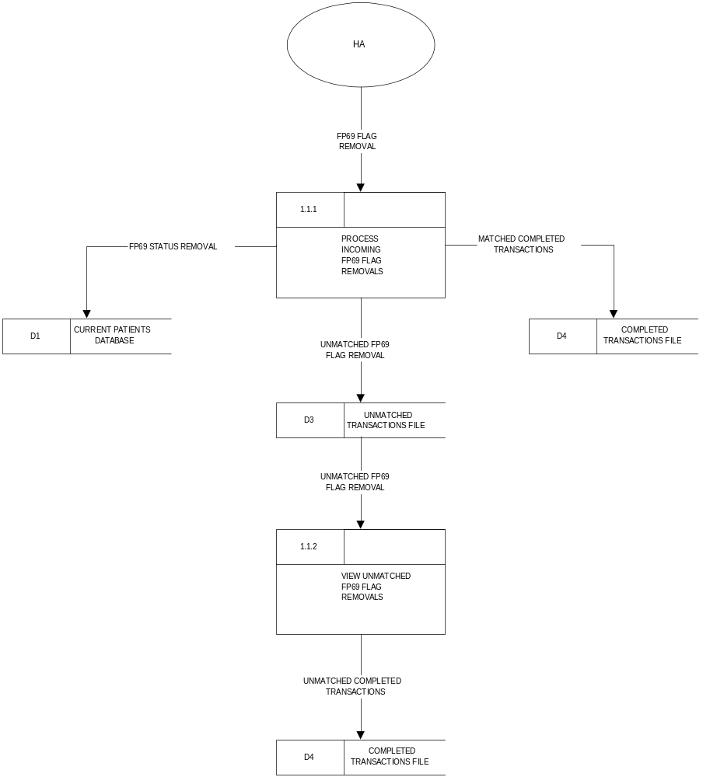

Processing Description and Further Mandatory Requirements

The GP System must be capable of receiving and processing FP69 Flag Removal transactions generated by an HA. The items of information within an FP69 Flag Removal transaction from an HA are listed in section 3.22.4.

The received FP69 Flag Removal transactions must be matched (on HA Cipher and patient NHS Number) with the "Current Patients" database within the GP System.

For each FP69 Flag Removal transaction, if the transaction is matched with the "Current Patients" database, the following processing must occur:
- The FP69 status previously allocated to the corresponding patient within the "Current Patients" database must be removed.
- The matched FP69 Flag Removal transaction must be copied to the "Completed Transactions" file.

If the FP69 Flag Removal transaction cannot be matched (for some reason) with the "Current Patients" database, the following processing must occur:
- The unmatched FP69 Flag Removal transaction must be copied to an error file (the "Unmatched FP69 Flag Removal transactions" file) for investigation by the GP.
A view facility on this file must be provided allowing a GP to list all the unmatched FP69 Flag Removal transactions within that file.
It is recommended that the GP System allows for:
- The unmatched FP69 Flag Removal transactions for all GPs, or for just one particular GP, to be displayed.
- The unmatched FP69 Flag Removal transactions within a specific date range to be displayed.
- The unmatched FP69 Flag Removal transaction for a specific patient to be displayed.
- This information to be printable as well as viewed.
The GP System must also allow a GP to delete transactions from within this file once they have been investigated.
Alternatively, the GP System may include a facility allowing for an FP69 Flag Removal transaction placed in this file to be "re-processed". Such a facility must not allow the details of the transaction to be amended in any way but would remove the transaction from this file and process it as if it had just been received into the GP Practice. Clearly, if such a facility is included, an unmatched FP69 Flag Removal transaction must not be copied to the "Completed Transactions" file until the GP has either successfully re-processed the transaction or decided to delete the transaction from the file.
- The unmatched FP69 Flag Removal transaction must be copied to and marked as "unmatched" within the "Completed Transactions" file.

It is recommended that the following information is stored for each received FP69 Flag Removal transaction within the "Completed Transactions" file:
- Transaction Type
- GP Code
- Sending HA Cipher
- Transaction Date
- Transaction Time
- Transaction Number
- NHS Number
- Unmatched Marker (indicating whether the received transaction was matched or unmatched on receipt).

Data Fields – Format Mandatory Requirements

The following information will be contained within an FP69 Flag Removal transaction. Fields marked (M) are mandatory and will always contain a valid, non-null value; fields marked (N-M) are non-mandatory and may or may not contain a non-null value.

Transaction Type (M)
All in-coming FP69 Flag Removal transactions received from an HA will be combined within their own EDIFACT message.
Within Archive files, the Transaction Type must equal "FFR".

GP Code (M)
Within EDIFACT FP69 Flag Removal transactions, the GP Code will be the valid GMC National GP Code concatenated with "," concatenated with the "local" code for the patient's GP as known by the sending HA (see section 4.3.7). The GP Code will:
- Have alphanumeric and "," characters only.
- Have a maximum length of 14 characters in the following format:
Characters 1-7 = Fixed 7 numeric character GMC National GP Code
Character 8 = comma (,)
Characters 9-14 = 1-6 alphanumeric Local GP Code
- Have alphabetic characters in upper case.
Within Archive files, the GP Code must be that received within the FP69 Flag Removal transaction.

Sending HA Cipher (M)
Within EDIFACT FP69 Flag Removal transactions, the Sending HA Cipher will:
- Be the Cipher of the patient's responsible HA.
- Be a valid HA Cipher, i.e. be a current live England and Wales code from the Table of Valid HA Ciphers (see Appendix D). As such, the Sending HA Cipher will:
- Have alphanumeric characters only.
- Have a maximum length of 3 characters.
- Have alphabetic characters in upper case.
Within Archive files, the Sending HA Cipher must be that received within the FP69 Flag Removal transaction.

Transaction Date and Time (M)
All in-coming FP69 Flag Removal transactions received from an HA will be combined within one EDIFACT message with a Transaction Date and Time qualifier "137", format "203" - "CCYYMMDDHHMM" within a DTM segment.
Within Archive files, the Transaction Date must be in the format "CCYYMMDD" and the Transaction Time in the format "HHMM".

Transaction Number (M)
Within EDIFACT FP69 Flag Removal transactions, the Transaction Number will:
- Have numeric characters only.
- Have a maximum length of 7 characters.
- Have a value of a positive integer.
Within Archive files, the Transaction Number must be that received within the FP69 Flag Removal transaction.

NHS Number (M)
Within EDIFACT FP69 Flag Removal transactions, the NHS Number will identify the patient to which the transaction belongs and will be in one of the acceptable formats detailed within Appendix F. As such, the NHS Number will:
- Have alphanumeric, "?" or "/" characters only.
- Have a maximum length of 15 characters.
- Have alphabetic characters in upper case.
or will be a 10-digit number, including a check digit as the 10th and final digit.
Within Archive files, the NHS Number must be that received within the FP69 Flag Removal transaction.

IN-COMING DEDUCTION REQUEST REJECTION TRANSACTIONS

Overview

On the HA system, the receipt of a Deduction Request transaction (see section 3.11) will, under normal circumstances, be processed in one of two ways. Either:
- the transaction will be used to update the HA patient database, and a Deduction transaction for the patient will be generated for notification back to the GP Practice (see section 3.14); or
- the transaction will be rejected, and a Deduction Request Rejection transaction for the patient will be generated for notification back to the GP Practice.

A Deduction Request Rejection transaction can only be generated in response to a Deduction Request transaction, which means that a Deduction Request Rejection will only be received from a "linked" HA.

Processing Diagram

Processing Description

The items of information within a Deduction Request Rejection transaction from an HA are listed in section 3.23.4.

The GP System must be capable of receiving and processing Deduction Request Rejection transactions generated by an HA in response to previously transmitted Deduction Request transactions.

The received Deduction Request Rejection transactions must be matched (on HA Cipher and NHS Number) with the "Current Patients" database within the GP System.

For each Deduction Request Rejection transaction, if the transaction is matched with the "Current Patients" database, the following processing must occur:
- The resulting matched Deduction Request Rejection transaction must be batched within the "Deduction Request Rejections Suspense" file for subsequent viewing and processing.

If the Deduction Request Rejection transaction cannot be matched (for some reason) with the "Current Patients" database, the following processing must occur:
- The unmatched Deduction Request Rejection transaction must be copied to an error file (the "Unmatched Deduction Request Rejection transactions" file) for investigation by the GP.
A view facility on this file must be provided allowing a GP to list all the unmatched Deduction Request Rejection transactions within that file.
It is recommended that the GP System allows for:
- The unmatched Deduction Request Rejection transactions, for all GPs or for just one particular GP, to be displayed.
- The unmatched Deduction Request Rejection transactions within a specific date range to be displayed.
- The unmatched Deduction Request Rejection transaction for a specific patient to be displayed.
- This information to be printable as well as viewed.
The GP System must also allow a GP to delete transactions from within this file once they have been investigated.
Alternatively, the GP System may include a facility allowing for a Deduction Request Rejection transaction placed in this file to be "re-processed". Such a facility must not allow the details of the transaction to be amended in any way but would remove the transaction from this file and process it as if it had just been received into the GP Practice. Clearly, if such a facility is included, an unmatched Deduction Request Rejection transaction must not be copied to the "Completed Transactions" file until the GP has either successfully re-processed the transaction or decided to delete the transaction from the file.

- The unmatched Deduction Request Rejection transaction must be copied to and marked as "unmatched" within the "Completed Transactions" file.

The GP must be able to see how many matched Deduction Request Rejection transactions he/she has (which he/she has not yet viewed and then deleted) within the "Deduction Request Rejections Suspense" file.

The GP must be able to opt to view the Deduction Request Rejection transactions within the "Deduction Request Rejections Suspense" file.

If the GP has opted to view any Deduction Request Rejection transactions, the details of each transaction must be displayed - probably one screen per transaction.

It is recommended that, on this screen, some of the patient's details from the "Current Patients" database are displayed (to identify the patient), together with the information included within the Deduction Request Rejection transaction (which must include the reason why the HA rejected the Deduction Request from the GP Practice).

On this screen, the GP System must allow for the GP to authorise the received Deduction Request Rejection to be applied to the "Current Patients" database.

If the GP authorises that the Deduction Request Rejection transaction within the "Deduction Request Rejections Suspense" file may be used to update the "Current Patients" database:
- The "Deduction Requested" status of the patient in the "Current Patients" database must be removed.
- The matched Deduction Request Rejection must be copied to the "Completed Transactions" file.
- The Deduction Request Rejection in the "Deduction Request Rejections Suspense" file must be deleted.

It is recommended that Deduction Request Rejection transactions continue to be displayed, one transaction at a time, until the "Deduction Request Rejections Suspense" file has been emptied.

It is recommended that the following information is stored for each received Deduction Request Rejection transaction within the "Completed Transactions" file:
- Transaction Type
- GP Code
- Sending HA Cipher
- Transaction Date
- Transaction Time
- Transaction Number
- NHS Number
- Free Text
- Unmatched Marker (indicating whether the received transaction was matched or unmatched on receipt).

Deduction Request Rejection Data Fields – Format/Validation

The following information will be contained within a Deduction Request Rejection transaction. Fields marked (M) are mandatory, and will always contain a valid, non-null value. Fields marked (N-M) are non-mandatory, and may or may not contain a non-null value.

Transaction Type (M)
All in-coming Deduction Request Rejection transactions received from an HA will be combined within their own EDIFACT message.
Within Archive files, the Transaction Type must equal "DRR".

GP Code (M)
Within EDIFACT Deduction Request Rejection transactions, the GP Code will be the valid GMC National code for the patient's GP concatenated with "," concatenated with the "local" code for the patient's GP as known by the sending HA (see section 4.3.7). The GP Code must:
- Have alphanumeric and "," characters only.
- Have a maximum length of 14 characters in the following format:
Characters 1-7 = Fixed 7 numeric character GMC National GP code
Character 8 = comma (,)
Characters 9-14 = 1-6 alphanumeric character Local GP code
- Have alphabetic characters in upper case.

Within Archive files, the GP Code must be that received within the Deduction Request Rejection transaction.

Sending HA Cipher (M)
Within EDIFACT Deduction Request Rejection transactions, the Sending HA Cipher must:
- Be the Cipher of the patient's responsible HA.
- Be a valid HA Cipher; i.e. be a current live England and Wales code from the Table of Valid HA Ciphers (see Appendix D). As such, the Sending HA Cipher will:
- Have alphanumeric characters only.
- Have a maximum length of 3 characters.
- Have alphabetic characters in upper case.
Within Archive files, the Sending HA Cipher must be that received within the Deduction Request Rejection transaction.

Transaction Date and Time (M)
All in-coming Deduction Request Rejection transactions received from an HA will have been combined within one EDIFACT message with a Transaction Date and Time qualifier "137", format "203" - "CCYYMMDDHHMM" within a DTM segment.
Within Archive files, the Transaction Date must be in the format "CCYYMMDD" and the Transaction Time in the format "HHMM".

Transaction Number (M)
Within EDIFACT Deduction Request Rejection transactions, the Transaction Number will:
- Have numeric characters only.
- Have a maximum length of 7 characters.
- Have a value of a positive integer.
Within Archive files, the Transaction Number must be that received within the Deduction Request Rejection transaction.

NHS Number (M)
Within EDIFACT Deduction Request Rejection transactions, the NHS Number will identify the patient to which the transaction belongs and will be in one of the acceptable formats detailed in Appendix F. As such, the NHS Number must:
- Have alphanumeric, "?" or "/" characters only.
- Have a maximum length of 15 characters.
- Have alphabetic characters in upper case.
or MUST be an all-numeric Number of 10 digits including a check digit (the 10th and final digit in the Number).
Within Archive files, the NHS Number must be that received within the Deduction Request Rejection transaction.

Free Text (M)
Within EDIFACT Deduction Request Rejection transactions, the Free Text must:
- Only contain characters within the EDIFACT Level A character set.
- Have a maximum length of 60 characters.
- Have alphabetic characters in upper case.
Within Archive files, the Free Text must be that received within the Deduction Request Rejection transaction.

Note that the NHS Number may be in any valid format for NHS Numbers (see Appendix F for valid NHS Number formats). Once entered, this NHS Number will be the most up-to-date NHS Number of the patient on the GP System and will, therefore, be used to identify the patient in any subsequent transactions.
This NHS Number will be the existing, most up-to-date NHS Number of the patient on the GP System.
Note that the NHS Number may be in any valid format for NHS Numbers, and will be the most up-to-date NHS Number of the patient on the GP System.
Note that the NHS Number may be in any valid format for NHS Numbers, and will be the most up-to-date NHS Number of the patient on the GP System.
Note that, after any NHS Number change included within the Amendment transaction has been applied on the GP System, the Amended NHS Number will be the most up-to-date NHS Number of the patient on the GP System and will, therefore, be used to identify the patient in any subsequent transactions.
Note that, after any NHS Number included within the Approval transaction has been applied on the GP System, this NHS Number will be the most up-to-date NHS Number of the patient on the GP System, and will therefore be used to identify the patient in any subsequent transactions.
The Medical Records Sent transactions received MUST be matched (by patient NHS Number, or by HA Cipher and NHS Number if the NHS number commences with the "?" character and, hence, represents a Query NHS number) directly with the existing, most up-to-date NHS Number for all patients within the "Current Patients" database (see section 4.3.14 for an explanation of Query NHS Numbers).
Note that, after any NHS Number change included within the Upload transaction has been applied on the GP System, the Amended NHS Number will be the most up-to-date NHS Number of the patient on the GP System, and will therefore be used to identify the patient in any subsequent transactions.

