NRLS TKW Simulator Guide.
- Install TKW to your preferred location on your PC via the installer.
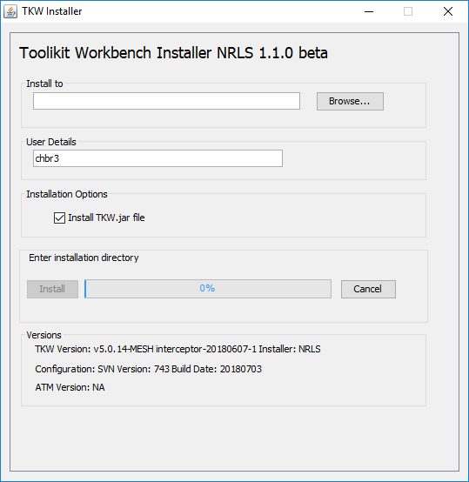
- Navigate to the ..config\SPINE_NRLS directory in your install
The important directory’s here are
simulator_saved_messages – this contains all messages and responses that the simulator has dealt with. From this you can see what has been sent in and what the response returned was. There is one logfile for each message sent.
validator_reports – this contains the validation report results from the runs against the request messages submitted. Reports are generated against all messages held in the messages for validation folder.
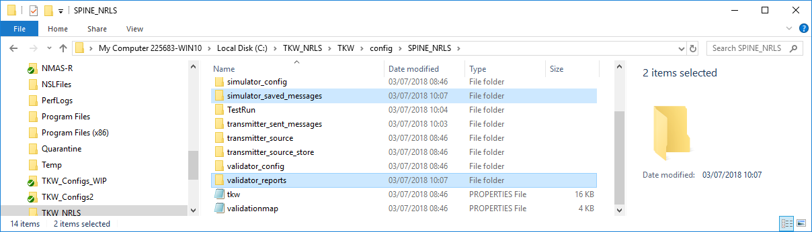
- To run the simulator, navigate to the TestRun directory and run the “2.Simulator_Start” batch file. You will see a DOS window open in the background.
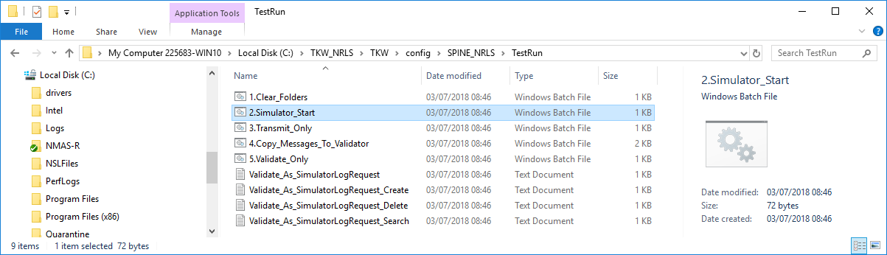
- Send in a message from your application to the simulator and receive a response. Details of this can be seen in the simulator_saved_messages folder. (To check the integrity of the install prior to using your application run “3.Transmit_Only” – this is set to do a Get.)
- To validate the message that you have submitted run the ”4.Copy_Messages_To_Validator” batch file to copy the logfile to the “messages_for_validation” folder
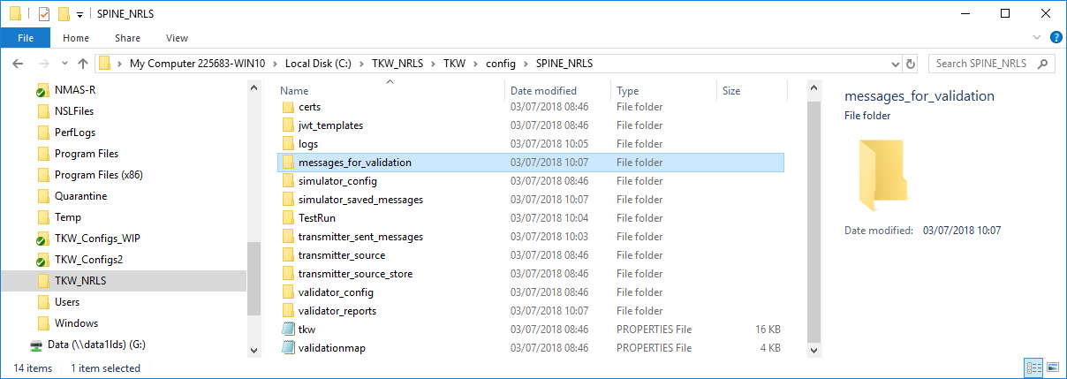
- Validate the message that you had sent in using “5.Validate_Only”. This will produce a validation report of the contents of the message sent to the simulator.
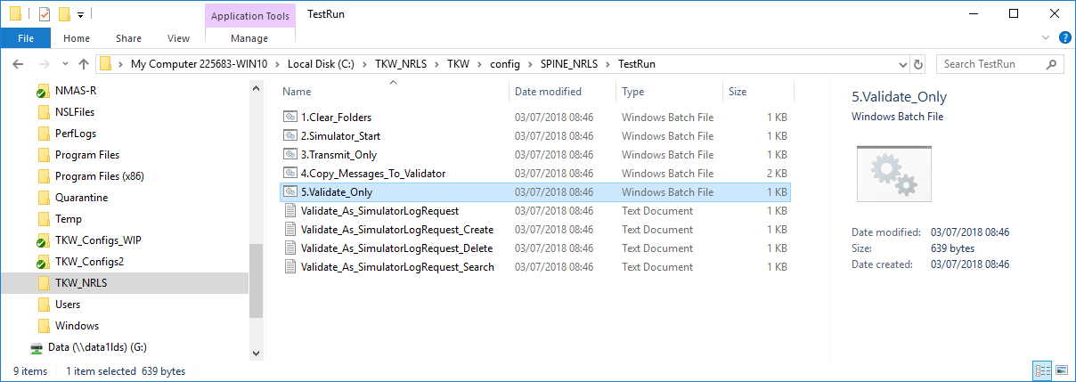
- Check the contents of the validation report created. . (Note: when you run this as part of the integrity check of your install, the validation report will show two errors. This is expected and is included to demonstrate how validation issues are report).
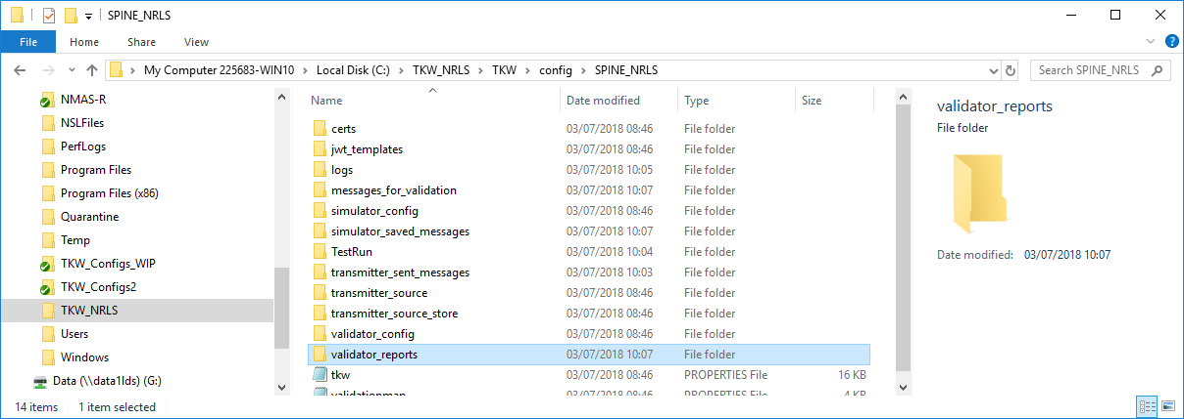
- The responses returned are dependent on the triggers sent in the request message. There is a spreadsheet of these triggers in the download in
….contrib\Common\simulator_packs\SPINE_NRLS\NRLS Simulator Triggers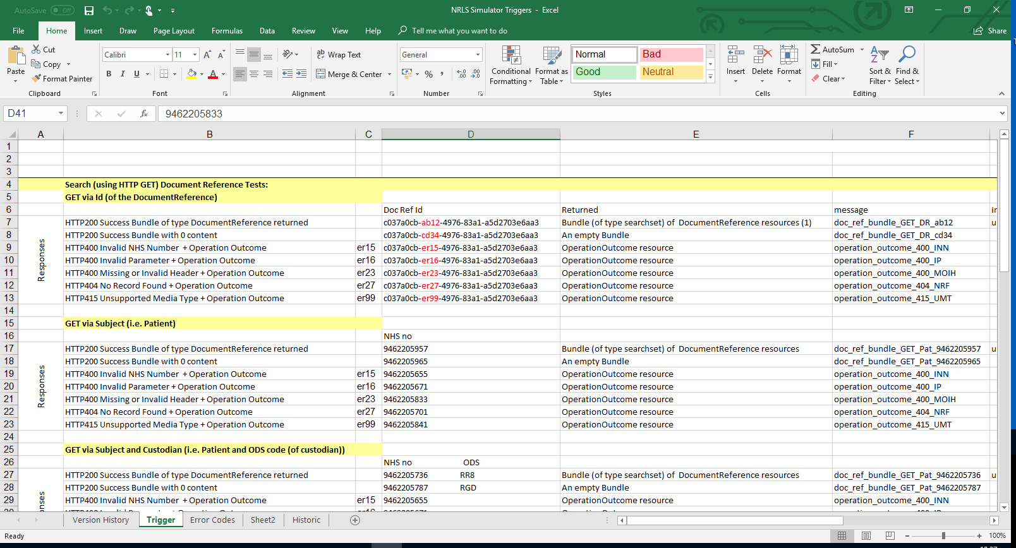
Notes
JRE must be present on the PC that the TKW Software is to run on.

Version control
Version | Date | Details
1.0 | 03/07/2018 | Initial version.
1.1 | 04/05/2018 | Notes section added. Requirement for JRE included here.
1.2 | 09/07/2018 | Added install test in step 4.
1.3 | 10/07/2018 | Added install validation report, 2 expected errors in step 7.

