Published XX Month 2019

Clinical Safety Case Report Template for use of the NHS e-Referral APIs
Organisation Name

Document filename:
Directorate / Programme |  | Project
Document Reference
Director |  | Status
Owner |  | Version
Authors |  | Version issue date

Document Management
Revision History
Version | Date | Summary of Changes

Reviewers
This document must be reviewed by the following people:
Reviewer name | Title / Responsibility | Date | Version

Approved by
This document must be approved by the following people:
Name | Title | Date | Version

Related Documents
These documents provide additional information and are specifically referenced within this document.
Ref | Doc Reference Number | Title | Version

Contents
Introduction 4
System Definition / Overview 4
Clinical Risk Management System 4
Supplier Conformance Assessment List 4
Clinical Risk Analysis 4
Clinical Risk Evaluation 4
Clinical Risk Control 4
Hazard Log 4
Test Issues 5
Summary Safety Statement 5
Quality Assurance and Document Approval 5
Configuration Control / Management 5
Appendix 1 6

Introduction
The purpose of this Clinical Safety Case Report is to cover the integration of NHS e-Referral processes into name of system using the NHS e-Referral name of suite suite of APIs to streamline name of processes.

System Definition / Overview
Description of the Health IT System; identification of Health IT System part and version number; description of the clinical environment it is to be used in; description of any existing systems it replaces or interfaces with; number of users and patients.
Description of the individual NHS e-Referral service APIs that the Health IT system will be using.
Description of the benefits that the use of APIs will deliver.

Clinical Risk Management System
Description of the Manufacturer’s clinical risk management system; identification of key personnel, their roles and responsibilities; identification of clinical risk management governance structure.

Supplier Conformance Assessment List
A copy of the completed SCAL should be embedded with a brief overview of the agreed approach.

Clinical Risk Analysis
Hazard identification should include identified hazards and their description; explanation of hazard causes and contributory conditions and consequences; identification of existing mitigating controls; estimation of clinical risk; identification of participating personnel.
Anything that has the potential to cause delay to a patient’s care, inappropriate care to a patient or absence of care for a patient constitutes a clinical safety hazard.
As part of the hazard identification, all the entry and exit points of the APIs between the e-RS pathway and the partner organisation’s pathway should have a risk assessment, paying particular note to how failures at any of these points can be safely managed.
Workflow using the APIs should also be considered to ensure that
Manufacturer should also include consideration on how to safety net the system against human error.
Appendix 1 has an overview of the e-RS pathway.

Clinical Risk Evaluation
Evaluation of initial level of risk of each identified hazard using a pre-defined risk matrix.

Clinical Risk Control
Identification, justification, implementation and verification of adequate risk controls; residual clinical risk evaluation and completion of controls.

Hazard Log
Presentation of associated Hazard Log.

Test Issues
Summary of any outstanding test issues and the impact on clinical safety.

Summary Safety Statement
Statement from the Clinical Safety Officer summarising the safety position of the Health IT System in the context of the intended deployment.

Quality Assurance and Document Approval
Evidence of appropriate quality, review and approval regimes.

Configuration Control / Management
Evidence of appropriate configuration control being used.

Appendix 1
Overview of the NHS e-Referral pathways
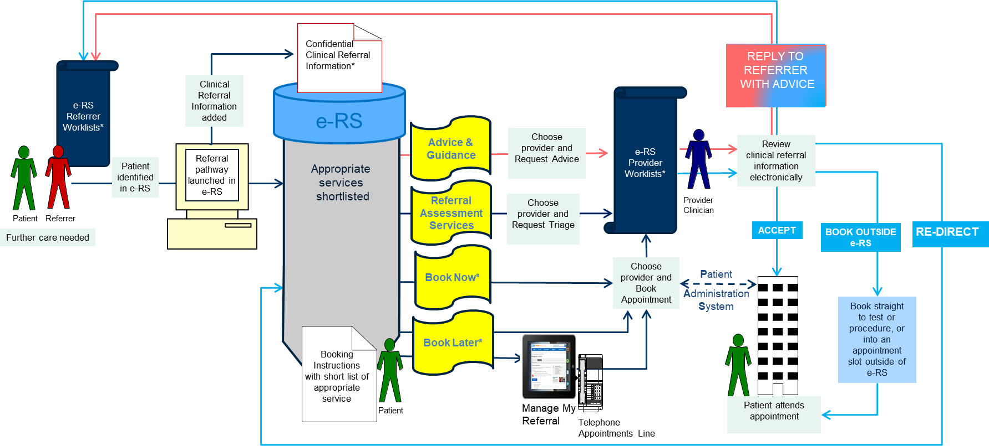
* e-RS has multiple Worklists for referrer and provider organisations with entry and exit rules. These worklists double up as safety nets to ensure all outstanding work is transparent to the user and to ensure the e-RS pathway is completed fully.
Book Now services cover a number of different types of services such as telephone assessment services, clinical assessment services, access to indirectly bookable services (for providers whose PAS is not aligned to e-RS), as well as face-to-face appointment services.
The Book Later option allows bookings to occur independently of the initial booking process using the professional or the patient application.
Clinical referral information must comply with the Joint Royal College standards and is added independently to the initial booking process. Rules exist around when clinical referral information is visible within the e-RS programme and who can see this information.

